This Photo by Unknown Author is licensed under CC BY-SA
RED IAITH TASK
-Using commas

TASK 1 FIX MY SENTENCE
Read through the slides on the power point and then correct the following sentences by putting in the commas

Repair the sentences by putting commas in the correct places.
1. The wrapping paper had blue white red and yellow stripes.
(Hint: 2 commas for a list)
2. The shard the tallest building in Britain is located in London.
(Hint: 2 commas for extra information)
3. The candle was burning brightly but I could see it was about to go out.
(Hint: 1 comma for breaking up a sentence)
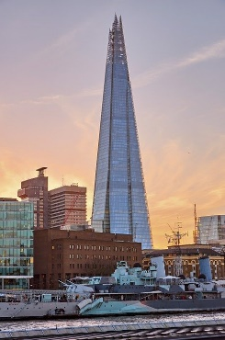
4. Thomas smiled warmly and said “Good afternoon.”
(Hint: 1 comma to show speech)
5. Dramatically the song finished with a bang!
(Hint: 1 comma for a fronted adverbial)
TASK 2
6. Write a list of five things you would need to camp out for the night.
Write your list as a sentence.
7. Can you add extra information to this sentence using an
embedded clause?
Laura walked to school.
8. Can you use a second clause to extend this sentence?
The air was very cold.
(Hint: you could start your second clause with ‘but’, ‘so’ or ‘and’.)
9. Can you decide what Skye said?
Skye frowned and said
(Hint: remember that a comma comes before the inverted commas open.)
10. Can you use a fronted adverbial to describe how the door slammed?

