L2- WALT; communicate simply some of the basic religious beliefs, teachings and practices investigated
L3- WALT; describe some of the basic religious beliefs, teachings and practices investigated

Steps to success
Create a presentation about the Muslim holy book
-Name the Muslim holy books
-Explain what the Muslim holy books is
-Explain how it is used
-Explain how the words in the holy book were revealed to Muhammad

Use some of these sub-titles to help you organise the information

Green
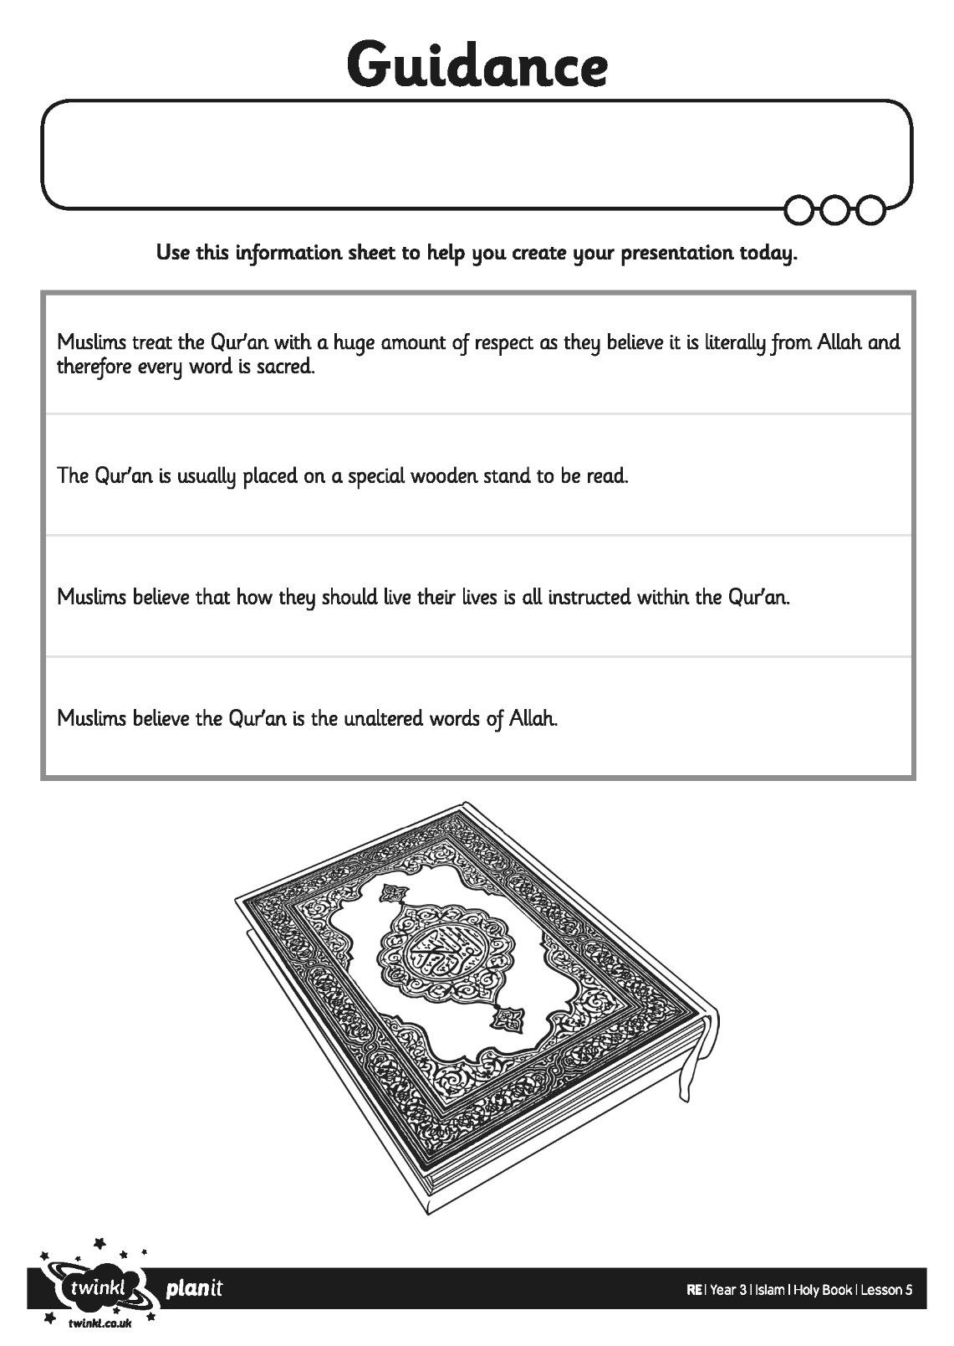

Blue
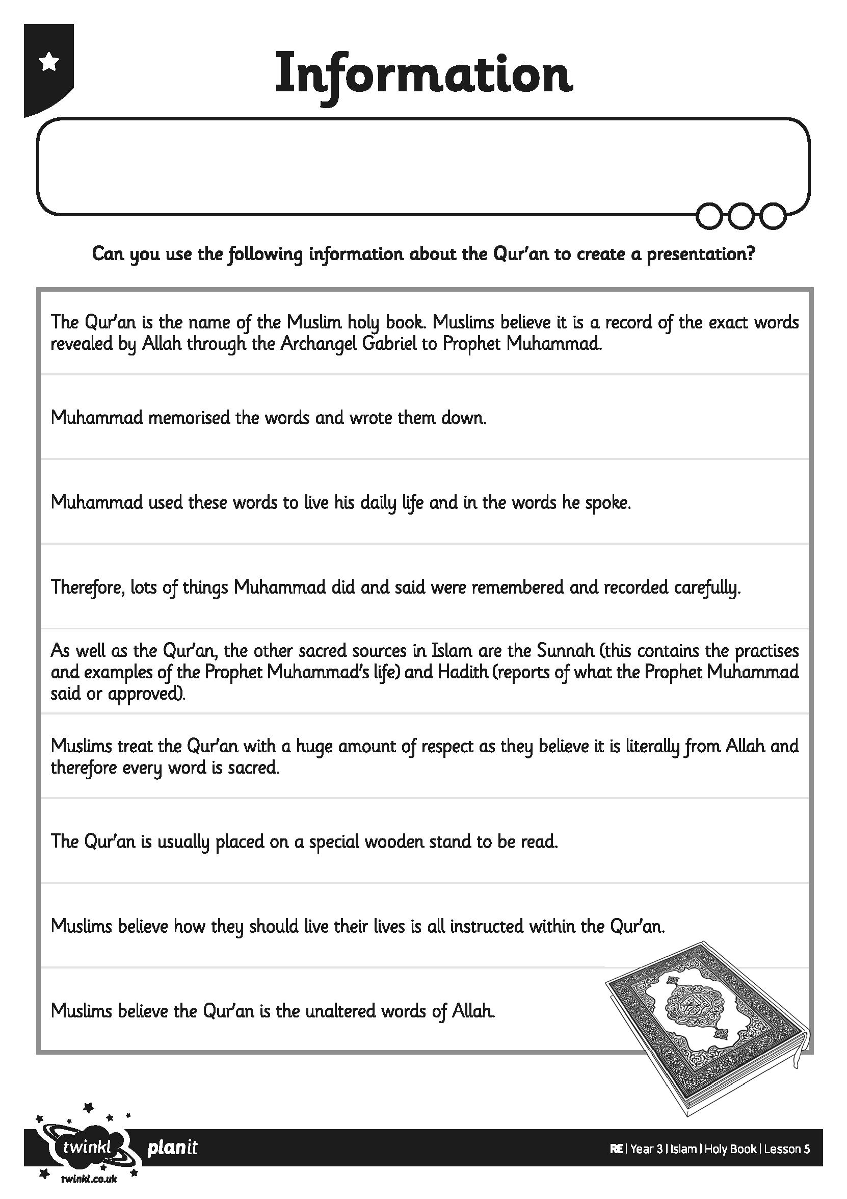

Red
