Science/maths database interrogation (Monday)
Introduction:
You will be needing to use the < > symbols.
>Means greater than
< means less than
For example: 5>2
We would say 5 is greater than 2

Look at how to create a query (ask and question) in your database. By creating a query the computer does all the hard work for you!
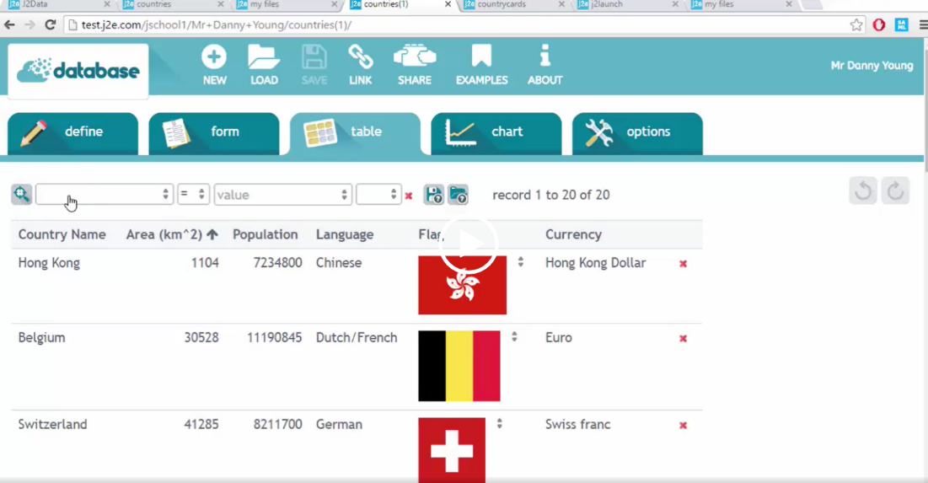

Example database
You will be using your own database – the one you created last week.

Click the magnifying glass then use the drop-down menus to find answers to questions such as:
Bones< 200
Bones less than 200 – this would show you any animal with less than 200 bones.
Hearts > 5
Hearts more than 5
This would show you and animal with more than 5 hearts

The query is number of bones more than 300. There are no matches to this. You can ask all sorts of questions linked to your database.
You can also make a graph from your database by clicking on the chart option.

Task - Interrogate your database.
Ask at least 5 questions using the < > symbols.
Write the questions out and record your findings.

Create a graph of your choice, possibly showing the amount of bones. You will need to use a bar graph as this is not continuous data.
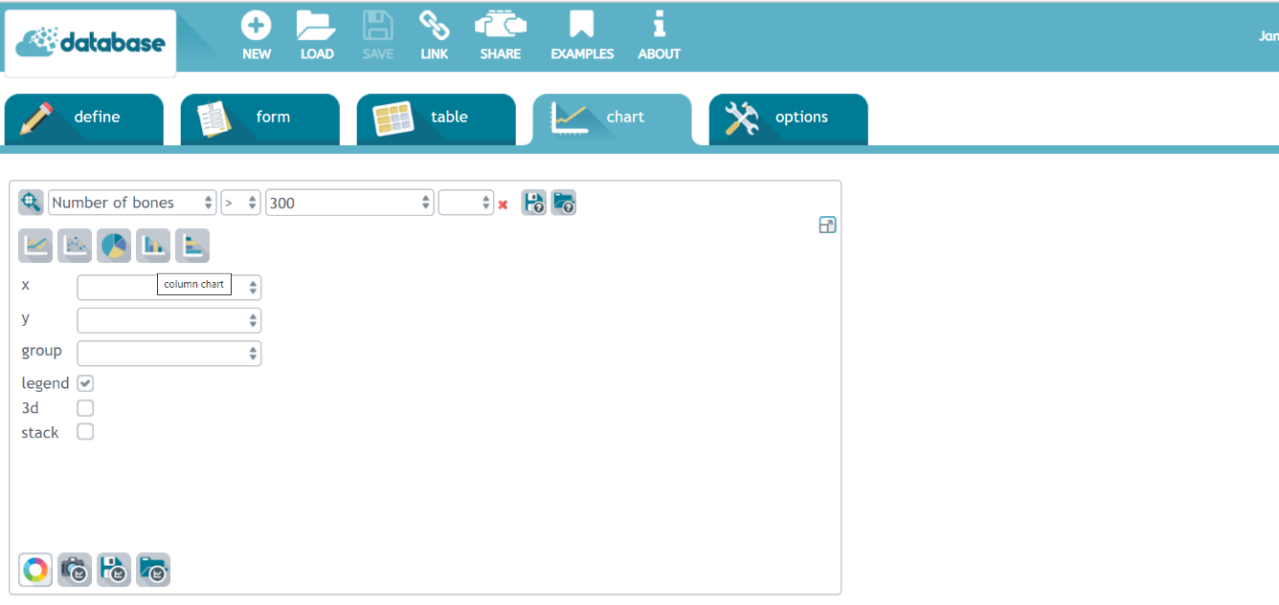

This is the option you will need.

The animal name will be needed on the x axis Then whatever you want to graph will be the y axis.

