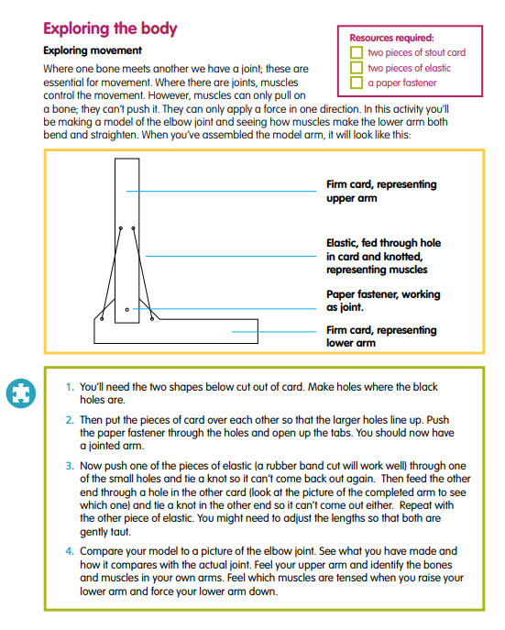

**MAKE A MODEL ELBOW JOINT**

**INSTRUCTIONS**