Iaith Wednesday
Look at different fiction and non-fiction books and discuss the similarities and differences between them.
Then look at different story books and discuss what every book has. Discuss the questions below. Write the elements of each book on post it notes or paper. On the paper you will write what characters your story has, what the setting is (woods, beach) and a few sentences to describe the plot.
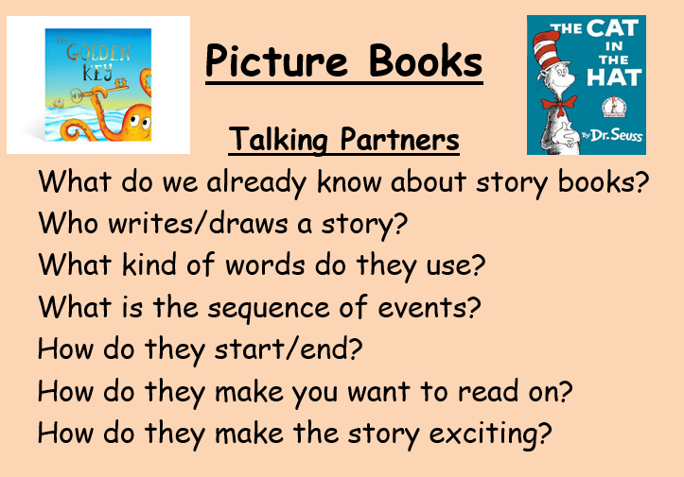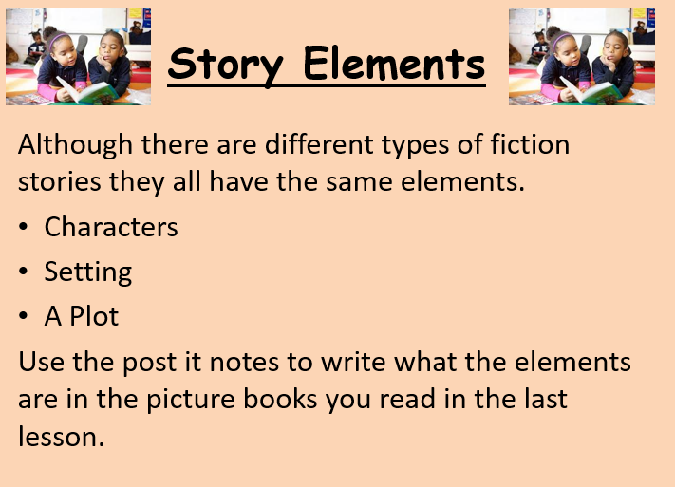

Wednesday pm
Create a story mountain/map of your favourite story-book. You can use one of the formats posted if you want to.

Friday
Create a bookmark related to your favourite story-book.

