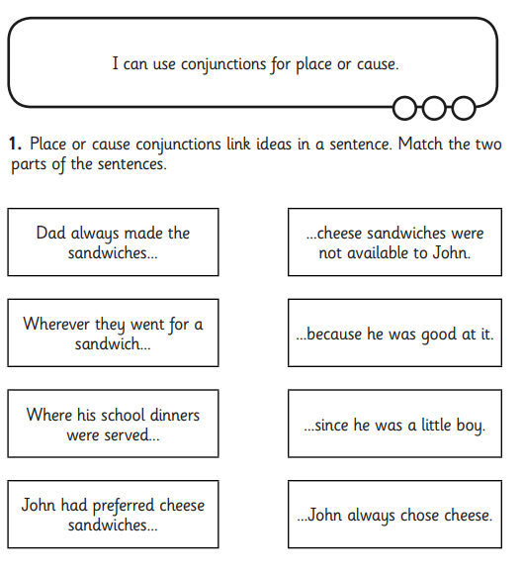

**GREEN IAITH TASK SHEET 1 - conjunctions**

**DAD and JOHN**