GREEN
Muscles and Moving
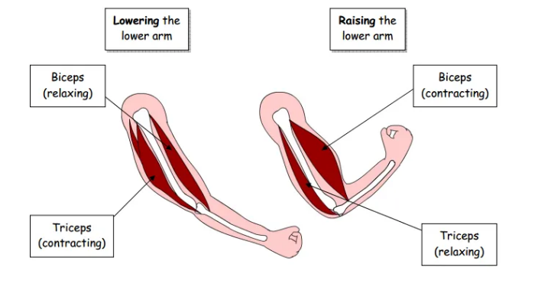
TASK 1

The arm has 2 muscles attached to the elbow joint
The top muscle is called a _________
The muscle underneath is called a _______
The muscles work in ______
They allow the arm to ____ and _____
We use these muscles to help us ____ things.
TASK 2 Use the template and instructions to make a model elbow joint
lift Bicep bend pairs Tri cep straighten

