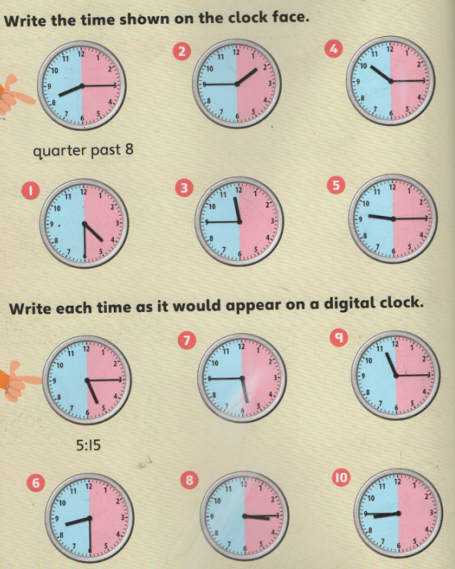

**GREEN MATHS SHEET**

**Analogue & Digital Time**