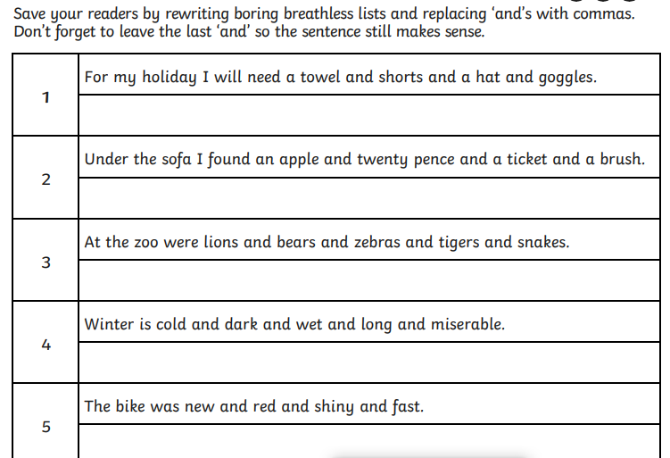

Now write your own list sentence, don’t forget to use commas correctly.

_____________________________________________________________________________________________________________

**GREEN IAITH**

**Using commas in Lists**