Dydd gwyl Dewi hapus – Happy Saint David’s Day
Celf o Gymry – Welsh Art

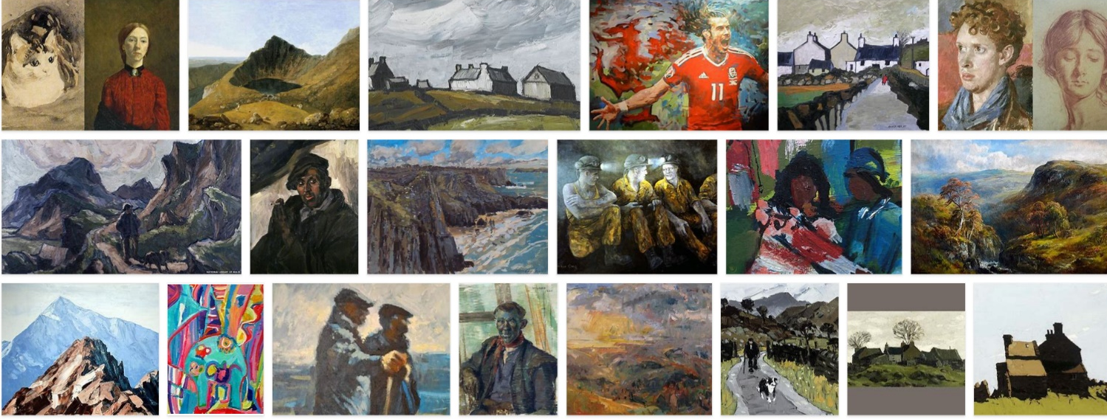
Here are a variety of famous Welsh art. There are a wide range of styles and themes.

You can see the many different tools used from oil paintings, watercolours, pencil sketches and photography. You can also see that many different themes have been used, for example Welsh coal miners and farmers, famous Welsh people, Welsh countryside and even Welsh animals (don’t forget sheep).

Task:
- Choose 2 different themes e.g. landscape around you and a famous Welsh person
- Choose 2 different ways to portray these themes e.g. photography and pencil sketch
- Now produce 2 different pieces of art work for example, a photograph of the Welsh countryside (maybe go out for a walk if you can) and a pencil sketch of a famous Welsh person.
Enjoy!

