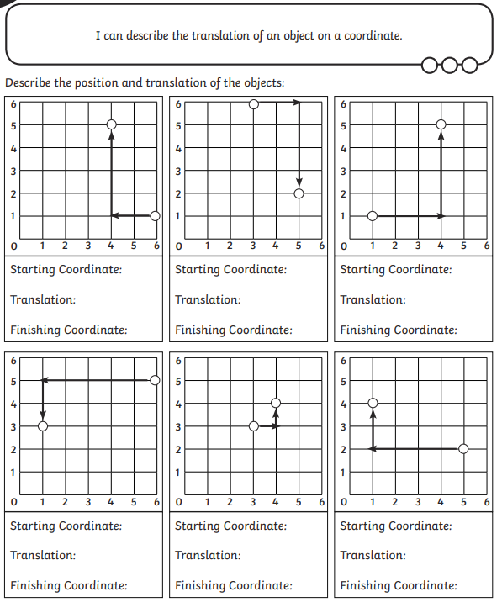

**BLUE CO ORDINATE TRANSLATIONS 1**