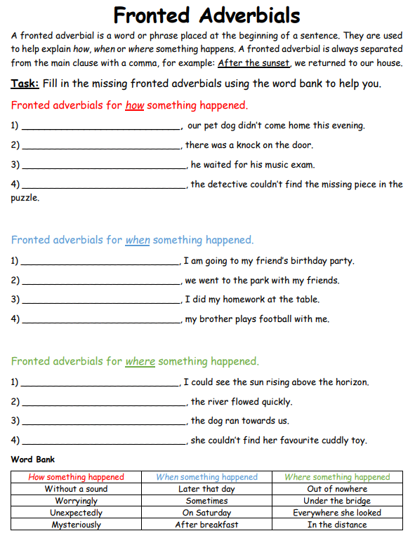

**BLUE IAITH TASK**

**Fronted Adverbials**