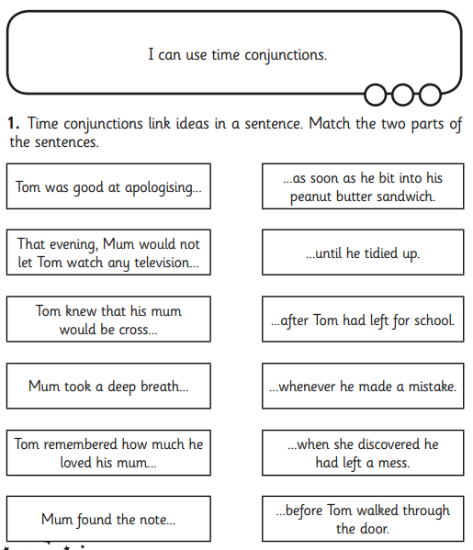

**BLUE IAITH TASK SHEET 1 - time conjunctions**

**Mum and Tom**