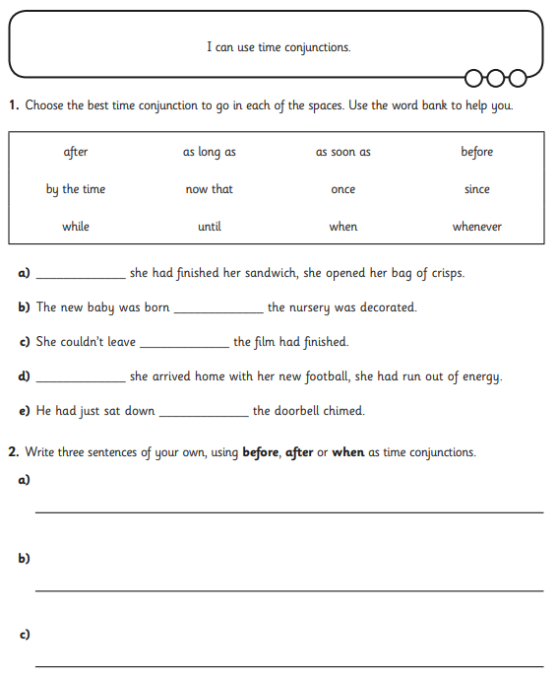

**BLUE IAITH TASK SHEET 2 - missing time conjunctions**