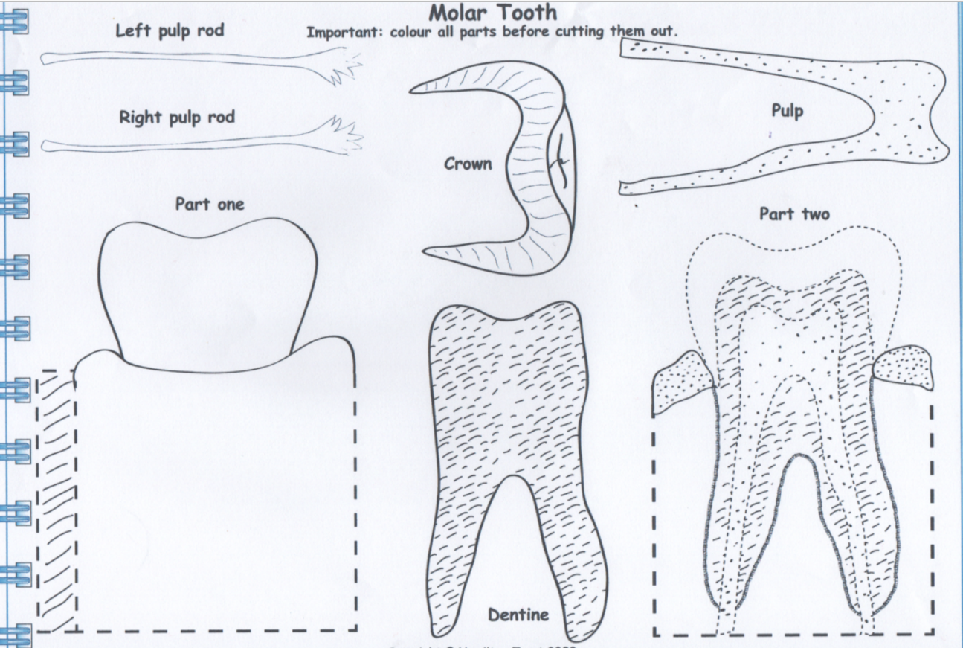

**ALL GROUPS SCIENCE**

**Tooth Template**