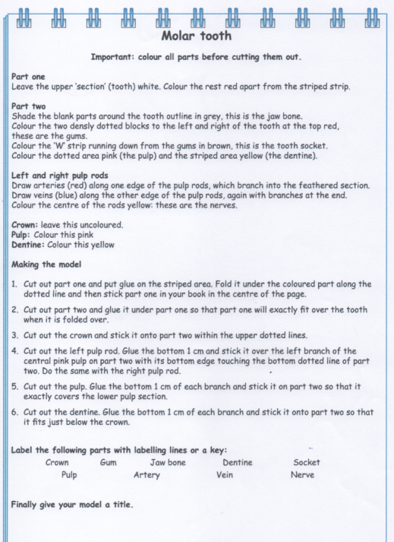

**ALL GROUPS SCIENCE**

**MODEL INSTRUCTIONS**