Monday
WALT; find unit and non-unit fractions of amounts

Steps to success
Copy the calculation carefully
Split your number into ? parts (the number on the bottom of the fraction- denominator)
Keep ? parts (the number on the top of the fraction- numerator)
Show your answer clearly

Tuesday
R-WALT; compare and add fractions

I can:
-use a fraction wall
-identify equivalent fractions
Challenge: include equivalent fractions from the fifteenth and sixteenth families.

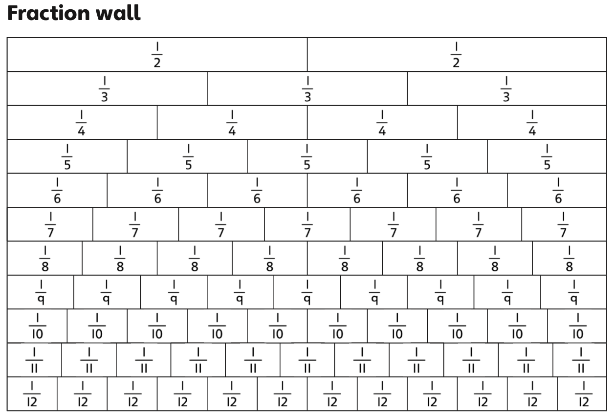

Wednesday
R-WALT; reduce fractions to their simplest form

Steps to success
Rearrange the number cards so the larger number is the denominator (bottom number) and the smaller is the numerator (top number)
Write the fraction in its simplest form
Identify any that cannot be simplified

Friday
WALT; draw conclusions from data
R-WALT; calculate fractional quantities

Fractions of Amounts - Would You Rather....?
- 4/3 of £90

Or

4/8 of £180

- 6/10 of 250 spots

Or

3/4 of 200 spots

- Eat: 9/10 of 180 sprouts

Or

5/8 of 240 sprouts

- Run up: 2/3 of a 60km mountain

1/5 of a 50km mountain

Or

2/8 of a 40km mountain

