Monday
R-WALT; divide 2- and 3-digit numbers by 1-digit numbers

Steps to success
Copy the calculation carefully
Use column division to solve it
Use your knowledge of times-tables to help you
Use your knowledge of column subtraction to help you
Record your answer

Tuesday
R-WALT; divide 2- and 3-digit numbers by 1-digit numbers

Steps to success
Copy the calculation carefully
Use column division to solve it
Use your knowledge of times-tables to help you
Use your knowledge of column subtraction to help you
Record your answer

Wednesday
WALT; identify factor pairs and use them to answer related multiplications and divisions

Steps to success
Identify factor pairs (pairs of numbers that multiply to give another number) for numbers
Use the factor pairs to help answer multiplications
Use factor pairs to help answer divisions

Friday
R- WALT; calculate number bonds to 100
Steps to success
To help you find bonds to 1000, use bonds to:
10
100 and
1000
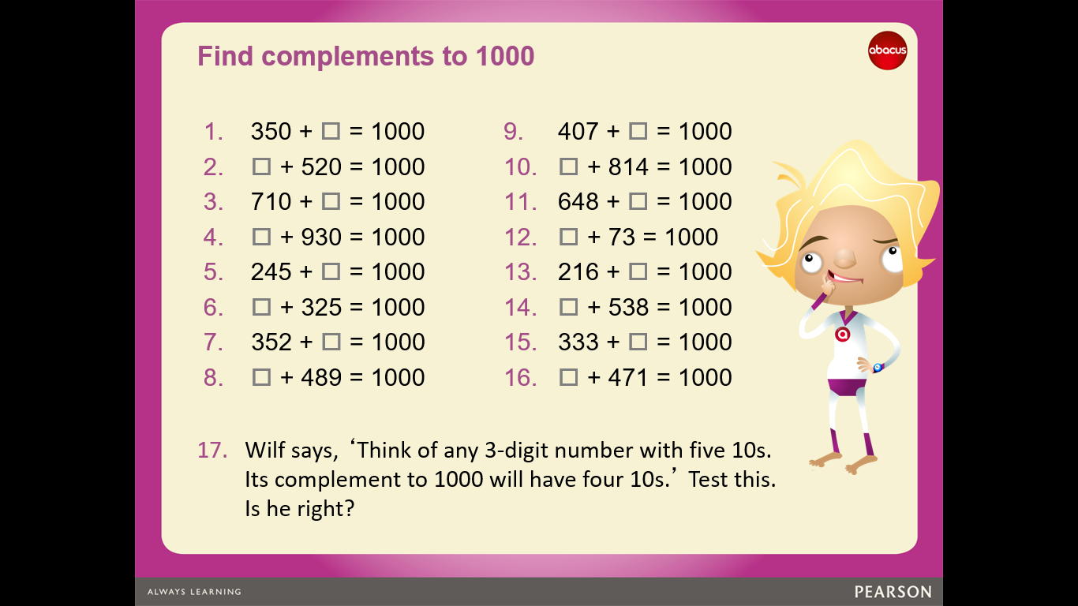

Answers

A challenge- if you want it

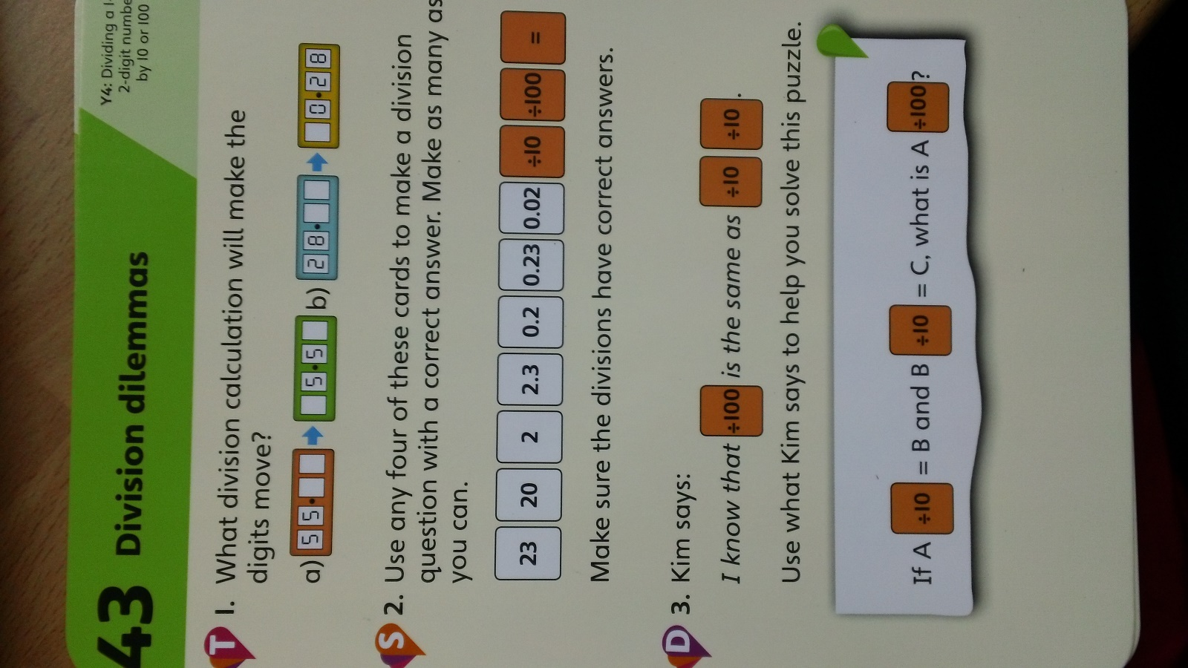

Answers

