Monday
B-WALT; divide 2- and 3-digit numbers by 3, 4, 5 and 6

Steps to success
Copy the calculation carefully
Use column division to solve it
Use your knowledge of times-tables to help you
Use your knowledge of column subtraction to help you
Record your answer

Tuesday
B-WALT; divide 2-digit numbers and make predictions

Steps to success
Copy the calculation carefully
Use column division to solve it
Use your knowledge of times-tables to help you
Use your knowledge of column subtraction to help you
Record your answer

Divide 81 by 3, 4, 5, 6 and 8,

Divide 92 by the same numbers.

Predict if there will be a remainder.

Wednesday
WALT; identify factor pairs and use them to answer related multiplications and divisions

Steps to success
Identify factor pairs (pairs of numbers that multiply to give another number) for numbers
Use the factor pairs to help answer multiplications
Use factor pairs to help answer divisions

Friday

B- WALT; identify and describe patterns when subtracting numbers from 1000

Steps to success
Make a 3-digit number and subtract from 1000
Use the same digits to make 2 different numbers and repeat
Add the digits of each answer together
What do you notice?
Explain the pattern

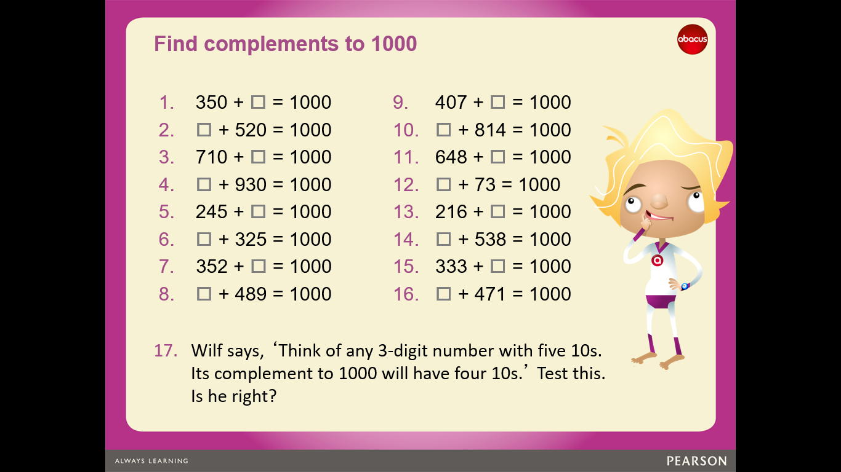

Answers

