Week Commencing 4th January 2021
Wednesday 6th January 2021
Iaith
Please look at the document on the school website from Mrs Clarke.
Science
Please look at the document on the school website from Mrs Clarke.
Maths
Green
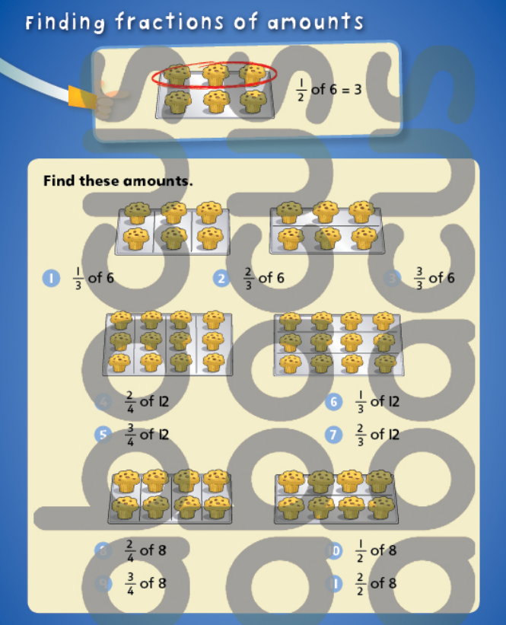
Blue
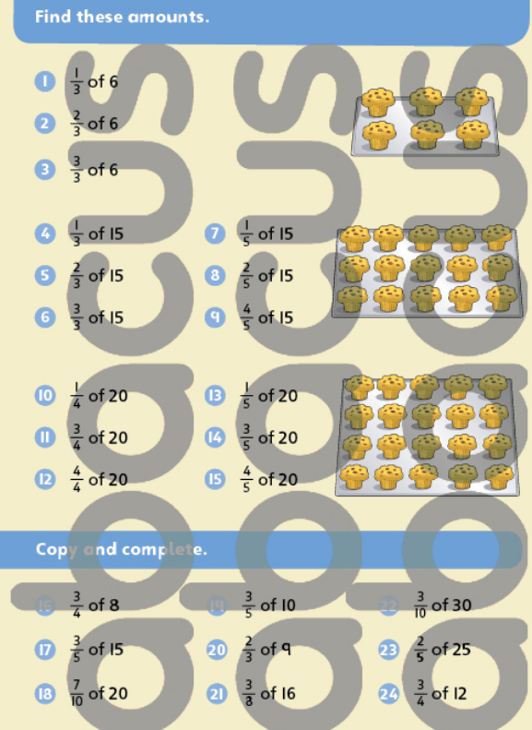

Red
Pupils to use their knowledge of the 8 times-table to help. Write the multiple of 8s down in your book. What is 1/8 of 8? Write 1/8 of 8 is 1 at the side of 8 divided by 8 equals 1. Take 16 interlocking cubes and split into 8 groups to find 1/8 of 16. Repeat for each multiple of 8 using the cubes to help until you spot a link. Repeat with another times-table of your choice.
Black
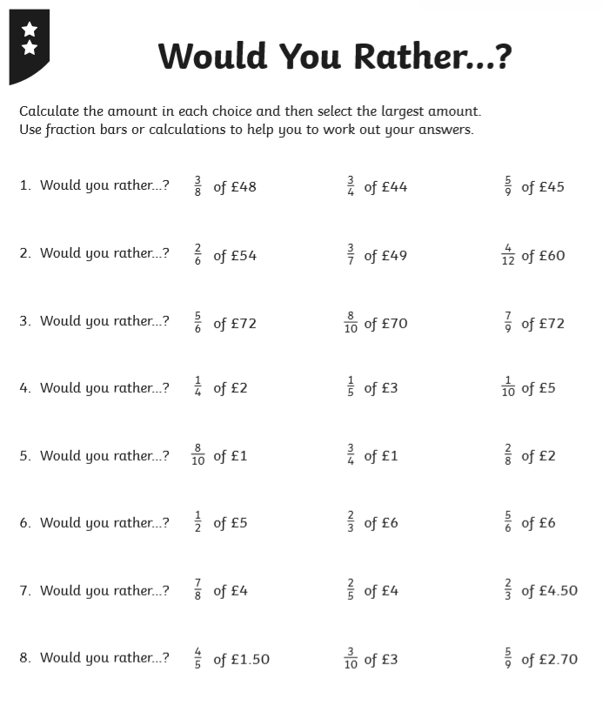

Thursday 7th January 2021
Mindfulness
Look at your balloon for the next two minutes and describe it in your head. Take a deep breath in and fill the balloon then hold it.
Take the next few minutes looking at your balloon while blowing it up. At the end everyone let go.
What did you notice?
Did you remain on task?
Were you distracted? Could you bring yourself back?
Letters and Sounds (Code Breakers)
There will be a live letter and sounds session on teams on Monday, Tuesday, Thursday and Friday. We will start the session at 9.30 and should only be about 15 mins. All you will need is a piece of paper and a pencil. Please place yourself on mute so everyone can hear. However, if you are unable to attend the session I have put the lesson below to do in your own time.
Code Breakers
This is a letter and sound scheme that we are going to try with all year 3 pupils. I have noticed that we have lost a few of the sounds and it would be great practice to recap. This scheme focuses on boys called Boris and Sid.
Sound ‘ee’
- Boris is feeling really tired today - the cat kept him awake all night! He wants to write ‘I need a sleep’.
- Ask chn if they recall how to write the tricky word ‘I’. Ask them to show you on their w/bs. Help if necessary.
- Say the next word ‘need’. Ask chn to segment (split it up) it and count the sounds on their fingers /n/ /ee/ /d/. Draw three cradles.
- Say ‘need’ and ask chn to tell you the first sound /n/. How can we write this sound? Ask chn to show you in the air. Write n on f/c and w/bs on the first cradle.
- Say the word again and ask chn to tell you the middle sound /ee/. Tell chn that here we spell this sound with ee not y. Stress that we use two letters for one sound. Write ee on second cradle on the f/c and w/bs.
- Encode /d/ as d in the usual way on the last cradle. Blend the sounds /n/ /ee/ /d/ to read the word ’need’.
- Ask chn if they recall how to write the tricky little word ‘a’. Ask them to show you on their w/bs. Help if necessary.
- Say ‘sleep’, segment (spilt up) it and count the sounds /s/ /l/ /ee/ /p/. Draw four cradles on the f/c and w/bs. Encode /s/ and /l/ in the usual way as s and l. Say ‘sleep’ and ask chn to identify the sound /ee/. Say that here we spell it in the same way as ‘need’ with ee. Write it on the f/c and on w/bs. Say ‘sleep’ and encode /p/ as p in the usual way. Blend the sounds /s/ /l/ /ee/ /p/ to read ‘sleep’. Read the whole sentence together ‘I need a sleep.’ • Boris says thanks – he’s off to have a nap!

Iaith
Take a look at the game below. What do you like about the game? What don’t you like? How could it be improved?
Write about it or film yourself talking about it.
If you have it, maybe you could play a game; if not, use this link to see how it works…https://www.youtube.com/watch?v=wYRPuIQc8eI

- 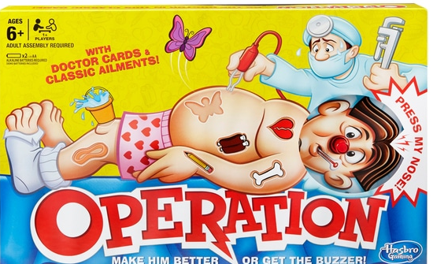
- 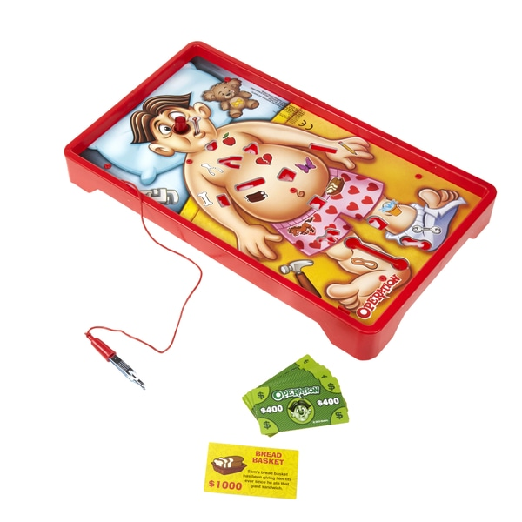

Maths
Please see the PowerPoint on the website or teams.
Green
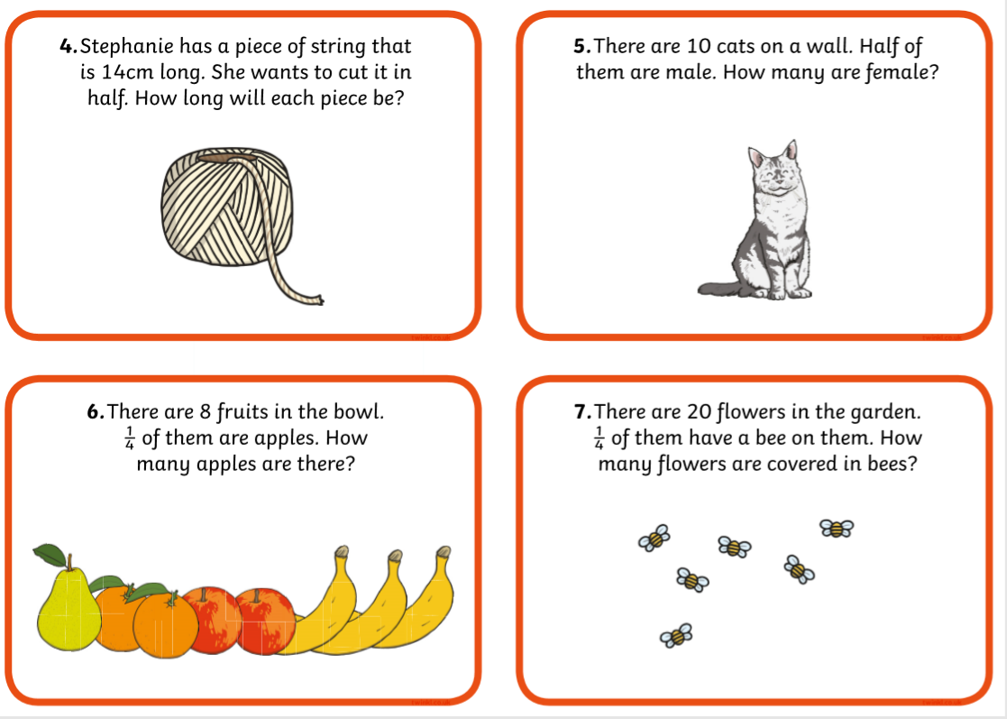
Blue
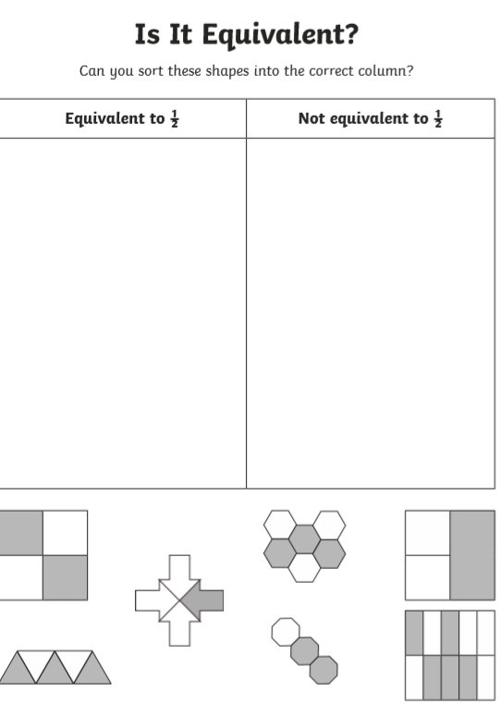

Red
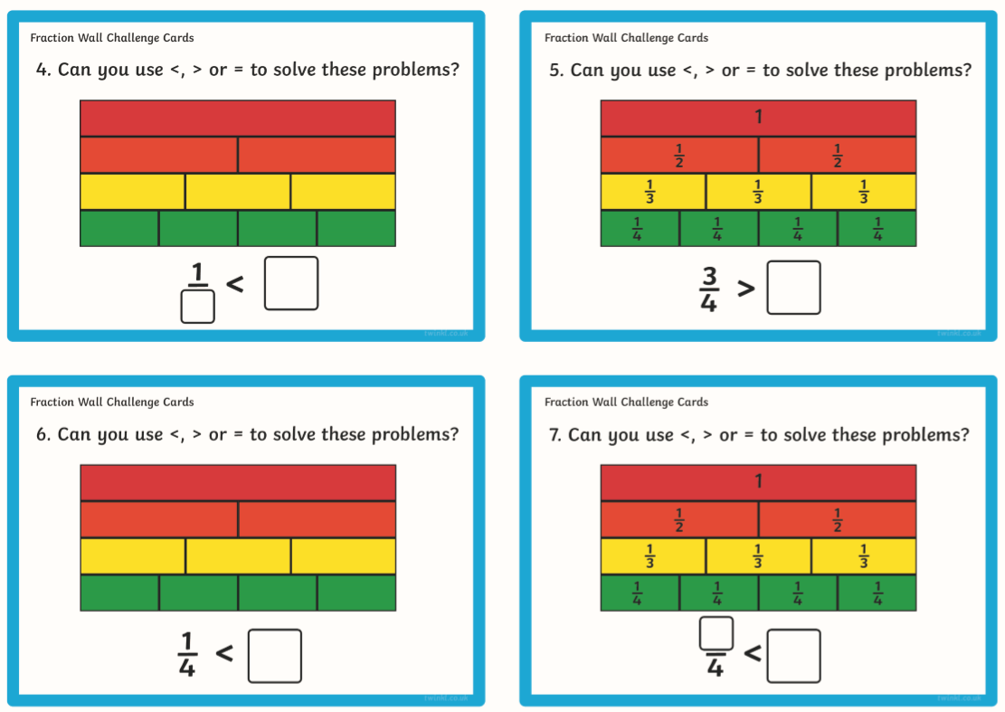
Black
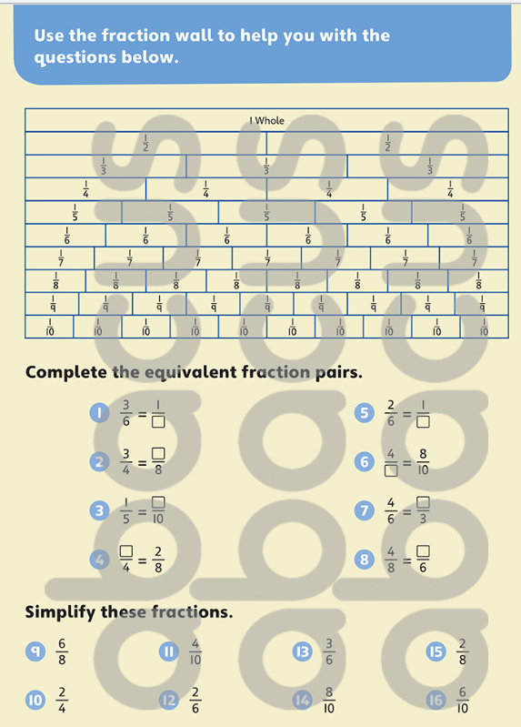
Thema/Mantle
Complete the following activities about the human body- you will probably need to use the Internet to help you.
- human-organ-matching-and-labelling-activity
Friday 8th January 2021
Mindfulness
Choose a Cosmic Kids Yoga from YouTube.
Letters and Sounds (Live at 9.30 on Teams)
Sound ee as ea
- Boris’s mum was wondering if the cat was hungry and wanted to know what Boris had given it to eat. Boris wants to write ‘plenty of meat’.
- Can we help him?
- Say the word ‘plenty’ and segment the sounds /p/ /l/ /e/ /n/ /t/ /ee/ and count them. Draw six cradles on the f/c and w/bs.
- Encode the sounds /p/ /l/ /e/ /n/ and /t/ as p l e n t in the usual way.
- Say ‘plenty’ and identify the last sound /ee/. Ask chn if they can recall the way we often write this sound at the end of a word. If necessary, remind them how to write y like in ‘mummy’. Add it to the f/c and w/bs. Blend the sounds to read ‘plenty’.
- Say the word ‘of’. Count the sounds (two) and help chn to encode /o/ as o and /v/ as f. This last is a tricky sound, and because we meet this word a lot, we need to remember it as a tricky word. • Say the word ‘meat’ and segment it as /m/ /ee/ /t/ and count the sounds. Draw three cradles on f/c and w/bs.
- Encode /m/ as m in the usual way on the first cradle. Say ‘meat’ and ask chn to identify the second sound /ee/. Say that here we write /ee/ in a different way and show them how to write ea on the f/c. They copy on their w/bs.
- Encode /t/ as t in the usual way. Blend the sounds /m/ /ee/ /t/ to read the word ‘meat’.
- Read the whole phrase together ‘plenty of meat’. Boris says thanks – he’ll leave the note for his mum.

Iaith
Look at the picture of the board game and the pictures of the body (from the previous lesson). Can you label the board game with the correct muscle/bone/organ names? For example, Charley the horse could be the thigh muscle or the femur bone.
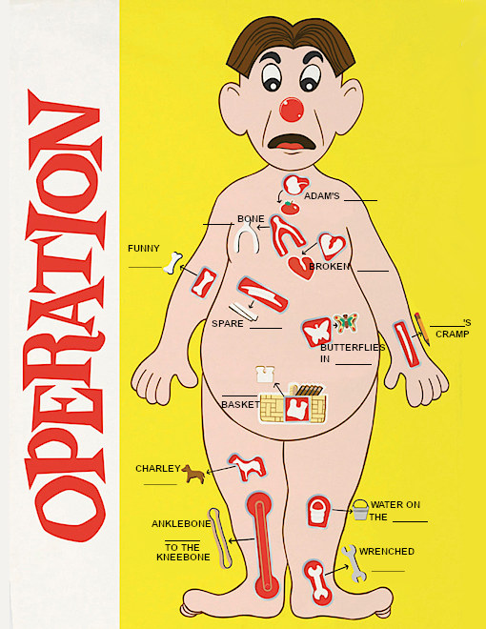

Maths
If needed go back through the PowerPoint from yesterday.
Pupils investigate how many equivalent fractions they can find. They cut the fraction walls into strips and fold the strips in half to see which have an exact equivalent to one half and which have a fold line in the middle of a fraction part. They record as ½ = 2/4= 3/6. Look at the fractions and notice that all the denominators were even. Equivalent fractions of ¼, 1/8, 1/5 and 1/10, 1/3. 1/6
Golden Time
We are creating a Winter wall in our class. Here are a range of activities you could do to make our display. Please keep the made pieces of work and once we are back in school I will put them on the wall. Thank you! If you do not have any resources for these crafts then you can choose something off the challenge list instead.
