Monday | Mindfulness  App  Smiling Mind  Buddhify | Letters and Sounds  9:30  V as ve  Recap | Iaith  Express yourself PowerPoint  Comprehension | Break | Read a book with an adult and discuss it. | Maths  Division | Lunch | Tric a Chlic  Welsh  1pm  Dialogues | ICT  Scratch | Reasoning | Listen to an audio book  David Walliams Website
Tuesday | Mindfulness  IMoves | Letters and Sounds  9:30  Oo as oo  Recap | Iaith  Emotions  Circle Time  Things that me feel… |  |  | Maths  Division |  | Tric a Chlic  Welsh  1pm  Bore Da Letters answering questions | RE | PE  Be active:  -ride your bike  -play a game of something  -go for a walk  -do a Joe Wicks workout  -Cosmic yoga  -You choose!
Wednesday | Work on the website from Mrs Clarke  clarkea89@hwbcymru.net | Iaith |  |  |  | Maths  Division |  | Science
Thursday | Mindfulness  Kind thoughts | Letters and Sounds  9:30  Oo as u | Iaith  Graffiti Wall  Cooperative collage |  |  | Maths  Division |  | Tric a Chlic  Welsh  1pm  Bore da letters change the words | Thema
Friday | Yoga  Cosmic Kids Yoga | Letters and Sounds  No Live | Iaith |  |  | Maths  Division |  | Tric a Chlic  Welsh  1pm  Apps | Golden Time  Child Mental Health Week

MONDAY 1st FEBRUARY 2021
Mindfulness
Pick a guided mediation off an app. Smiling mind and buddhify are free, you just have to create an account.
Letters and Sounds (V as ve)
Sid says the king was really upset and said ‘We have to get him up.’ Sid wants to write this – can you help?
Say ‘we’ and see if chn can recall how to write it. If not encode it in the usual way.
Say the word ‘have’, segment it /h/ /a/ /v/ and count the sounds. Draw three cradles. Encode the first two sounds /h/ and /a/ as h and a in the usual way. Ask chn to identify /v/ and say that here we write it with two letters ve. Add ve. Stress that we often use ve at the end of a word.
Say the word ‘to’. Ask chn to suggest how to write this. Encode /t/ as t and help them with the tricky bit, /ooh/ as o. Stress that this is a word we use a lot and need to remember.
Say ‘get’ and segment and encode it in the usual way.
Say ‘him’ and segment and encode it in the usual way. • Say ‘up’ and segment and encode it in the usual way.
Read the whole sentence ‘We have to get him up.’
Sid says he hopes the dog will live. He thinks we can write ‘live’ in the new way we learned today. Segment ‘live’ /l/ /i/ /v/ and count the sounds. Put three cradles. Encode /l/ as l and /i/ as i on the first two cradles. Say ‘live’ and ask chn to tell you the last sound /v/ Ask chn to show you on their w/bs the new way we have learned to write /v/. Add ve. Blend the sounds to read the word ‘live’. Sid says he’ll be back tomorrow to tell you more!
Sid says the king got a long rope and sent someone small down the well to get the dog up! They took him to the vet to get him checked over. Sid wants to write ‘Then they went to the vet’.
Say the word ‘then’, segment the sounds /tthh/ /e/ /n/ and count them. Draw three cradles. Say ‘then’ and ask chn to identify the first sound /tthh/. Ask them to recall how we wrote this and write this using a capital T. Encode the next two sounds /e/ and /n/. Blend the sounds to read ‘then’.
Say ‘they’ and ask chn if they can recall how to write this word. Say ‘went’ and ask chn if they can remember how to write this word.
Say ‘to’ and ask chn if they can remember how we wrote this word yesterday.
Say ‘the’ and ask chn how we write this.
Say ‘vet’, segment the sounds /v/ /e/ /t/ and count them. Draw three cradles. Ask chn to identify the first sound in ‘vet’ and tell you how we write it at the beginning of a word. (Stress that ve is used at the end of words)
Encode the final two sounds /e/ and /t/. Blend sounds to read ‘vet’.
Read the whole sentence together. • Sid says the dog was fine – just a bit shocked!
IAITH (Comprehension)
Green
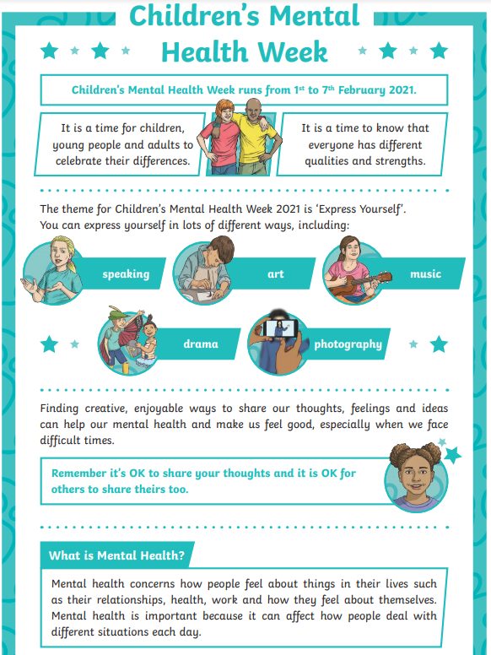
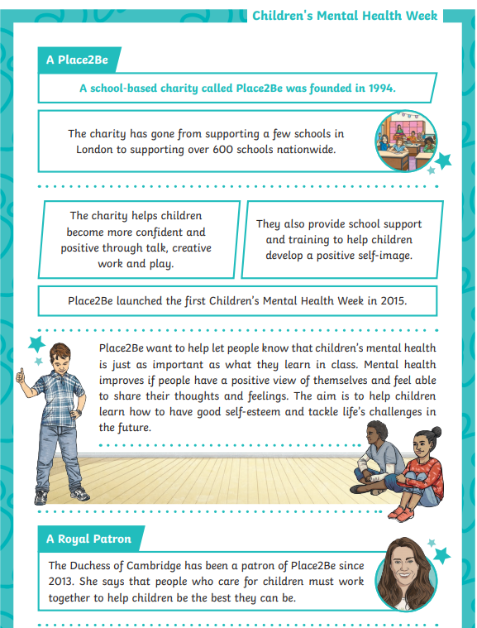

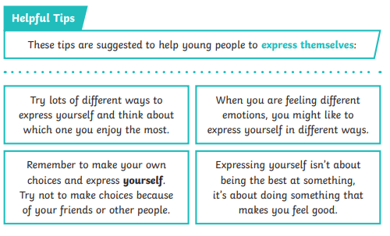
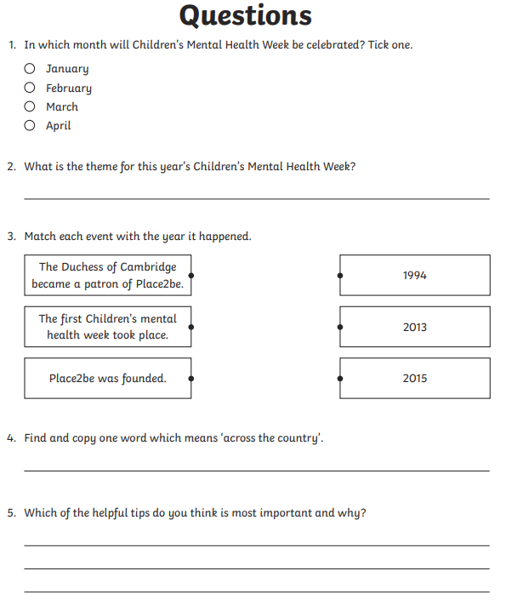
Blue 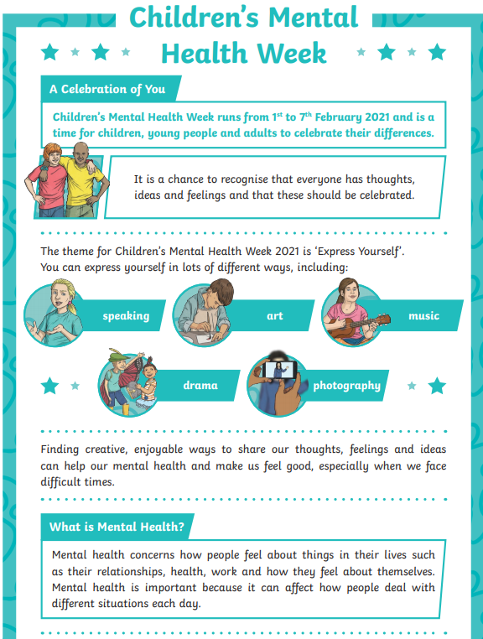
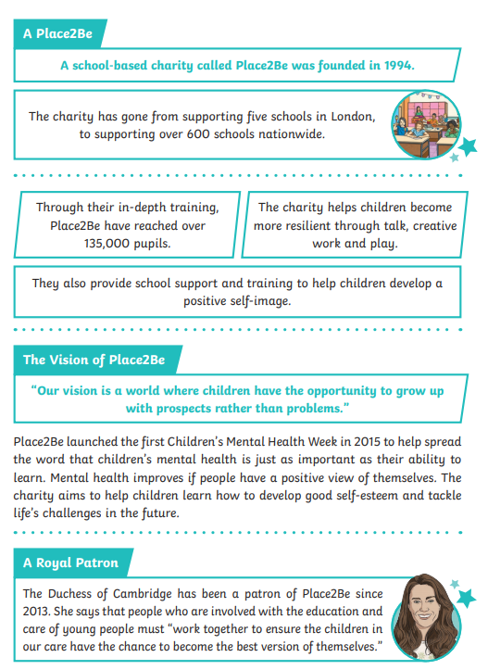
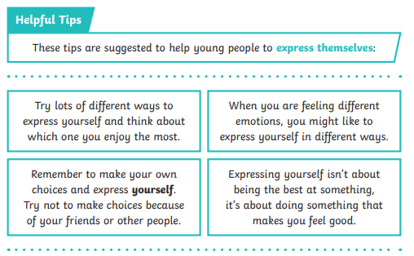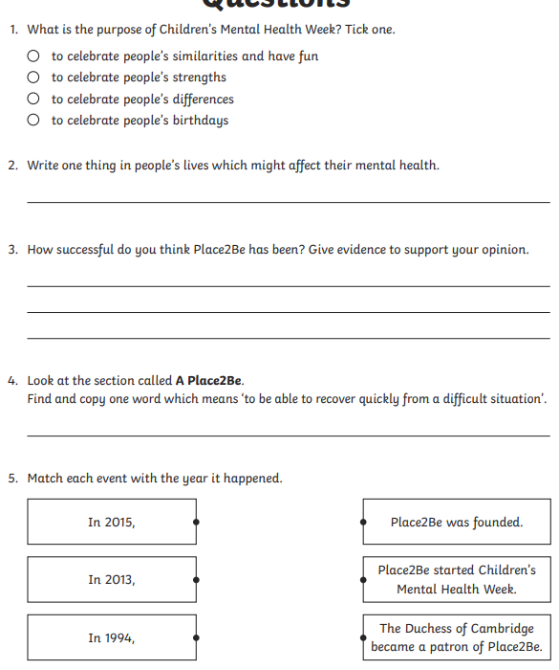
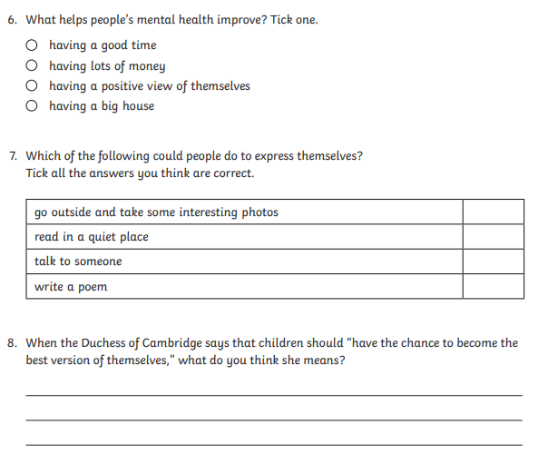

Red
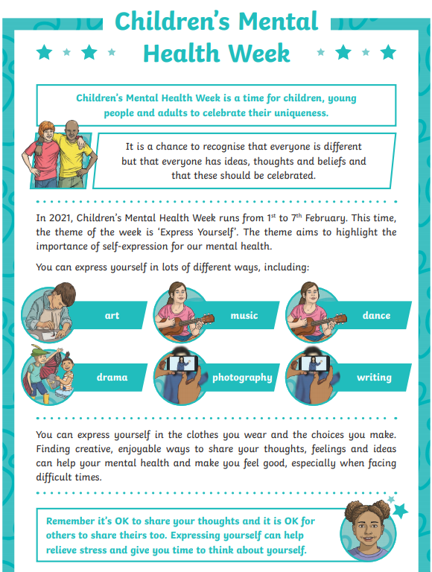
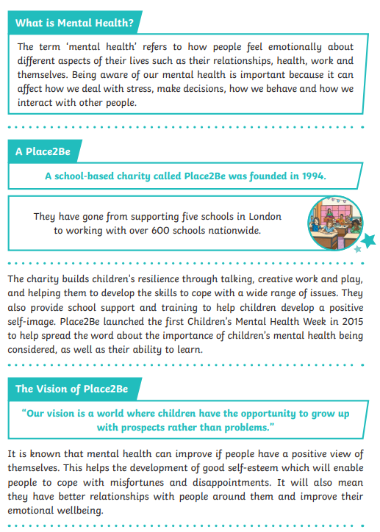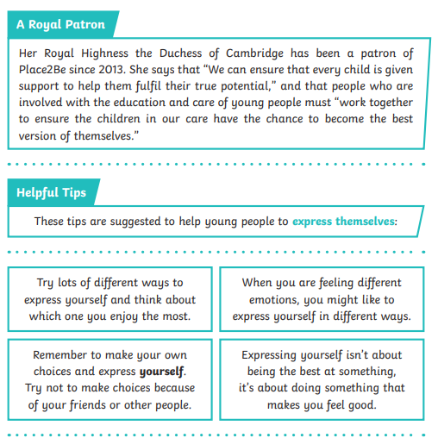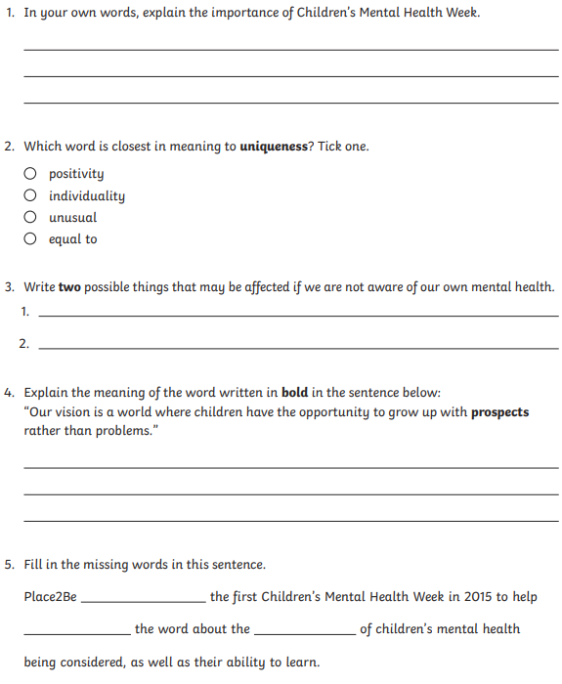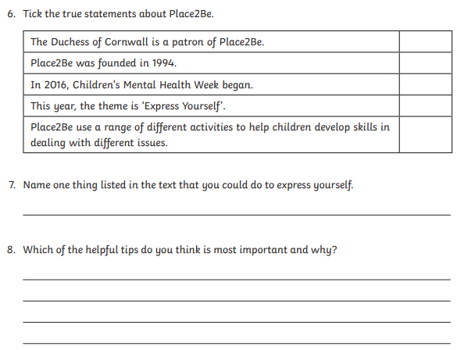

Maths
Division
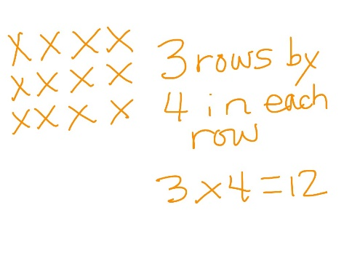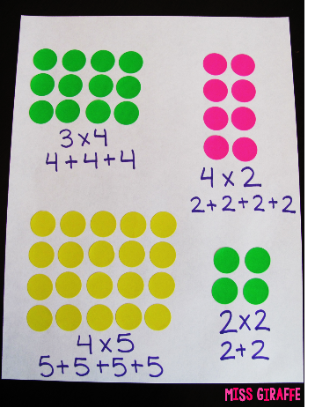
Show an array of 3 rows of 4 spots on a piece of paper. What does this show? Establish that it shows3 lots of 4. Write 3x4=12. What else do you know from this 1 number sentence. How many 4s are in 12? Three. Write the division. Rotate the array to show 4 lots of 3, what has changed, what has stayed the same? Ask pupils to write the multiplication. Write the four connected number facts. What do you notice (all have the same numbers?) Write 4x5=20 and ask pupils what the array will look like. Write the 4 number sentences.
Green
Use the beads and rings activity. Place the number cards face down. Pick a card. The first number is how many counters you need. Split them into the groups and see how many groups you have.

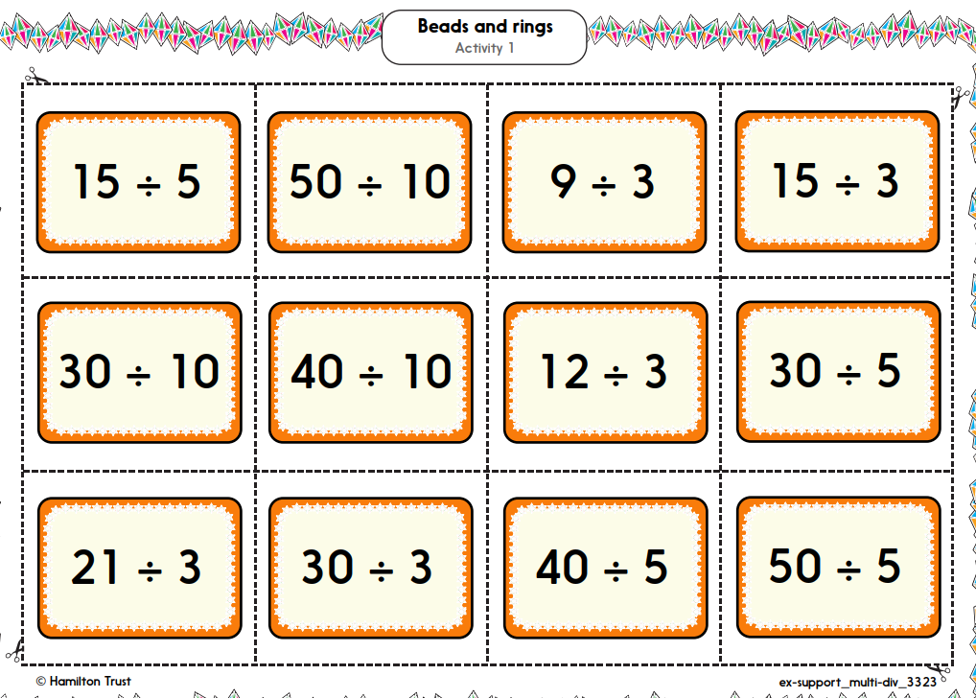
Blue
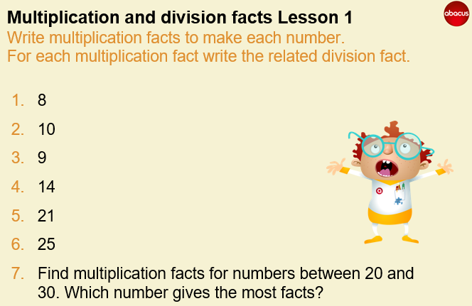
Red
Explain that the headteacher is thinking about how to arrange chairs for a show at school. She has 36 chairs and wants to arrange them in a rectangle. Each row must have the same number of chairs. Investigate how many ways the chairs can be arranged. Draw the arrays and write the four number sentences to match.
Welsh
Read the following dialogues with a member of your family.
Easy Version
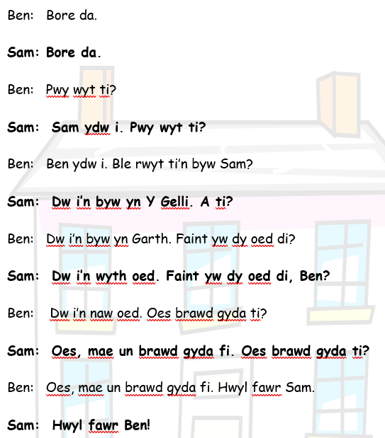
More challenging version
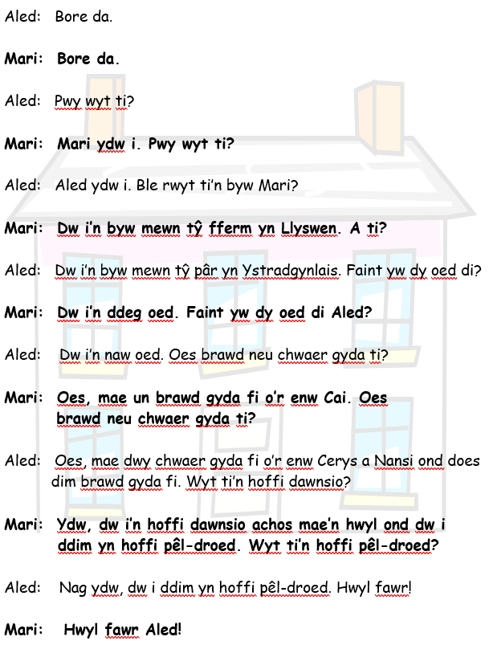

ICT (Computer Work – Video on FB or request via Email)
Instructions on how to create lost in space on the website.
Reasoning
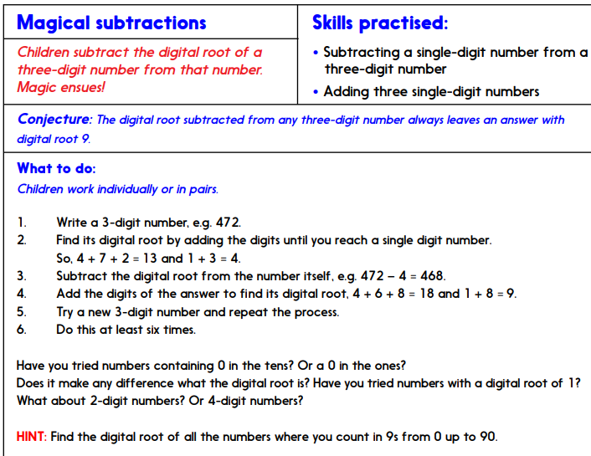
TUESDAY 2nd FEB
Mindfulness
Pick something from the Imoves website, free to register.
Letters and Sounds (oo as oo)
Boris wants to tell us about a book he has been reading - he thinks you might know it - it’s about a girl. Write ‘She has a red hood.’
Look at ‘She’ and see if chn can recall it. If not decode it in the usual way and blend to read ‘She’. Look at ‘has’ and see if chn remember this word. If not decode the word and say it together. Ask chn to tell you the next word ‘a’. Read the words so far ‘She has a ‘.
Point to the next word and mark the three graphemes with cradles. Decode each in turn, r as /r/, e as /e/ and d as /d/. Blend them to read the word ‘red’.
Look at the next word ‘hood’ and help chn to mark the graphemes h oo d. Stress that oo stands for one sound. Point to h and ask chn to tell you what sound this stands for. Say the sound together /h/. Point to oo and tell chn that this is a new sound /oo/. Ask them to look at your mouth shape and repeat the sound.
Ask chn to decode the last grapheme d as /d/. Say the sounds /h/ /oo/ /d/ and blend them to read ‘hood’. Read the whole sentence together.
Boris wonders if you can guess what story he has been reading. He says it is very good – can we write ‘good’? Point to the word ‘hood’ and ask chn to read it. Say ‘good’ and ask chn to tell you which sounds are the same. What sound does ‘good’ start with? How can we write /g/? Choose a child to add g to the f/c. Blend the sounds to read ‘good’.
Boris wants to write a sentence about his book. He wants to write ‘She went to see granny in the wood.’ Say the word ‘She’ and ask chn to recall how we write it. Segment ‘went’ and encode /w/ as w, /e/ as e, /n/ as n and /t/ as t in the usual way.
Say ‘to’ and see if chn can recall this word learned last week.
Say ‘see’, segment it /s/ /ee/, and count the sounds. Draw two cradles. Encode the sounds in turn, /s/ as s and /ee/ as ee. Blend the sounds to read the word ‘see’.
Say ‘granny’, segment it /g/ /r/ /a/ /n/ /ee/ and count the sounds. Draw five cradles on the f/c. Encode the first three sounds as g r a. Say ‘granny’ and identify the fourth sound /n/. Ask chn how we can write this sound (n, nn). Remind chn that towards the end of a word we often write it with nn. Identify the last sound /ee/ and ask chn how we often write this sound at the end of a word. Can chn recall how we write ‘in’? Ask a child to write ‘the’.
Say ‘wood’, segment it /w/ /oo/ /d/ and count the sounds. Draw three cradles. Encode /w/ as w, /oo/ as oo (reminding them of hood) and /d/ as d. Blend the sounds to read ‘wood’.
Read the whole sentence together. Boris says well done! He’s off to read his book!
Iaith
https://www.youtube.com/watch?v=2fZjMYdQjGM
https://www.youtube.com/watch?v=STdJ__8ORyE&feature=youtu.be
After watching the video create your own drawing of how you feel inside.
Begin by brainstorming a range of emotions. What do we mean by that word? What words or images come to mind when we hear that word? How might someone feel if they are experiencing this emotion? Where might they feel it in their body?
For each emotion you will then explore the experiences around it further by completing the below worksheet.
Once you have written about the feeling how could you describe it without using the word. For example, she jumped up and down waiting for her turn.

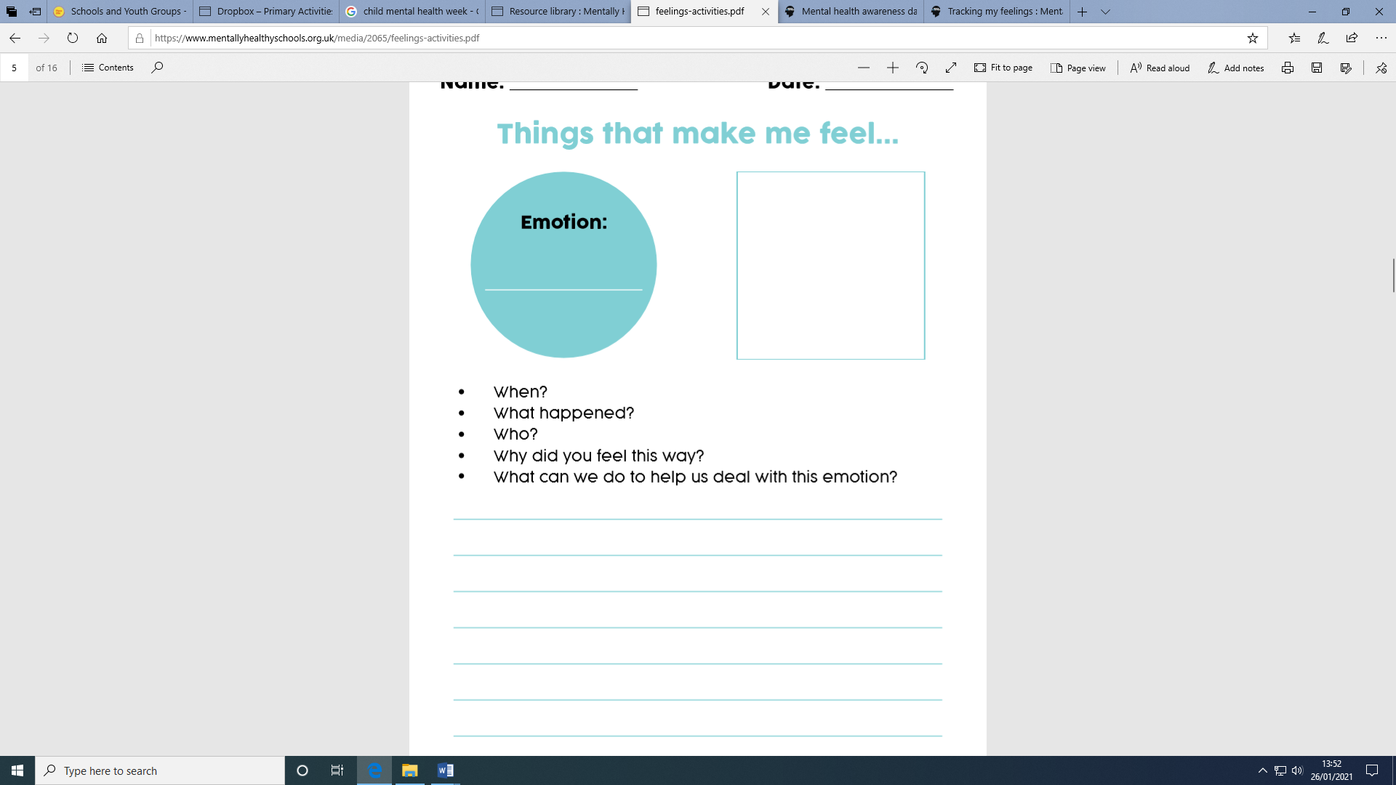
Maths
23 counters. Explain that you are going to use these counters to make triangles. How many sides does a triangle have? Use three counters to make a triangle. Can we make another? Ask pupils up to the board to move the 3 counters to make a triangle. Repeat until you cannot make any more. Are there any left over? We call this remainder. We made seven triangles and had two left over. Model that we write this 23/4=5r2. Pupils to now use 23 counters to create pentagons. Write the division statement.
Green and Blue
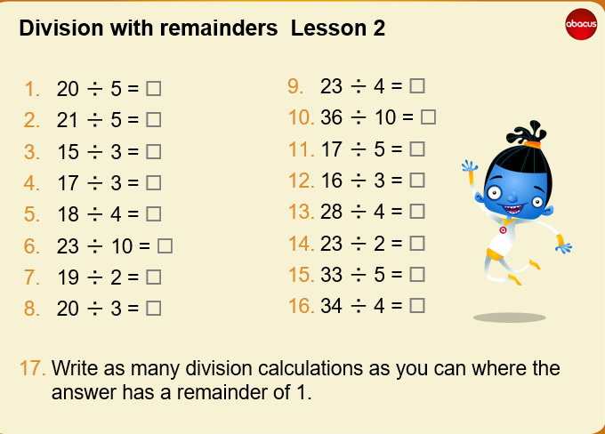

Red
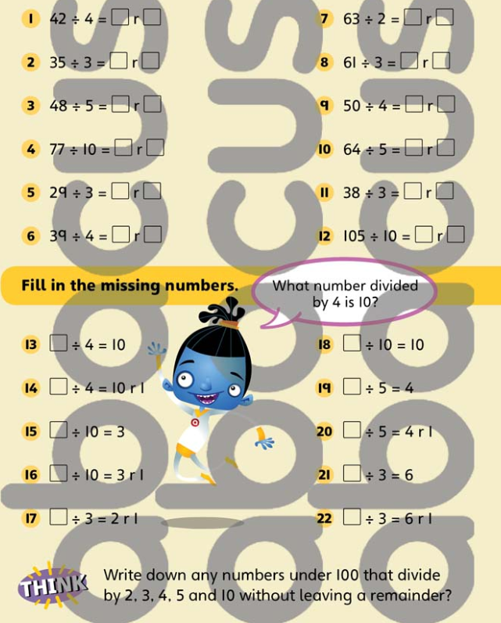
Welsh
PowerPoint
Look at the first slide and give a go at reading it. Remember the Welsh sounds we have been learning over the last few weeks. Can you then answer the questions at the bottom?
RE (PowerPoint)
Watch the PowerPoint
Name the key Muslim festivals
Explain the key Muslim festivals
Make a documentary to explain the main festivals to others

Film yourself and anyone at home who is willing to help- use the script or write your own. If you have the software you could add an image as a background, and even use some props.

Wednesday
Iaith (Mrs Clarke)
Science (Mrs Clarke)
Maths (Video on FB or request via Email)
Tell pupils that Chunky Chimp can help us to do division which are beyond our tables (larger numbers). This method of division that we started to look at last time is called ‘chunking’ as we don’t draw every hop, but use ‘chunks' of the number we are dividing; ten lots is a useful chunk to use. He shows us how to jump in chunks.
Activity
Give pupils a beaded number line and ask them to mark 52. Explain that they are going to find out how many 4s are in 52. Discuss how this can be written as 52÷4 or __x4=52. Ask pupils to circle each group of four beads, starting with the first four beads. How many groups have they circled? Remember that we don’t need to circle every group of 4. How many fours are in 40?
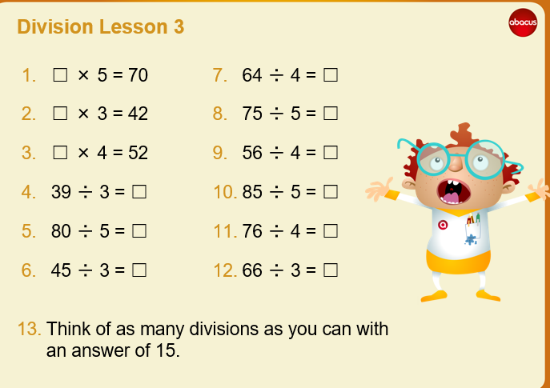
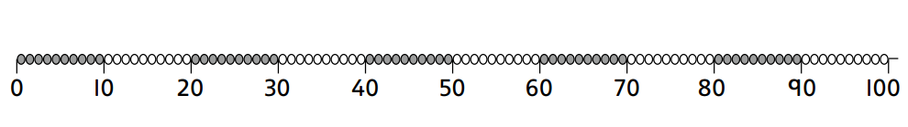

THURSDAY 4th FEB
Mindfulness
Kind Thoughts
What does it mean to be kind?
How does it make you feel when someone is kind?
How does it make you feel when you are kind?
Think about 5 people you would want to send kind wishes to.
Letter and Sounds (oo as u)
Boris’s book is getting scary. Red Riding Hood has just seen a wolf. Can you help him read the next bit? ‘She hid in a bush and shook.’
Point to ‘She’ and ask chn to tell you this word.
Point to ‘hid’ and ask chn to identify the sounds with cradles h i d. Decode each one in turn, h as /h/, i as /i/ and d as /d/. Blend to read the word ‘hid’.
Look at ‘in’ and see if chn recognise it. If not decode it. Point to ‘a’ and ask chn to tell you what it says. Read the words so far ‘She hid in a’.
Point to ‘bush’ and help chn to identify the graphemes b u sh with cradles. Decode b as /b/ in the usual way. Point to u and ask chn to tell you what sound this letter usually stands for (/u/). Say that here it stands for the sound /oo/ which we learned yesterday to write as oo. Point to sh and ask chn to tell what sound these letters represent. Say /sh/ together. Blend the sounds /b/ /oo/ /sh/ to read the word ‘bush’. Point to ‘and’ and ask chn to read it. Say ‘and’.
Point to ‘shook’ and mark the sounds with cradles, sh oo k. Decode sh as /sh/ in the usual way. Point to oo and identify the sound it stands for /oo/. Decode k as /c/ in the usual way. Blend the sounds to read the word ‘shook’.
Read the whole sentence together. Boris says he would be scared too if he met a wolf – wouldn’t you?
Iaith + Thema
https://www.youtube.com/watch?v=rfbOkWFTRAw
https://www.youtube.com/watch?v=m0R-ftFBm38
What is self-expression, and why is it important?
Self-expression is about communicating your individuality. This can be through words, clothing and hairstyle, or through art forms such as writing, drawing, music and dance.
Self-expression can help you to showcase your true self – your story, your thoughts, feelings and emotions.
Self-expression helps us connect to our true self. Self-expression is a great way to relieve yourself of stress and free your mind. Self-expression can help you to reflect on your life, actions, decisions, relationships, beliefs, and thoughts — rather than keep them buried deep down.
Here are some examples:
Gareth Malone’s online choir — bringing self-isolating singers together during the Covid-19 lockdown.
Grayson’s Art Club —a series of online masterclasses to help unleash creativity during theCovid-19 lockdown.
BBC Lockdown Orchestra – as part of a ten-day creative challenge, nearly 1,500 members of the public joined the newly formed BBC Lockdown Orchestra as part of a huge virtual performance.
Create 2030 Solidarity Art Shows - The World Health Organisation, Create2030 and a group of international working artists collaborated on a project to showcase films, music, poetry and visual art about the COVID-19 pandemic.
Te Rito Toi — using art to help children when they first return back to school in New Zealand following a traumatic or life-changing event.

Express how you are feeling today. This could be in the form of collage, mood board, graffiti, art, music, movement, writing. Anything you want!
Maths
Write 70/5, 52/3 and 42/3. How can we use chunky chimp to help us get the answer? Give pupils time to draw their own Chunky Chimp line. Pupils to then explain how they got the answer. Discuss the inverse and write the corresponding number sentences.
Green
Write the following divisions on the boards for pupils to practise Chunky Chimp. Pupils can use the partial jottings for the first few.
39/3
60/5
45/3
70/5
96/8
75/5
48/3
85/5
104/8
48/4
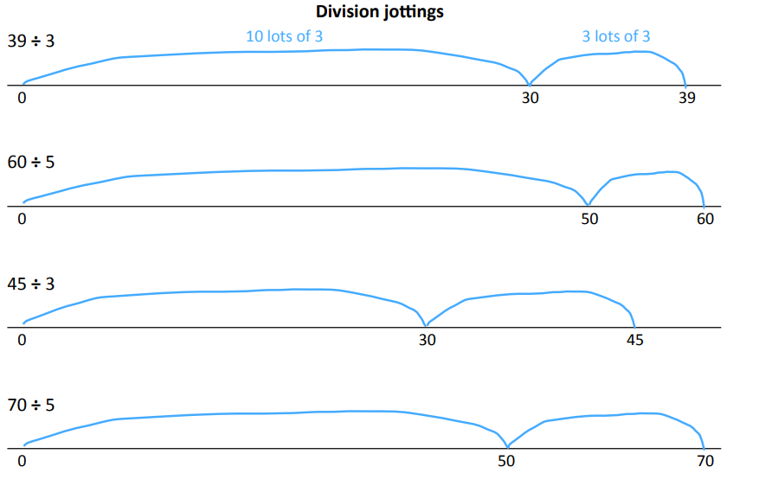
Blue
Same calculations as green, however they need to create their own jottings.
Red
Give pupils a set of cards. One pupils turns over a number card and state if they think the answer will be more or less than 20. Pupils to then check their work by jotting down the chunky chimp line.
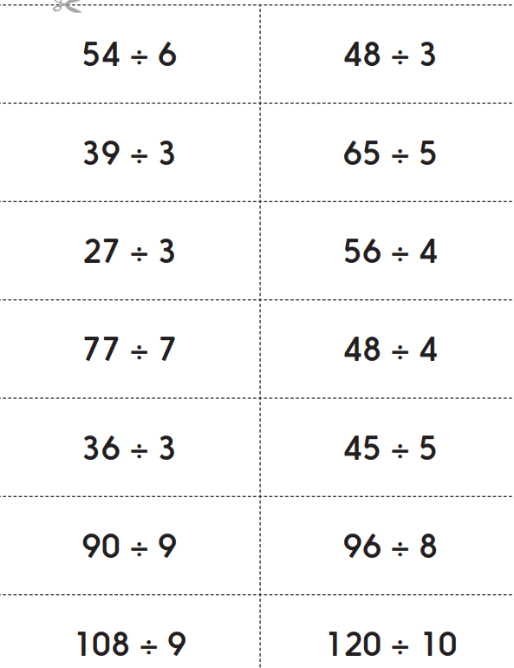
FRIDAY 5th FEB
Mindfulness
Cosmic Kids Yoga
Letters and Sounds (oo as oul)
Boris thinks Red Riding Hood should get out of the wood. He wants to write ‘She should leave the wood.’
Say ‘she’ and ask chn if they can recall how to write it. If not encode it in the usual way.
Say ‘should’, segment it /sh/ /oo/ /d/ and count the sounds. Draw three cradles. Point to the first cradle and encode /sh/ as sh. Say ‘should’ and identify the next sound /oo/. Ask chn to tell you the ways we have learned to write this sound (oo and u). Say that here we use another way. Write oul on the next cradle and ask chn to say /oo/. (Stress that /oo/ is only spelt this way in a few words like this) Say ‘should’, identify the last sound /d/ and encode it as d on the last cradle. Blend sounds to read ‘should’.
Say ‘leave’, segment the sounds /l/ /ee/ /v/ and count them. Draw three cradles. Encode /l/ as l in the usual way on the first cradle. Ask chn to identify the next sound /ee/ and ask chn to tell the ways of writing the sound (y, ee, ea, e). Say that here we write it with ea. Identify the last sound /v/ and ask ch to tell you the way we have learned to write /v/ at the end of words. Add ve. Blend the sounds to read ‘leave’.
Ask chn to write ‘the’.
Ask chn if they can recall how we wrote ‘wood’ yesterday. Otherwise encode it in the usual way. • Read the whole sentence together. Boris hopes she’ll escape.
Boris was pleased that Red Riding Hood escaped from the wolf. He thought it was a good book. He wants to write the word ‘book’. Can you help him?
Say ‘book’, segment and count the sounds /b/ /oo/ /c/ and add three cradles. Identify the first sound /b/ and choose a child to place the grapheme card b above the first cradle. Identify /oo/ and discuss alternatives oo, u and oul. (Stress that most words with /oo/ use oo. oul is only used in could, would and should) Add oo. Identify /c/ and discuss alternatives c, k and ck. (Stress that c is not usually used at the end of a word and that after oo we usually use k) Add k. Blend the sounds to read the word ‘book’.
Change the first grapheme to l and ask chn to read the word using the analogy with ‘book’. Read ‘look’ together. Ask chn how we could change the word to make ‘took’. Repeat to make ‘cook’ and ‘hook’. Make the word ‘pull’ and ask chn to decode the sounds in turn as /p/ /oo/ /l/. Blend sounds to read ‘pull’. Now change the first grapheme to b and ask chn to read the word ‘bull’. Ask chn how we could change the word to make ‘full’.
Boris says what a lot of words we know now!
Maths
Ask pupils to work in pairs and draw an empty number line jotting to show how Chunky Chimp might work out 45/3. Report back and walk through together. Is the answer to 56/4 going to be more or less than 10? How do you know? Is it going to be more than 20? Why?
Green
Show us how you could answer the questions using:
- Words?
- Pictures?
- Numbers?
- Objects?
- Other ways?
It's Jola's birthday and she is having a party. She has 24 cup cakes to share equally between 3 plates for the party. How many cakes will go on each plate?
There are 8 children coming to the party. They are all going to the cinema. How many cars will they need to take them there? Each car will hold 4 children and they will each need a driver too.
Jola is going to give everyone some chocolate eggs to take home at the end of the party. They fit into egg boxes which hold 6 eggs each. Will 50 eggs be enough for each of the 8 visitors to have a box to take home?
Blue
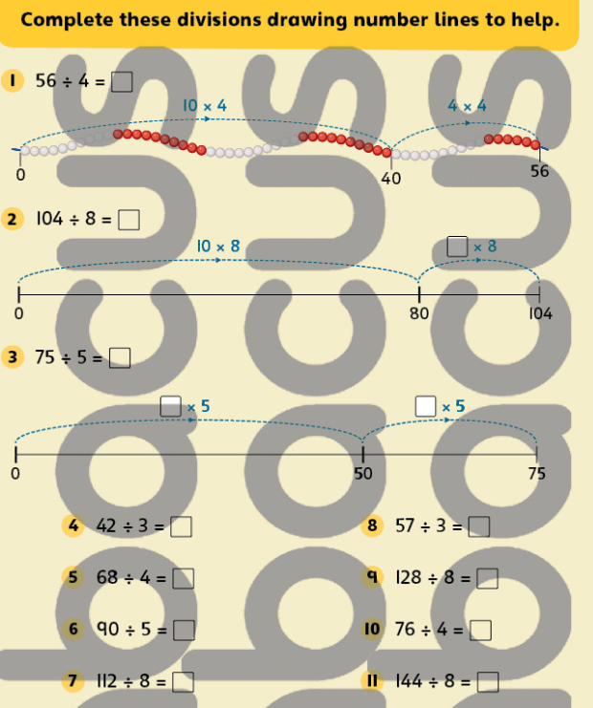
Red
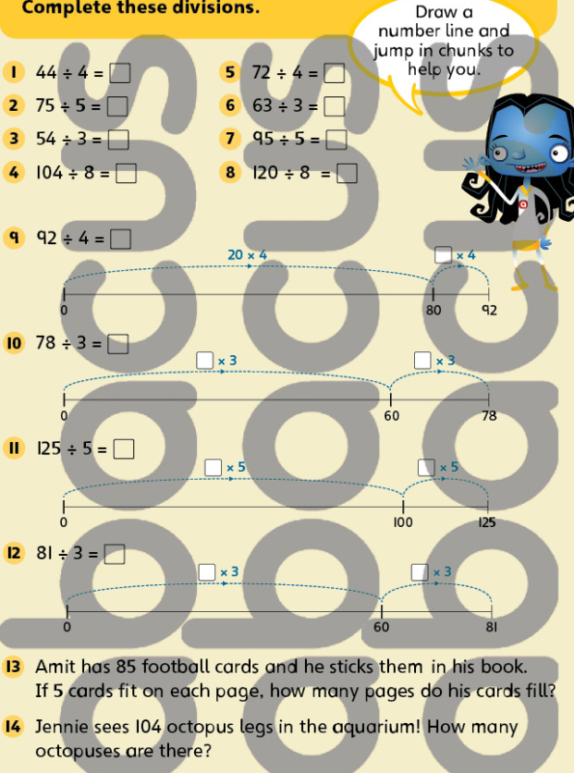
Iaith
https://www.youtube.com/watch?v=ozKW1M97JXE&feature=youtu.be
https://www.youtube.com/watch?v=dD4Gv3s3QH8
https://www.youtube.com/watch?v=sELz0aCx9Lw
Play the miming game, ‘In the manner of the word’, to teach children how we can communicate with each other and express ourselves without words.
Follow these simple instructions:
- ask your class to sit in a circle (or online if children are not physically in the same space) choose one child to draw a card from a hat which has an adverb written on it (for example: happily, sadly, angrily, joyfully, carefully, casually, slowly, quickly, foolishly, etc.)
- the rest of the children in the circle then ask the child to mime an action (for example: walk, study, play, ride a bike, watch TV, eat, get dressed etc.) ‘in the manner of the word’ the child has to mime these different actions in a way that reflects the adverb they selected, for example: ‘walk’ (action chosen by class) ‘carefully’ (adverb picked by the child). The child does this until the rest of the class guesses the adverb correctly
DRESS TO EXPRESS
Hold a 'Dress to express' day and encourage the children to express themselves through their clothes, hair etc. Pupils could wear their favourite colour or choose a range of colours that express how they’re feeling. Colour can be very personal and mean different things to different people, so this is a great opportunity to encourage self-expression and celebrate a diverse range of emotions. Then try the following activity:
- Take a Photograph/draw a picture of your outfit.
- Label what you are wearing.
- Write about why you have chosen these clothes.
Welsh (No live session)
Look at the following apps to further improve your understanding.
Cymraeg Campus
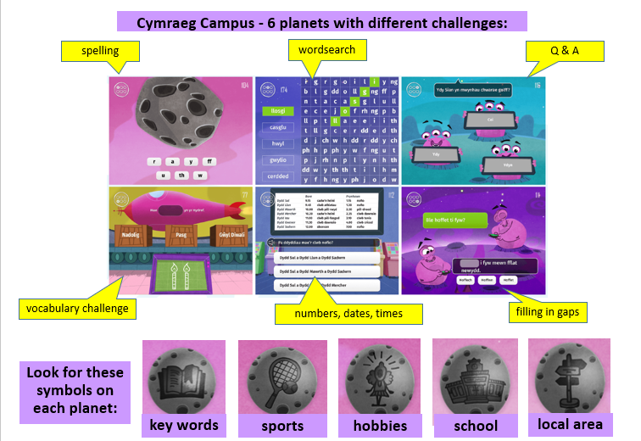

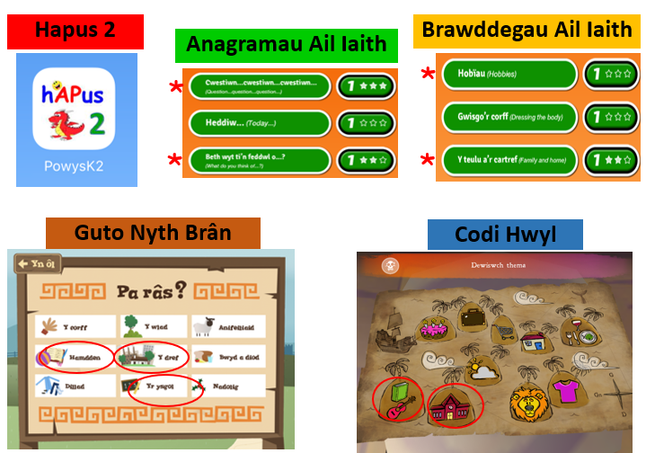
Golden Time
