Healthy Eating
Food keeps us healthy and help us grow. Food provides us with energy to be able to function throughout the day. By eating a balanced diet, your body obtains the fuel and nutrients it needs to function properly. Your body needs minerals to make hormones, build bones and regulate your heartbeat. Water flushes out toxins, transports nutrients to cells and performs other vital bodily processes.

Carbohydrates

Bread, rice and potatoes are examples of carbohydrate rich foods. These foods give us plenty of energy. You should try and eat a lot of carbohydrates each day. As well as energy, carbohydrates provide us with fibre, iron, B vitamins and calcium.

Fruit and Vegetables
Fruit and vegetables provide us with vitamins and minerals essential for keeping us healthy as well as fibre which is important for digestion. A diet high in fibre can also reduce your risk of heart disease, stroke and some cancers. Try to eat at least five portions of fruit and vegetables a day. Remember that potatoes do not count as a portion of vegetables.

Dairy
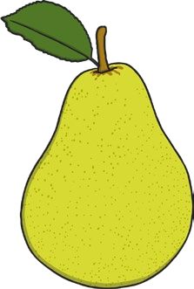
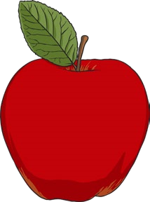
1. Dairy products are great sources of protein and calcium and are found in milk, cheese and yogurt. Protein helps our bodies to grow or repair themselves. Protein builds, maintains, and replaces the tissues in your body. Your muscles, organs, and immune system are made up mostly of protein. Calcium helps to keep our bones and teeth strong. We should eat between two or three portions of dairy foods a day.
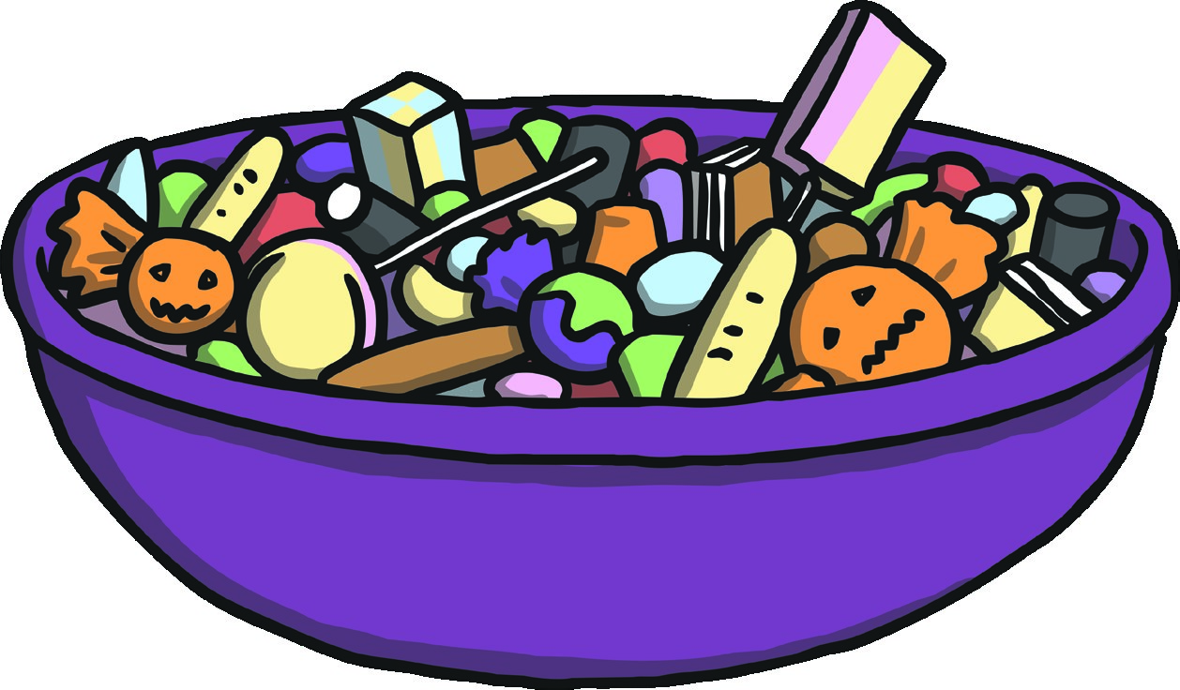
Healthy Eating
Meat, Fish, Eggs and Beans

These foods are a good source of protein, vitamins and minerals in your
diet. These foods help the body to grow and repair itself and keep hair, skin,
muscles and nails strong. We should eat some of these foods a day.

Foods High in Fats and Sugar
These foods provide the body with energy, warmth and insulation around vital
organs. Too much fat in your diet can raise cholesterol, which increases the risk
of heart disease. A small amount of fat is part of a healthy, balanced diet. Fat is
a source of essential fatty acids such as omega-3 because the body can’t make
them itself. Fat helps the body absorb vitamins A, D and E.
To be healthy, nutritious food is needed to provide energy for the body. A variety
of food is needed in the diet because different foods contain different substances
that are needed to keep you healthy.
Questions
- Why is a balanced diet important?

- What is the function of protein?

- Can you give examples of foods that we should try and avoid eating excessive amounts of? Why should we limit our intake of these foods?

- Choose the word closest in meaning to the underlined word.
With a balanced diet, your body obtains the fuel and nutrients it needs to function properly.
a) rest b) work c) eat d) healthy
- Fruit and vegetables provide us with vitamins and minerals essential for keeping us healthy.
a) necessary b) optional c) excellent d) extra
- Rewrite this passage using capital letters, commas and full stops.
healthy eating is vital for a healthy body many people eat too much unhealthy food like readymade meals sweets and chocolates instead people should eat more fruit and vegetables fruit is an ideal snack because it tastes sweet it is easy to take with you and is very good for your body
_______________________________________________________________
__________________________________________________________________________
____________________________________________________________________________

_______ ______________________________________________________________________

CREATE
Either on the computer or draw/collage your own poster to inform children of what a healthy diet is.
You need to include information about the different food groups and what they help your body to do. Use clear lettering , correct spelling and suitable pictures to get your message across

Time to Write!

Imagine you are a journalist in a children’s magazine. Write a paragraph about why it is important to eat fruit and vegetables.

