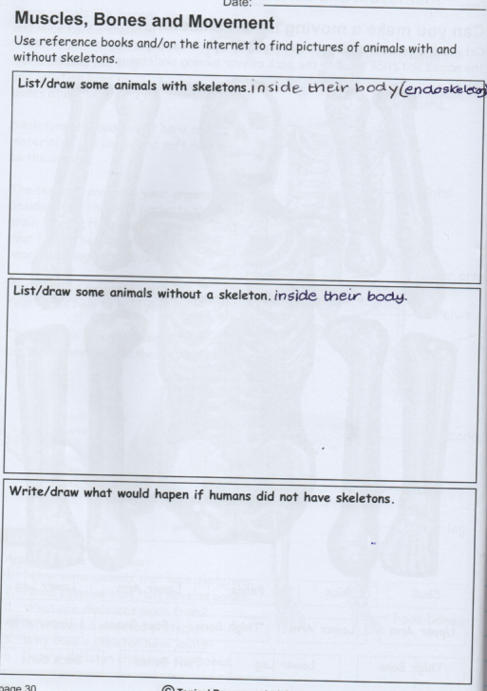

**RED TASK 2**

Read the information and complete the tasks. Present them in a way of your choice- poster/ Table