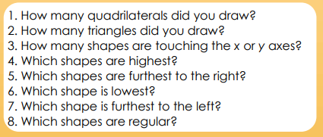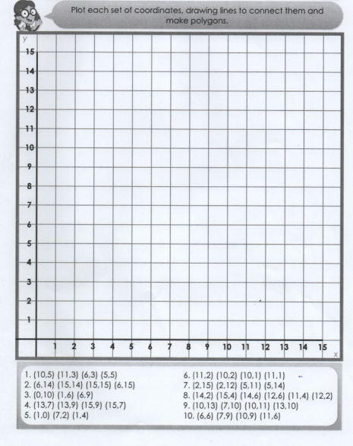

1.(10,5) (11,3) (6,3) (5,5) 6.(11,2) (10,2) (10,1) (11 ,1)

2. (6,14) (15,14) (15,15) (6,15) 7.(2,15) (2,12) (5,11) (5,14)

3.(0,10) (1,6) (6,9) 8. (14,2) (15,4) (14,6) (12,6 )(11,4)(12,2)

4.(13,7) (13,9) (15,9) (15,7) 9.(10,13) (7,10) (10,11) (13,10)

5. (1,0) (7,2) (1,4) 10. (6,6) (7,9) (10,9) (11,6)

**RED PLOTTING SHAPES TASK - MATHS**