Maths and Science Databasing

I strongly suggest that you join us for the live lesson on Tuesday 9.20M where I will show you how to use the ‘Data’ section on j2data on HWB.

If you can’t join us for this session you can watch the ‘How to’ video in the getting started section:
Click on this and watch the video clip which tells you how to make a database.

Task: You will be making a database with the information you gathered on your excel spreadsheet early this term which should have looked like this:

You will be making records on your database which include 6 fields
Field 1 – Animal name which will be a text type
Field 2 – Number of bones which will be a number type
Field 3 – Number of hearts which will be a number type
Field 4 – Number of stomachs which will be a number type
Field 5 – Life span which will be a number type
Field 6 – Photograph which is a picture/sound/video tyoe
This should look like:
Save this now with a sensible title.

Then click on the ‘Form’ tab at the top
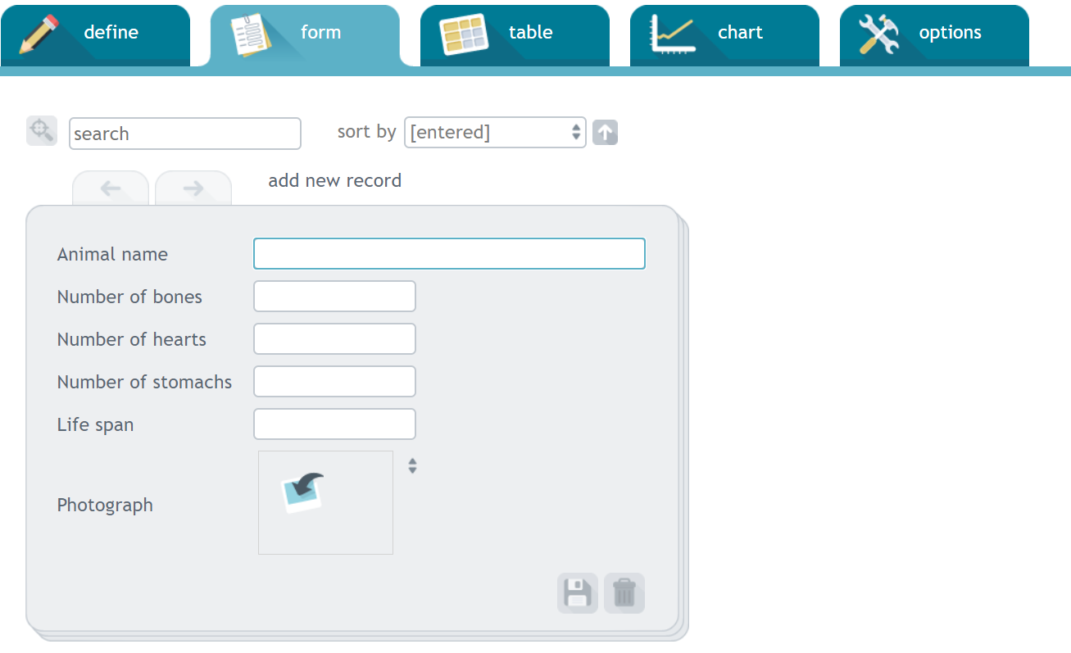

Using your excel spreadsheet, you can input the data for the animals you have so far. Then find out about 5 other animals to create a good-sized Database.

