Lesson 2
Green- trace the big one, trace the next ones then do 3 of your own- circle your best one for each section
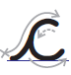
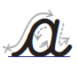
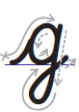
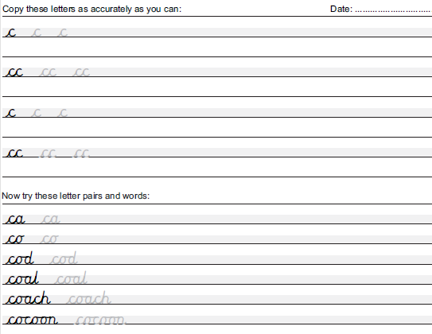
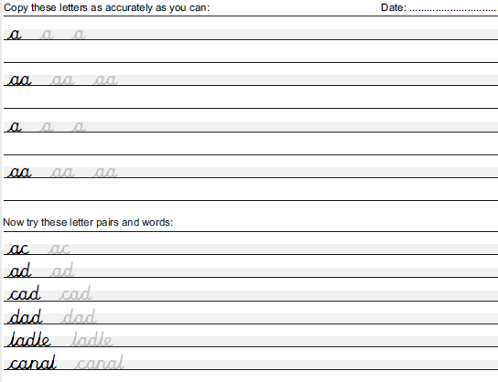
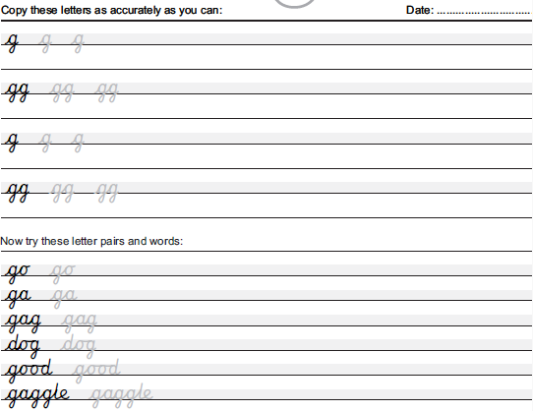

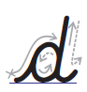
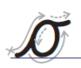
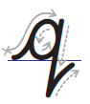
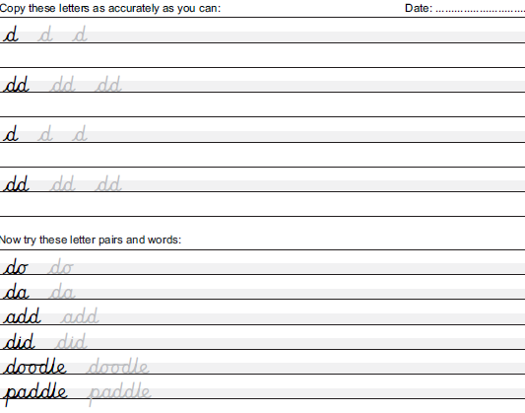
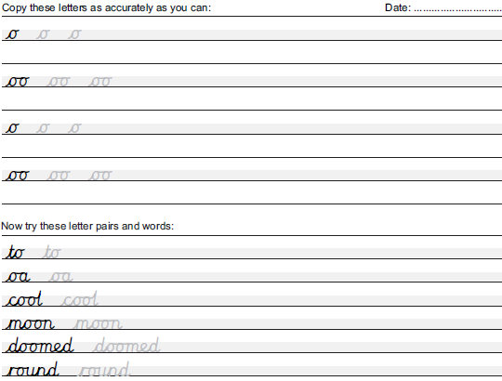
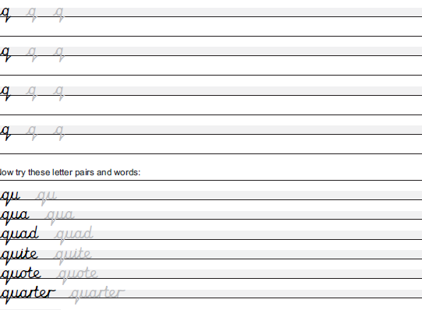
3 3 Blue- trace the big one, trace the next ones then do 3 of your own- circle your best one for each section
Red- trace the first one then do 3 of your own- circle your best one for each section

