Monday- Lesson 1
Green Galaxys
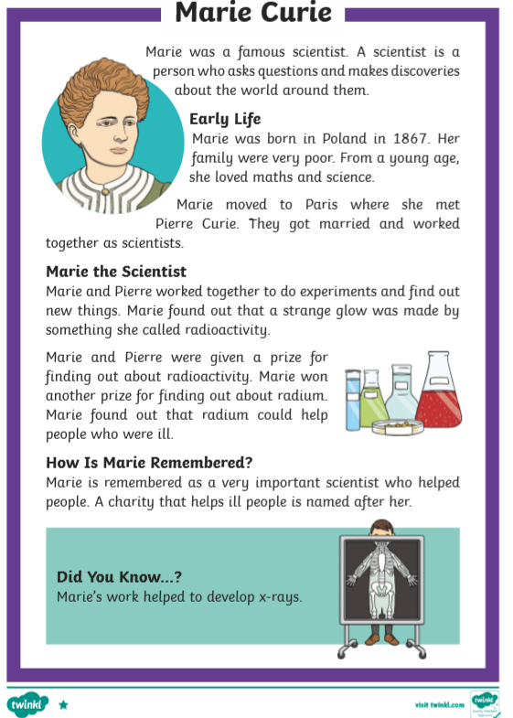
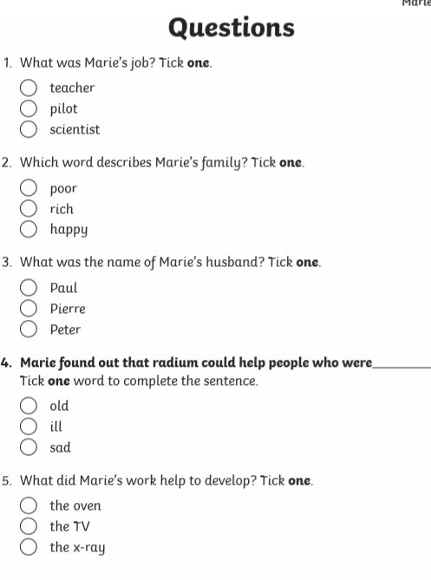

Green Godivas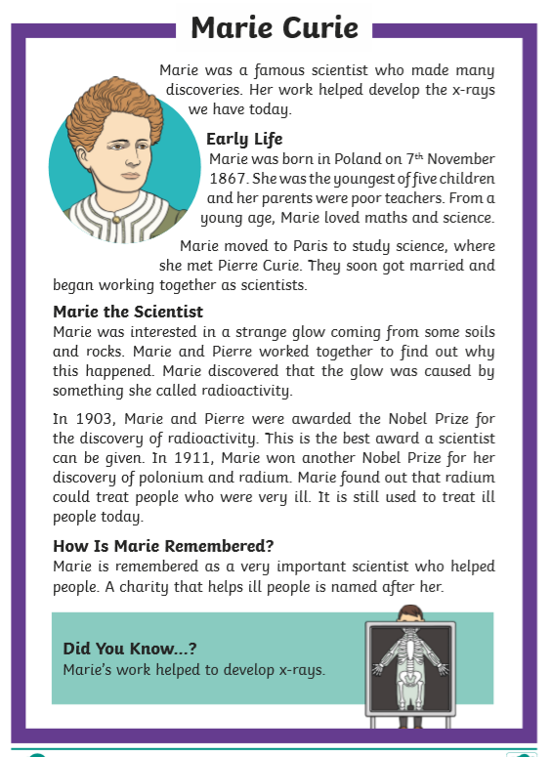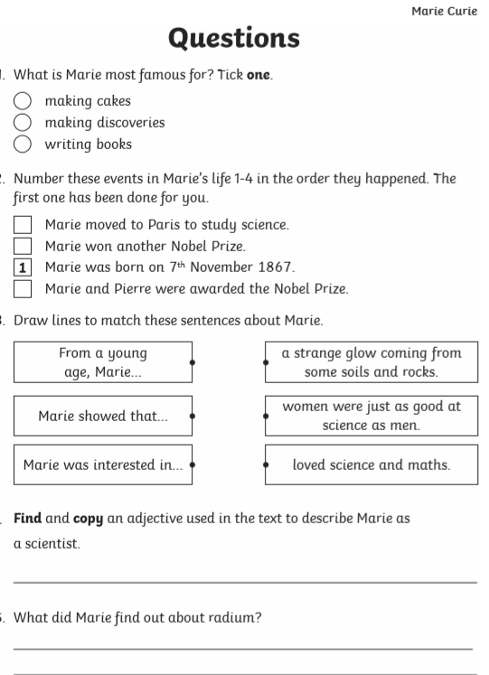

Turquoise Twirls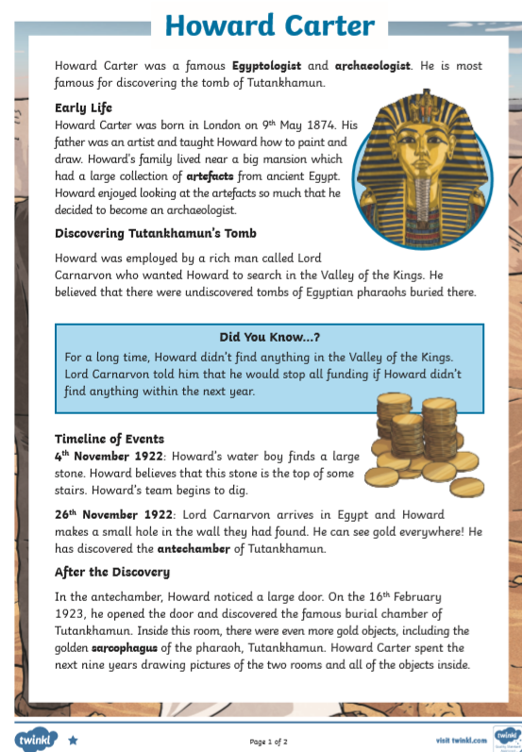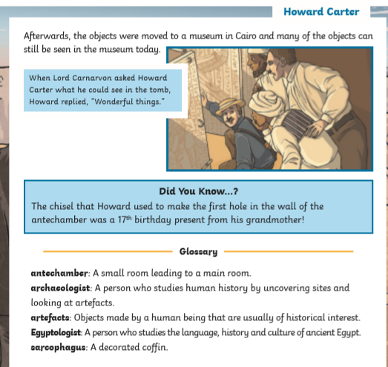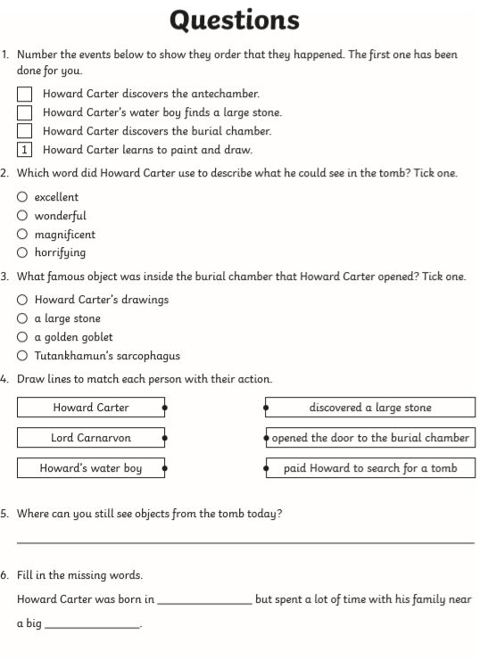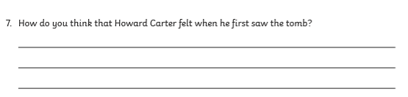
Purple Picnics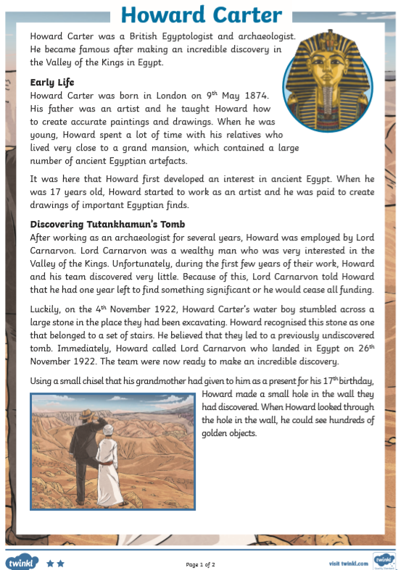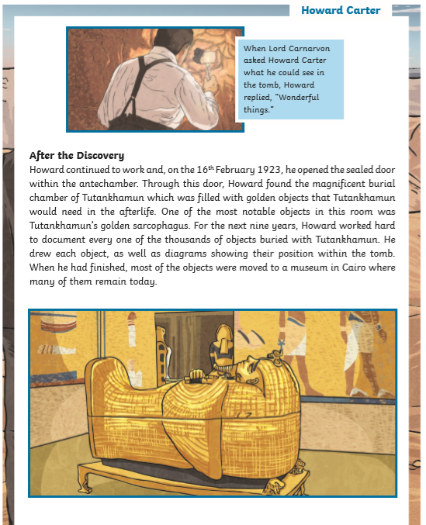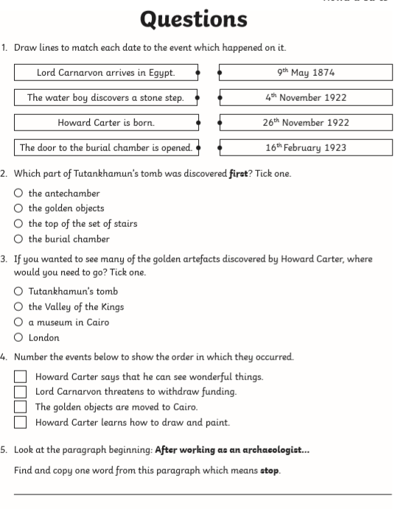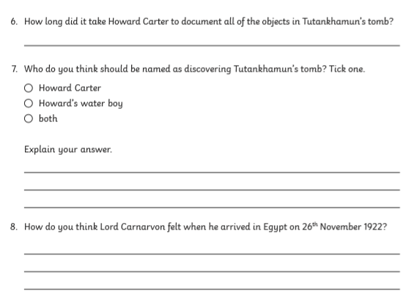

Tuesday- Lesson 2
Categories of organs. Use the Internet to research the different body systems, match the system to its function and add which organs/body parts are part of that system.

Wednesday- Lesson 3
Pick an organ that you want to learn about. Research the organ and make notes ready to write your own information text. Think about: where the organ is, what it does, which system it is a part of, what other organs it works with, when we learned what we know about the organ, etc.
Wednesday pm- Lesson 4
Plan your information text- use the skeleton below or draw your own so you have the correct number of circles. Look at the example (on the website or in the files on Team) from last week’s heart text if you think it will help you.
The title goes in the big circle - Sub-titles/Sub-headings go in the smaller circles - Add the notes around the correct circle.

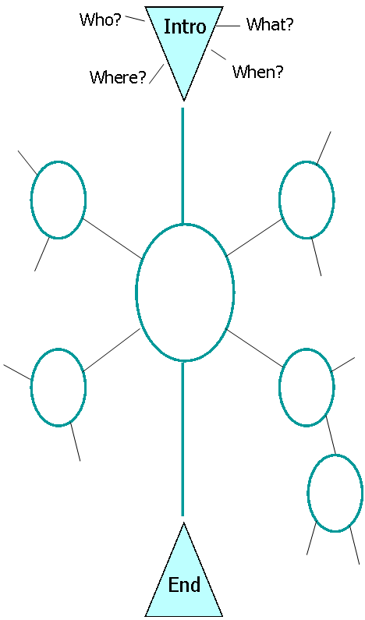

Friday- Lesson 5
Look at your plan- complete more research to fill any gaps you have.

Spellings
high  sigh  weigh  thigh | high  sigh  weigh  thigh | sleigh  neigh  outweigh  highjack

