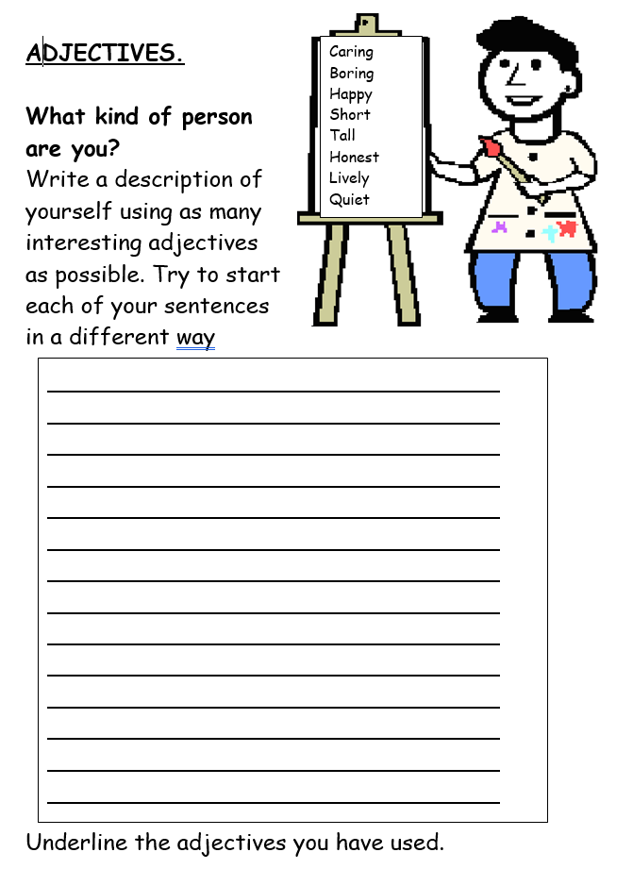

IAITH EXTRA CHALLENGE