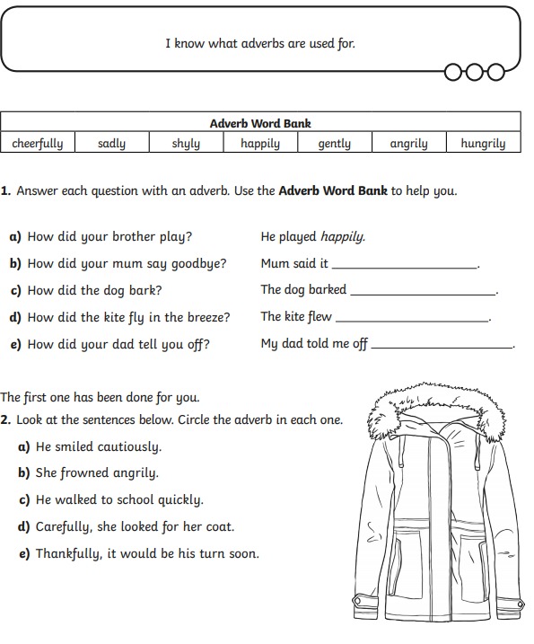

**GREEN IAITH TASK 2 - ADVERBS**