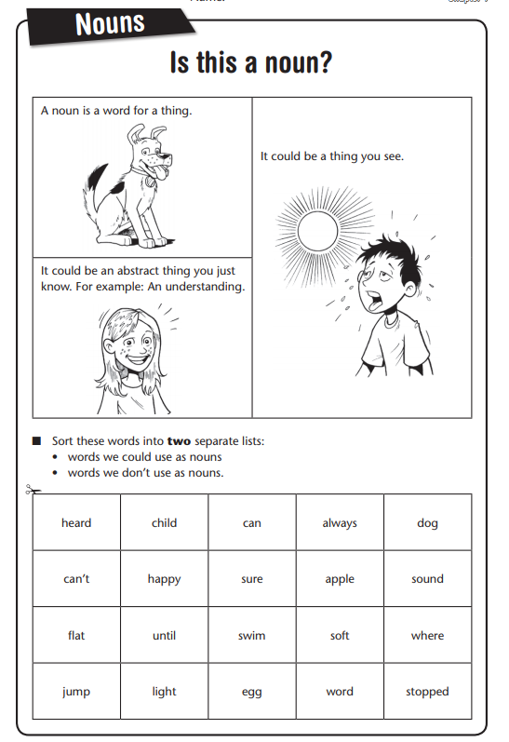

TASK 1

**GREEN TASK 1**