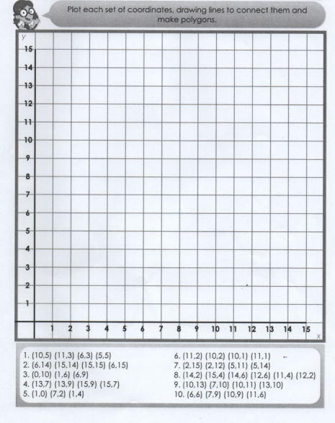

1.(10,5) (11,3) (6,3) (5,5)

2. (6,14) (15,14) (15,15) (6,15)

3.(0,10) (1,6) (6,9)

4.(13,7) (13,9) (15,9) (15,7)

5. (1,0) (7,2) (1,4)

**GREEN PLOTTING SHAPES TASK - MATHS**