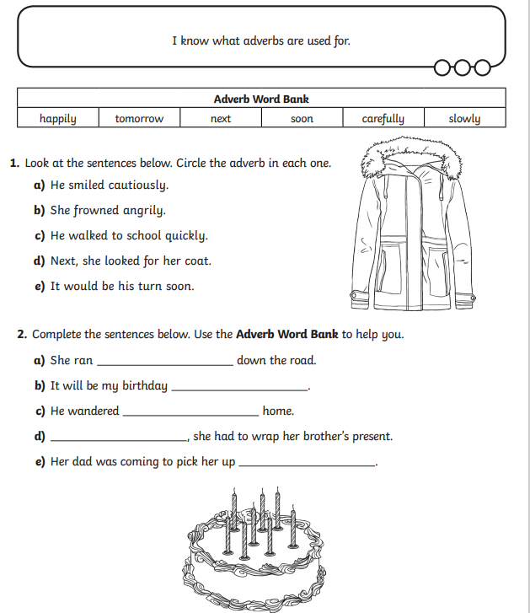

**BLUE IAITH TASK 2 - ADVERBS**