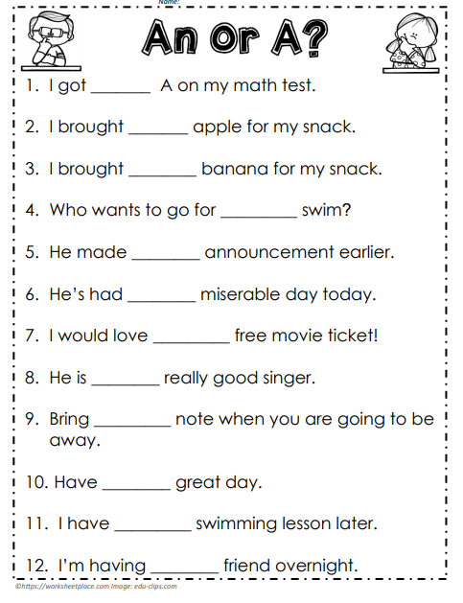

Use your best handwriting to write out each sentence using ‘a ‘ or ‘an’ correctly. Remember to check you are using correct punctuation

**BLUE TASK**

**A or AN?**