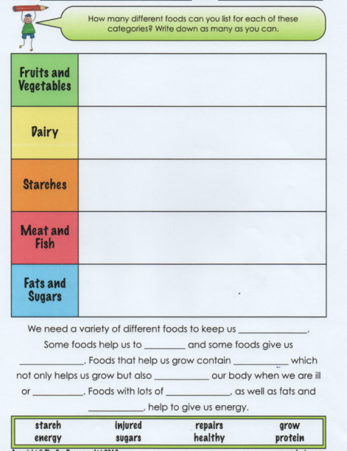

Read and use information from the power point slides to help you.

**BLUE SCIENCE TASK 2**