Wednesday 16th December
MATHS
Introduction
Vocabulary: 1/2/3-digit numbers, number, addition, ones, partitioning, equals, tens
Write 54 + 35 and ask pupils to tell you how they can work out the answer. Check that they are partitioning, adding and then recombining. Repeat with 73 + 55, point out how the 10s now have a total more than 100. Repeat with 58 + 65, and agree that you can work out the last addition 110 + 10 by adding 10 and then 3 to 110. Write additions and discuss which will have total of more than 100. How do you know?
Support Green  Write 48+27 on a flip chart. Pupils to work in pairs with the place value cards to make the number. Split the number into 1s and 10s. Add the 1s together. Add the 10s. Add the answers together.  Agree on the answer.  Then let pupils answer the following in their nooks.  25+58  73+18  46+38  84+41  93+24  45+62 | Green  Use the pocket money promotion items to give a total of less than 100/£1. pocket money. Model how to convert the total into pounds and pence. | Blue  Y3 TB2 p11 | Red  Use the pocket money promotion items to give a total of more than 100/£1. The promotion is aimed ad kids who have £2 pocket money. Model how to convert the total into pounds and pence. | Black  Pupils to use the place value cards to create their own 3-digit numbers to add together using expanded column addition.
Plenary Show a really big calculation on Screen 3.12.1d. Can we do this in the same way? Encourage children to have a go with a partner. Take feedback. Establish the partitioning.
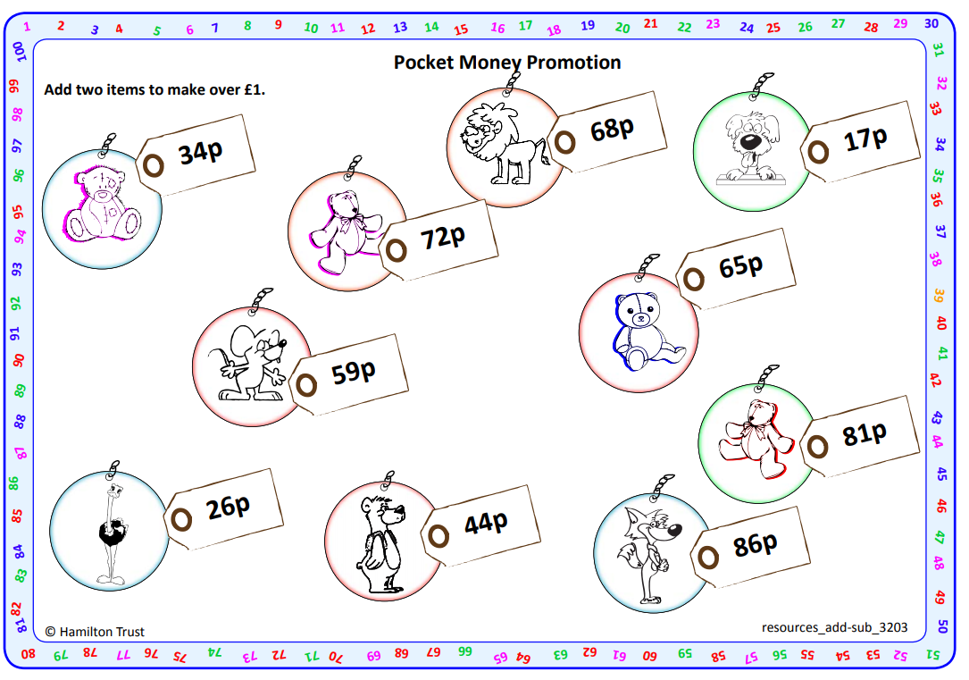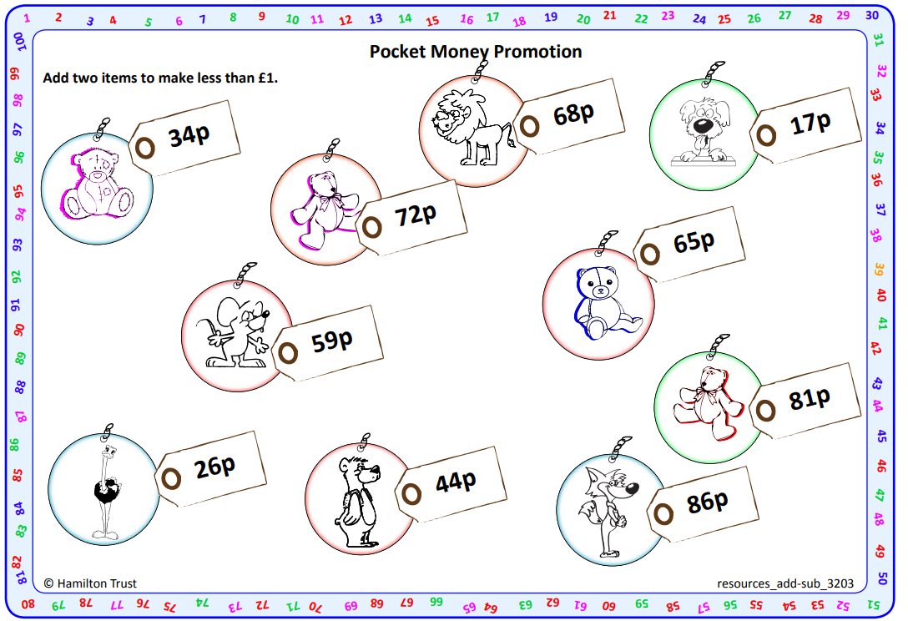
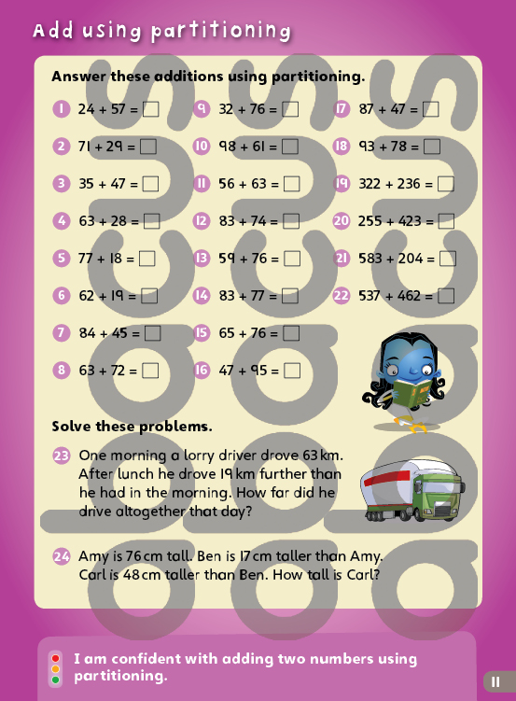
IAITH
GREEN
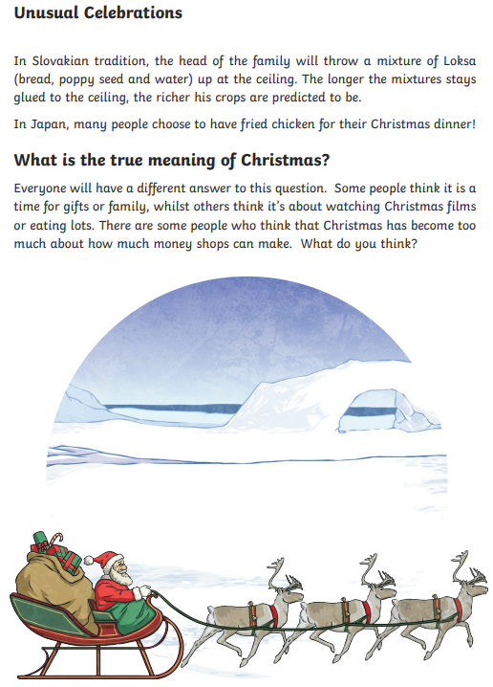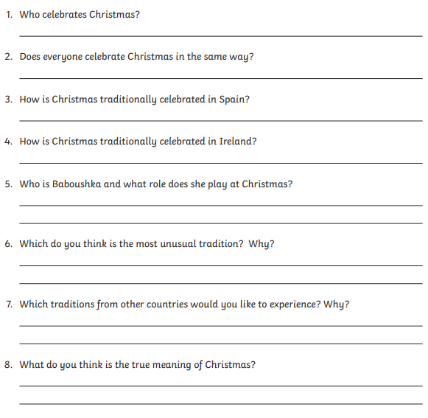
BLUE
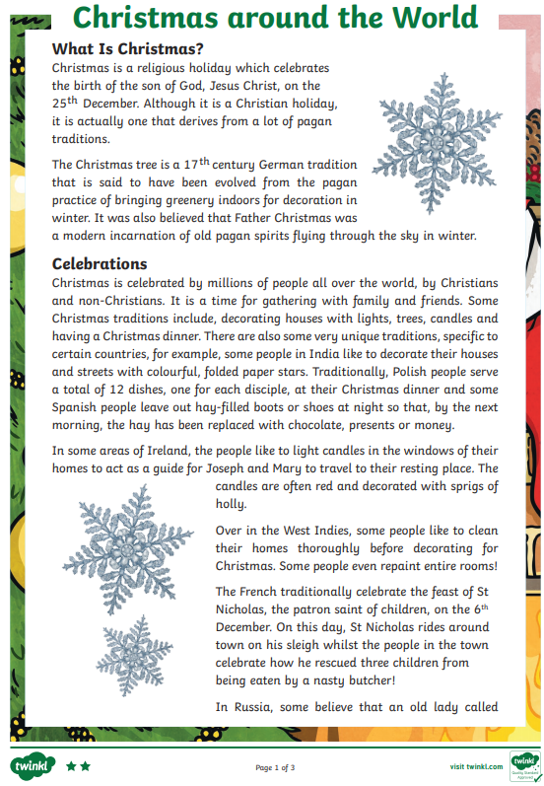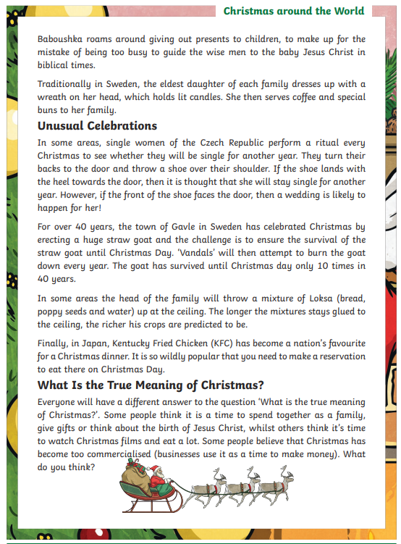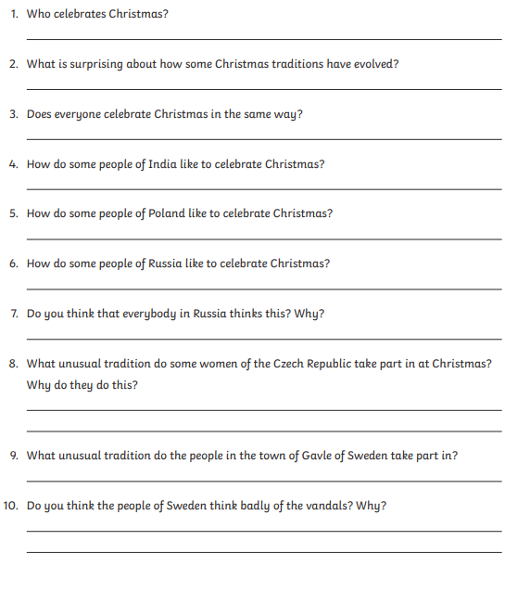
RED
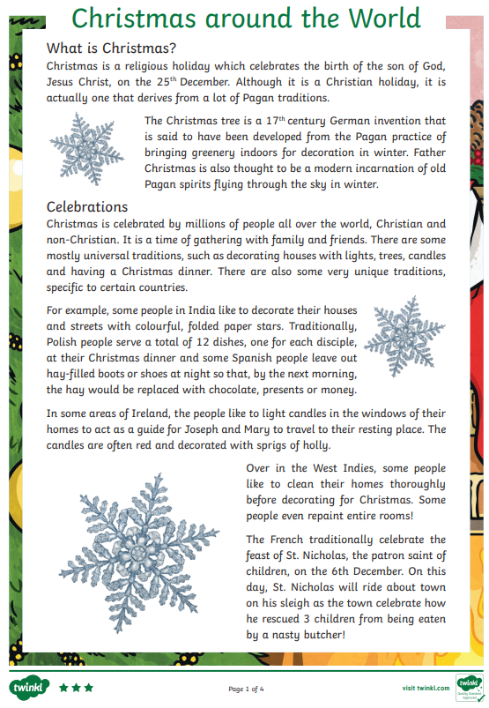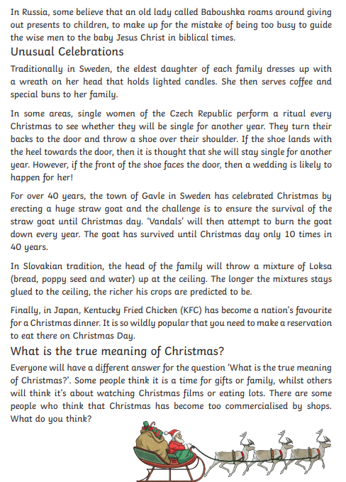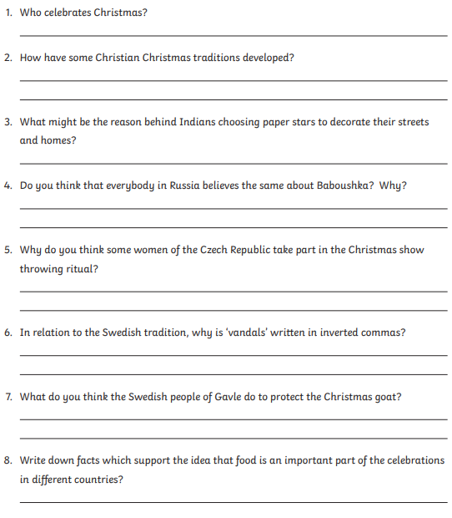

CYMRAEG
Defnyddio cliwiau – Using clues

Stori Sêl Cist Car

Mae Babs eisiau’r jig-so. Dydy Babs ddim eisiau eisiau’r tedi. Mae Babs eisiau io-io ond mae Mam yn dweud, ”Na!” Mae Benja eisiau’r Blwch Hud. Pam? Mae llawer o bethau yn y Sêl Cist Car. Mae Benja eisiau ffôn. Pam?

- Yn y tecst amlygwch:
In the text highlight:

 |  | Lliw / Colour
geiriau sy’n debyg i’r Saesneg | words similar to English
priflythyren | capital letters
atalnod llawn | full stops
cwestiynau | questions

ICT
Write an email to tell me all of the things you have enjoyed this term. Think of the following:
- What lessons you have enjoyed?
- What activities you have enjoyed?
- Your best bit?
- What you can improve on?
- Your favourite thing about being in the juniors?
- Your favourite golden time activity?
- Your favourite mindfulness activity?

To write an email follow the following steps:
1. Log into HWB
2. Go into Office 365
3. Press outlook
4. Click on new message
- My address is bevans@knighton.powys.sch.uk

I look forward to reading your emails.

Mindfulness

Practice the yoga poses we have done so far.
- Mountain Pose
- Chair Pose
- Tree Pose
- Crescent Moon Pose
The new pose is Snake Pose
Yoga  Snake Post | Strengthens spine and backs of arms and legs; stretches shoulders, chest and belly; improves posture; helps relieve stress.  - Begin by lying on your tummy.  - Exhale and lift your head, upper torso off the floor.  - Gaze forward or slightly upward.  - Hold this position then release.

