Iaith
Monday
Watch BBC bitesize clip about writing instructions
https://www.bbc.co.uk/bitesize/topics/zgqxwnb/articles/zfrcmfr
Follow these instructions to make a dragon on springs.
https://www.youtube.com/watch?v=ktHwQ7MEypE&list=RD5Dsb_r8qDss&index=4
Write instructions for ‘How to Train Your Dragon’

Tuesday
Look at different instruction texts- LEGO kits, recipes, DIY instructions etc. Make a list of the features.

Hopefully you will find these- Title, Introduction, List of equipment (using bullet points), Method, Numbers or bullet points with time connectives, Bossy verbs, Sub-titles, Conclusion, Adjectives, Adverbs

When you write your own instructions, these features will help to challenge you and extend your writing.

Wednesday
R- WALT; explore issues and themes through role play
R- WALT; use techniques in planning writing

Steps to success Steps to success
Steps to success
Listen to Chapter 4 of ‘How to Trian Your Dragon’
Role-play using the instructions from the book
Discuss the effectiveness of these instructions
Shared-read Chapter 9
Work as a group to role-play your own instructions for ‘How to Train Your Dragon’
Plan your instructions- use the list of key features to help you
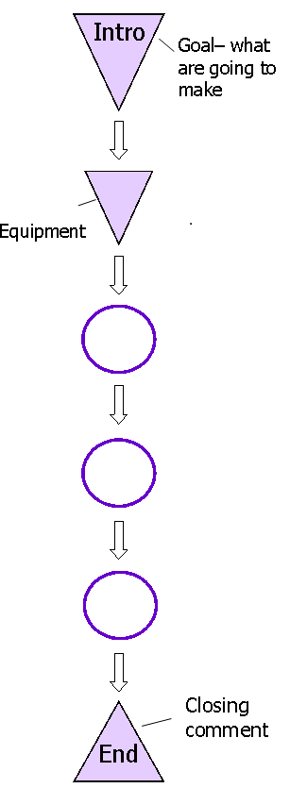

Friday/Monday
R-WALT; use features which show the structure of the writing
Steps to success
Write a title- each word should start with a capital letter
Write an introduction (eg. This might be something to try if you are finding your dragon to be troublesome and unruly!)
Sub-titles
Include an equipment list
Write your instructions with a bullet point and bossy verb at the beginning of each one OR time connectives then bossy verbs
Include a relevant picture
A conclusion (eg. You should find that your dragon becomes much more manageable and well-behaved!)

Tuesday
R WALT: proofread their own work and that of others, assessing it and making appropriate recommendations for improvement; edit/redraft work to show progression
Steps to Success
Re-read your work
Complete the wish
Neat copy with your best handwriting or type it
Correct spellings
Correct punctuation
Complete in the format of instructions

Maths
Monday

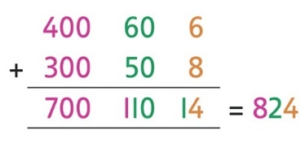

(R)WALT; create three 3-digit numbers and add using column addition

Steps to success
Use a 9-sided dice.
Create three 3-digit numbers.
Add using column addition.
With a calculator, use the inverse operation to check them (For example: 466-358=824, so you type in 824-358…you are correct if the screen shows 466)

Tuesday
What we are told:
- Each letter represents a digit (0–9).
- The letter ‘O’ is zero.
What to do:
- Write out this sum.

- Work out which digit each letter represents.

- Make a list of the letters so that you can match digits to them.

- When you have found a solution – check it works!

- Use this solution to find a different one where both T and G are two different digits, so they have not just swapped!

- Can you find more than six different solutions?
Challenge
Can you invent your own similar puzzle?
(This is harder than you’d think!)

Wednesday

(R)WALT; identify patterns when creating doubles chains

Steps to success
Start with an odd number.
Double the numbers.
Create a doubles chain
Carry on the chain to 1000.
Create a doubles chain starting with an odd number
Create another doubles chain starting with a multiple of 5.
What do you notice?

Friday

(R)WALT; investigate and find four 3-digit numbers that will halve twice to get a whole number

Steps to success
Investigate halving numbers.
Halve 3-digit numbers twice.
Do they make a whole number?
Find four numbers which do.
Work with a partner to create the longest halving chain you can (it must begin with a 3-digit number and end with an odd number)

Monday
(R)WALT; use inequality symbols to compare unit and non-unit fractions

Steps to success
Look at the fractions carefully.
Use < and > signs between the pairs of numbers.
Look at the shapes.
How many sections of the shape have been shaded?
Write the fraction.

Tuesday
(R)WALT; find equivalent fractions and simplify fractions

Steps to success
Look at the fractions carefully.
Look at the denominator.
Look at the numerators.
Do the same to the top number as you do to the bottom number.

