Maths
Continue with completing TT Rockstars.
Maths (Adding)
Using the four-operation document on the website complete the following additions.
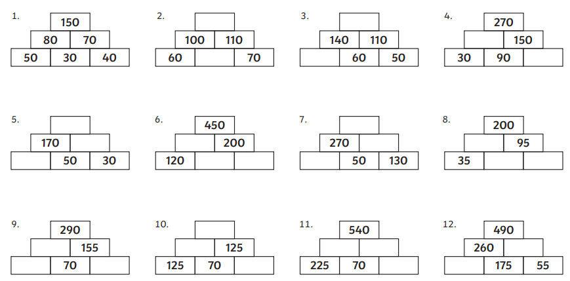
Can you create your own pyramid?
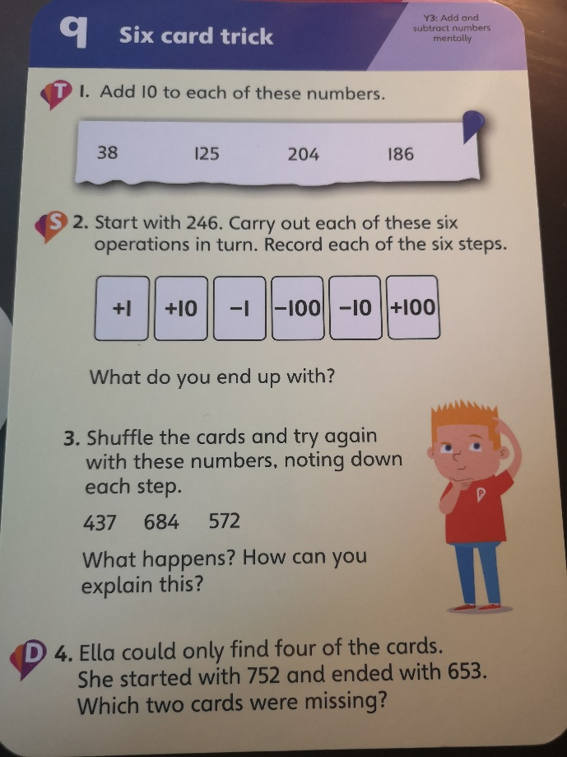
T – Green Group
T & S – Blue Group
All – Red and Black Group

Maths (Take Away)
Using the four-operation document on the website complete the following using froggy lines to help.
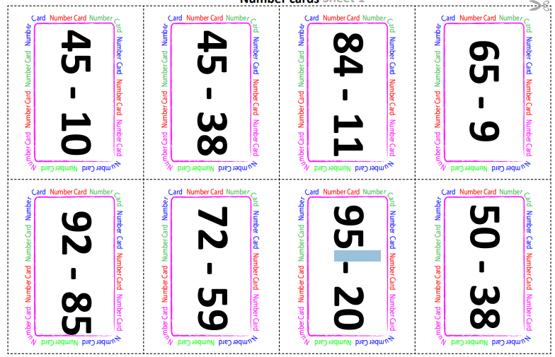
Red and black group are to create their own subtractions using one 3-digit number and one 2-digit number. Still use a froggy line to complete the subtraction. For example, 476-54=

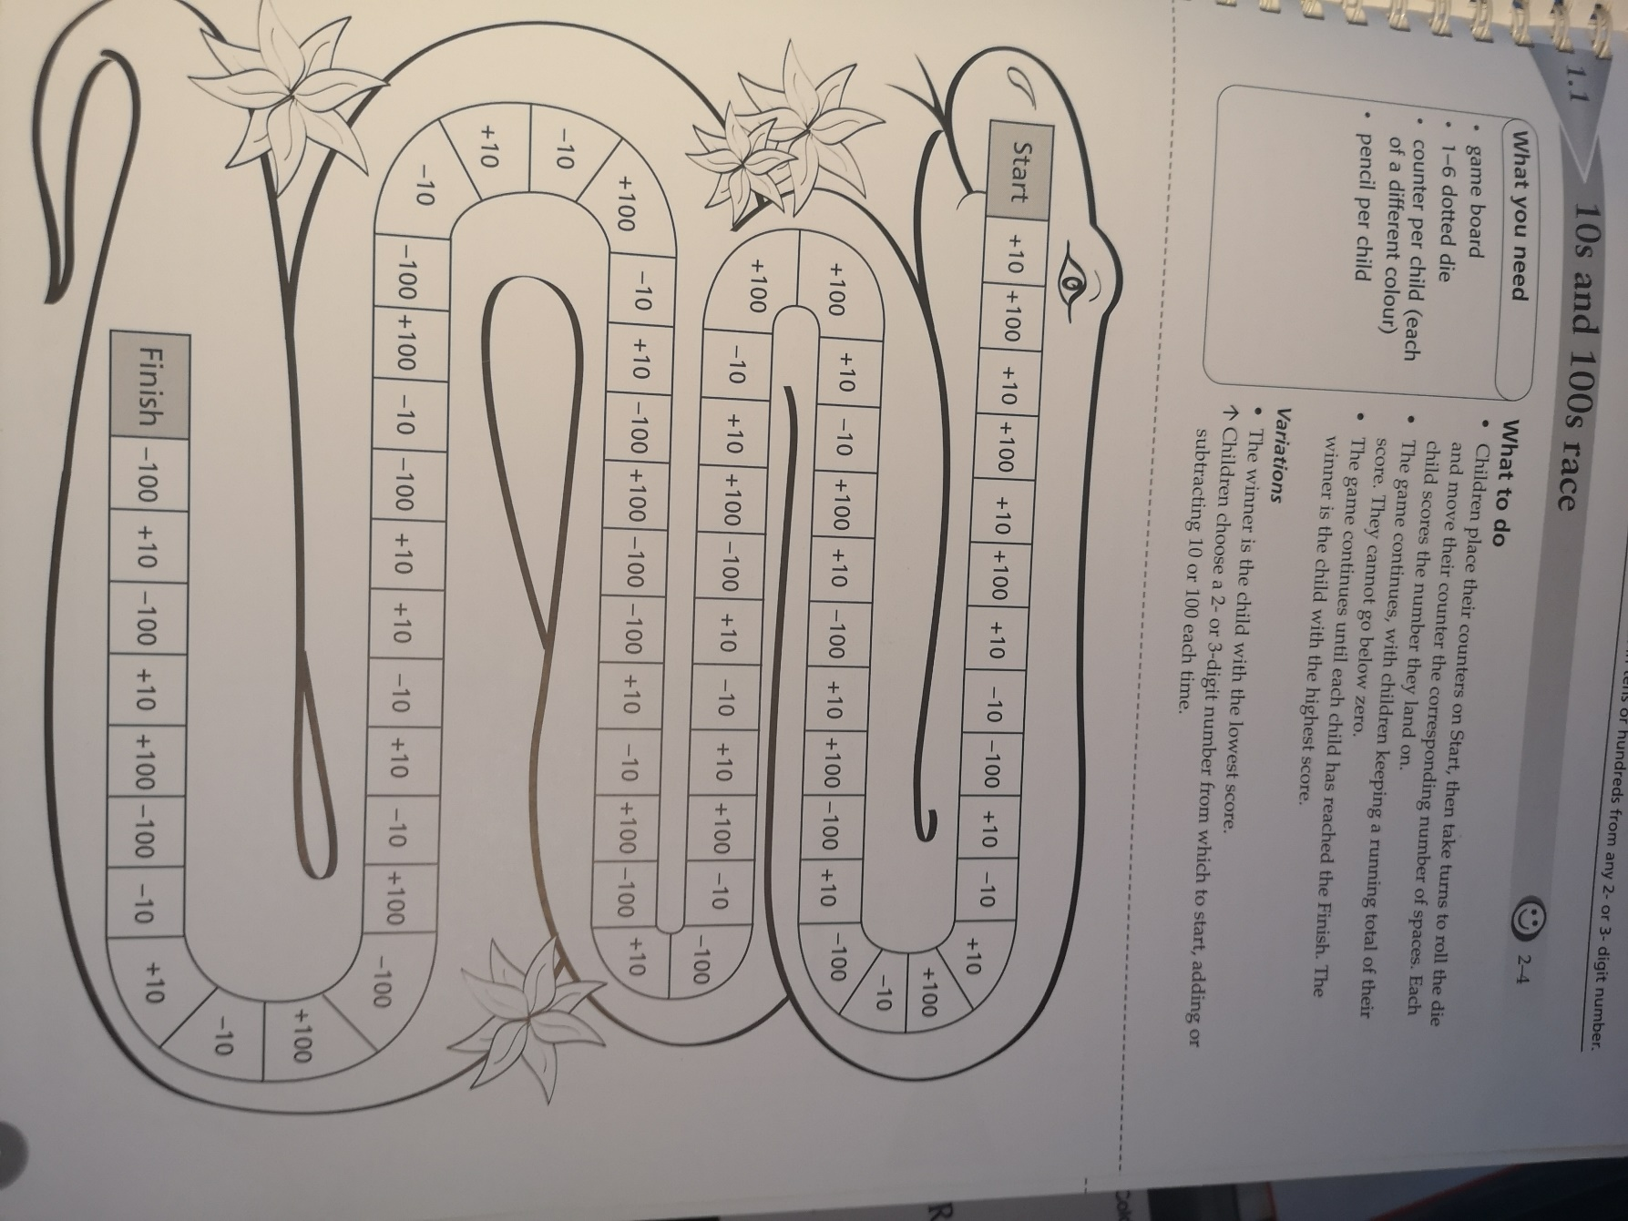

Place Value
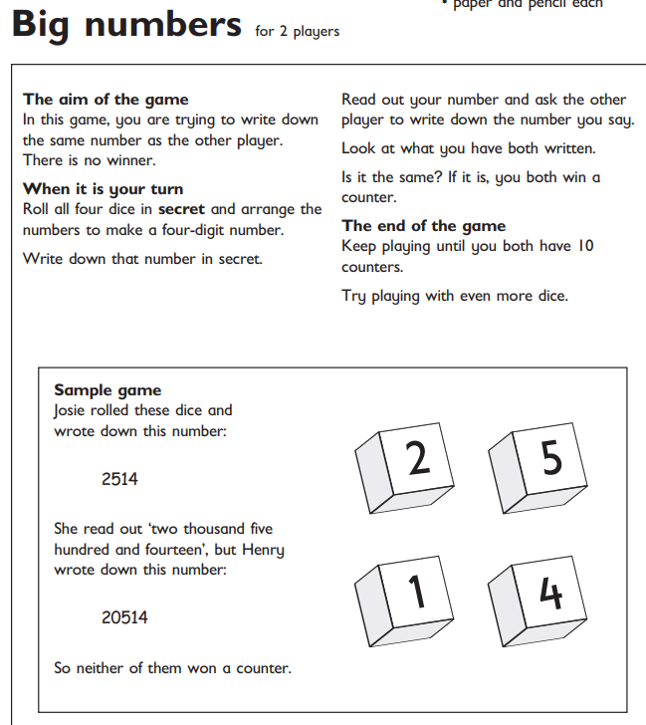

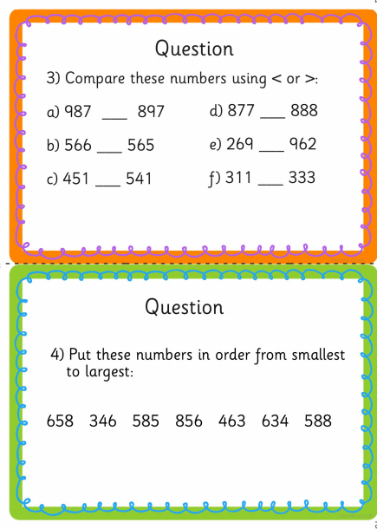
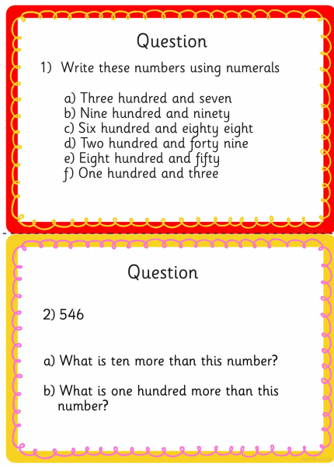

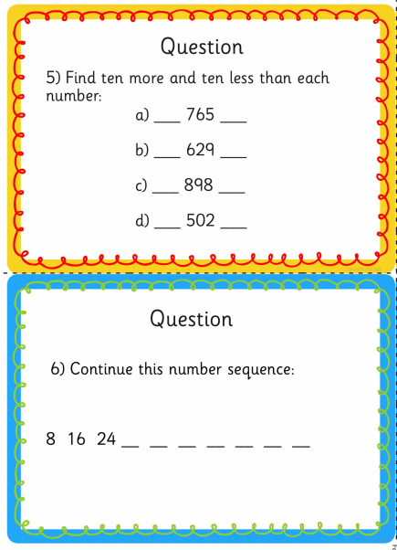

Literacy
Continue reading 4 times a week and practicing handwriting.
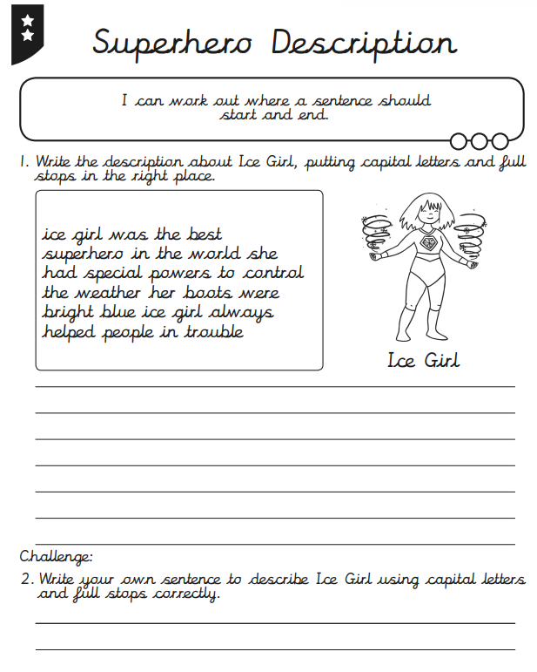

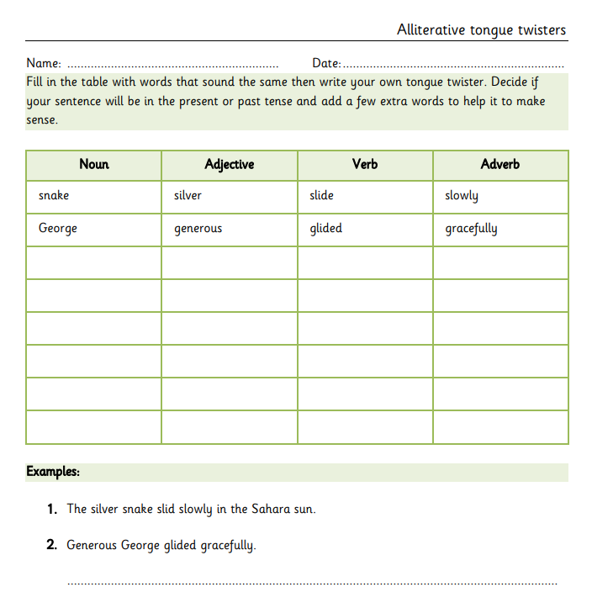
Instructions
We are going to be looking at how to create our own instructions. A great way to do this is to watch some YouTube such as cooking channels, Art Attack, how to draw and origami. Once you have seen a few videos can you then create your own instructional video. You can do anything from drawing to cooking. Your video should include these key features.
- Introduction to what you are making.
- List of equipment/ingredients.
- Time connectives (first, after that, finally)
- Steps in the correct order
- Bossy Verbs (cut, place, fold)
- Present tense (as if it is happening now)
- Concluding sentence
Once you have completed your video I would now like you to write your instructions down for a class book. In your writing you have to include the following:
- Title (how to make …)
- Introduction
- Subheadings
- List of equipment/ingredients
- Time connectives (second, last, next)
- Numbered steps in the correct order.
- Bossy verbs (put, stir, paint)
- Present tense (as if it is happening now)
- Diagrams/Pictures/Photographs
- Conclusion
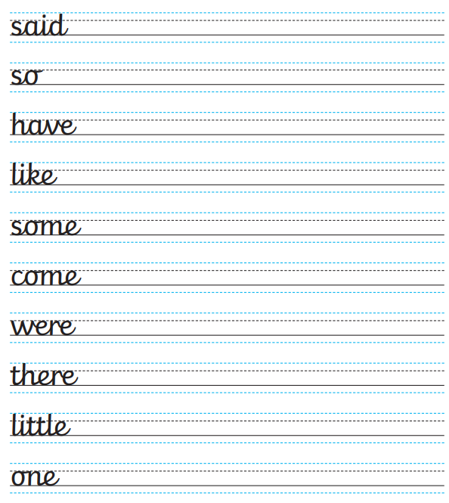
Thema
RECAP: We found a sound clip of something fighting and making a lot of noise. We had to research things that roar and came up with a huge list of animals. We created fact files on the animals. We found out it was dragons fighting as we received a letter from Mrs Harris complaining about the noise level. We made ear defenders for Mrs Harris and we are now trying different things to help reduce the noise level.
Activity 1
We know the dragon is from Wales. Research hat kind of dragons lived in Wales or some myths and legends around dragons in Wales.
Activity 2
We know that some dragons in Wales lived at the bottom of the lake. Can you create a mind map on living at the bottom of a lake? You will need to use your senses (sight, hear, smell, touch and taste) and your adjectives (describing words).

Lake

Then use this description to write sentences for the start of a story. You do not need to write the whole story just the beginning.
Activity 3
Interview the dragons and see what they have to say. Do this with your family. One of you is the interviewer and the others are dragons. Think of the types of questions you could ask. Try and get as much information as possible from the dragons. If you would like you could record this.
Activity 4
We starter to read the book ‘How to Train your Dragon’. At the beginning of each chapter it had a description about a dragon. Could you use arts and crafts to create one of the dragons.
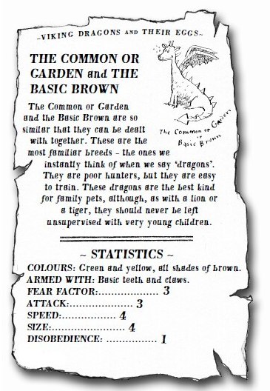
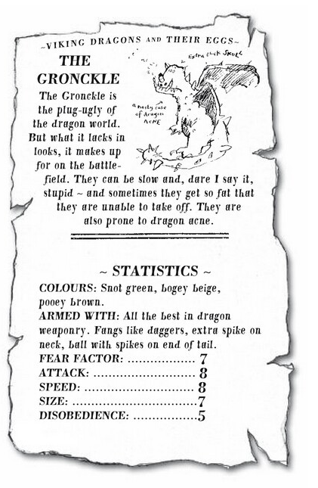
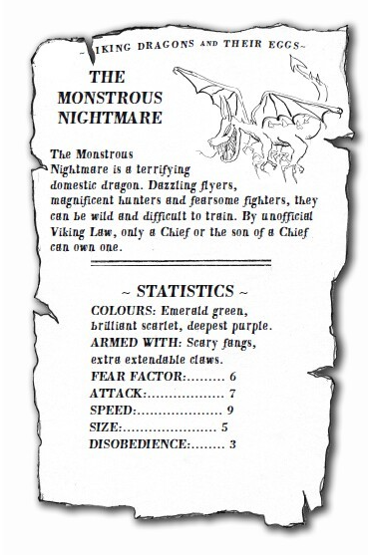

Activity 5
Create and play Top trumps
Create more cards like the ones above about the dragons. Play a game of top trumps using these cards.

Mindfulness
I am an amazing person |  |  | Pupils to think of the following:  - My special talent is…  - I feel good about myself when…  - I am a special friend because…  - I am good at…  - I am proud of myself when…  - I know people like me because they…  - I am a good classmate because…
STOP | Recapping the glitter  Discuss what we should do if we get angry |  | Stop Skill  - Stop  - Take a step back  - Observe  - Proceed Calmly  Discuss what each one means and when we should use our stop sign. Can pupils think of a time that they should have stopped before reacting. | Pupils to make their own stop signs.
Butterfly Breaths |  | Sit on the floor with the bottom of your feet touching and the knees bent out to the sides. Put your hands on your ankles and gently bounce your knees like you are flapping butterfly wings. Close your eyes and breathe slowly and calmly. Pretend you are flying to your favourite place in the world. Imagine what it looks like. What do you see? What do you hear? What does it feel like? Imagine you are flying around, and you are happy and calm. Now it is time to fly home, slowly flap your wings back home. Take a deep breath in and slowly exhale. Now open your eyes.

https://youtu.be/9-GvTXEoQfk
https://youtu.be/pT-s1-phgxs

Welsh
We have been looking at the café in Welsh. Can you create a menu using the welsh words for foods? Place prices on the menu too, remembering that instead of p (pence) it is c (ceiniog)
https://www.learn-welsh.net/welshgames/four-in-a-row?topic=Food%20-%20fruit&level=primary

ICT
Log into Hwb and then into 365 to write up some of your work in Word.
I will be looking for: bold, italics, underlined, aligned to the right, aligned in the centre, inserting a picture and changing the size, font and colour of the writing.

Science
LIQUID SCIENCE

Liquid Science
TRY THIS INDOORS … LIQUID RACES
You will need
❋ Timer or stopwatch
❋ Thick card, plastic or wooden board to use as a ramp
❋ Different liquids, e.g. whole milk, orange juice, chocolate sauce, ketchup, cooking oil, treacle
❋ Cornflour
❋ Plastic bowl
❋ Water and spoon
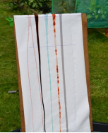
Set up a ramp by leaning the card, plastic or wooden
board against the back of a chair. You might want to
cover it with white paper so you can see the liquids
more clearly, and it is good idea to put a cloth on the
floor under the ramp. Put spoons of different liquids at
the top of the ramp and time how long they take to run
down to the bottom. Try to pour the same amount of
liquid down the ramp each time.
.

WHAT DO YOU NOTICE?
Things to talk about …
Which liquid reaches the bottom first? And last?
What do you notice about the liquids that take the longest or flow most slowly?
What do you notice about the liquids that flow most quickly?
What happens when you change the angle of the ramp – does this affect how quickly the liquids flow?

Record your findings in any way you choose
- A short filmed presentation
- A poster
- A table and a written explanation

Discuss with an adult and think how your investigation shows this
All liquids have a property known as viscosity. This is a measure of how much the liquid resists changing shape, or flowing. A thin liquid like water has a low viscosity and flows easily. A thicker liquid like ketchup has a higher viscosity and so flows more slowly.

