Year 4 – Week 13 Home Learning –20/07/2020

Hi everyone.
Please send Maths, Science, Welsh and mindfulness to Miss Jones: jonest499@hwbmail.net
Please send you Iaith and Mantle work to Miss Edwards: edwardsS490@hwbcymru.net
Or send it over Facebook where we will both see it.

Everyday Activities
Reading- this is really important, even if it’s only 5 minutes a day!
TT Rockstars
Physical Activity – Joe Wicks, Oti Mabuse Dance lessons etc.

 | Iaith | Maths |  | Other Curriculum Areas
Monday | Features in newspaper report | Sometimes, Always, Never.  Choose 4-5 of the statements, test it at least 3 times to decide if it is sometimes true, always true or never true. If it is sometimes true you need to explain why. |  | Mantle- Write a letter to your future self about the year 2020
Tuesday | Plan report | Shopping |  | Science- Start/finish your sundials depending on the weather!
Wednesday | Plan report | Year 4 Mastery week 28
Thursday | Write newspaper report | Ben has five coins in his pocket.  How much money might he have?  Find as many combinations as you can. Use real coins if it helps. |  | Mindfulness  List some hopes for the summer holiday!
F`riday | Complete and self-assess newspaper report | The money maze | ICT- practise touch-typing  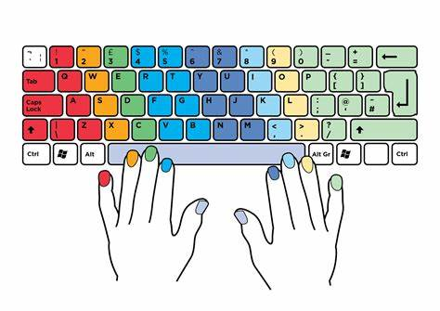

Happy holidays!!

2020 has been a strange year! But you’ve made it to the summer holidays- well done for persevering with home-learning, the difference it will have made to your child is huge! Enjoy the holidays and stay safe!

