Blended Learning – How to access Microsoft Teams
- Google Hwb.
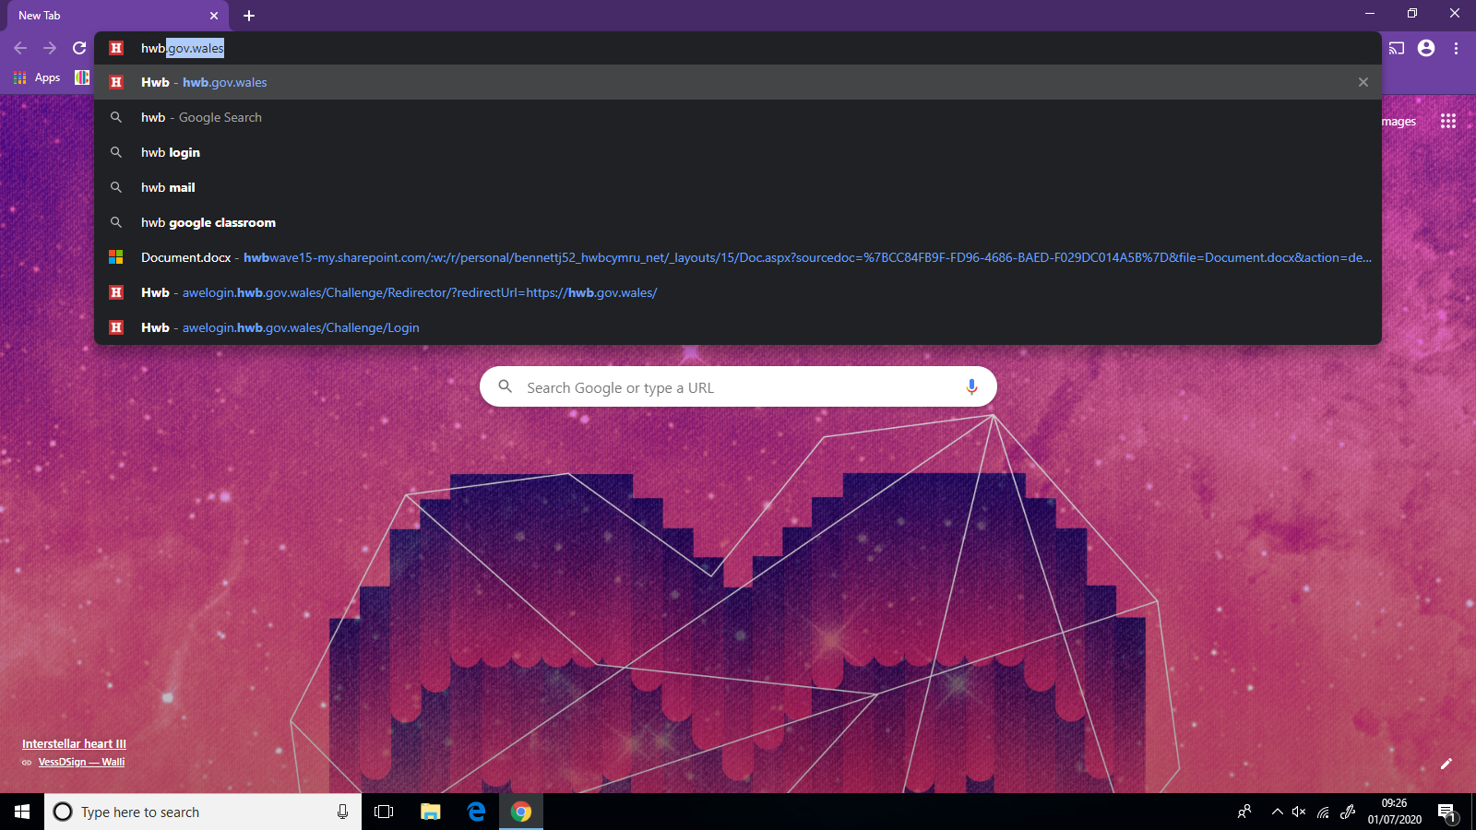

2. Log in with your child’s HWB account.
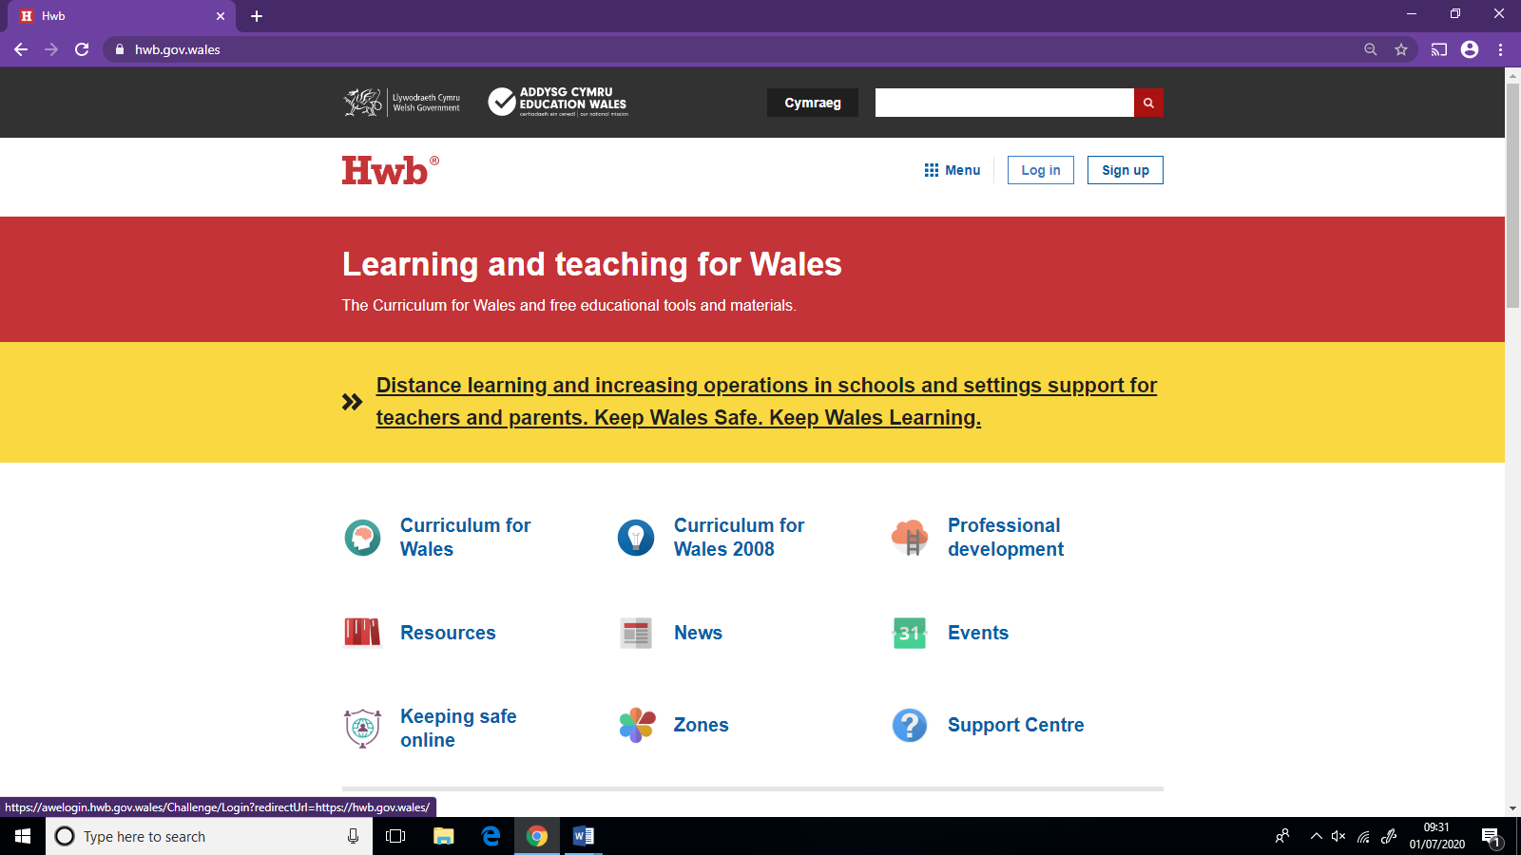

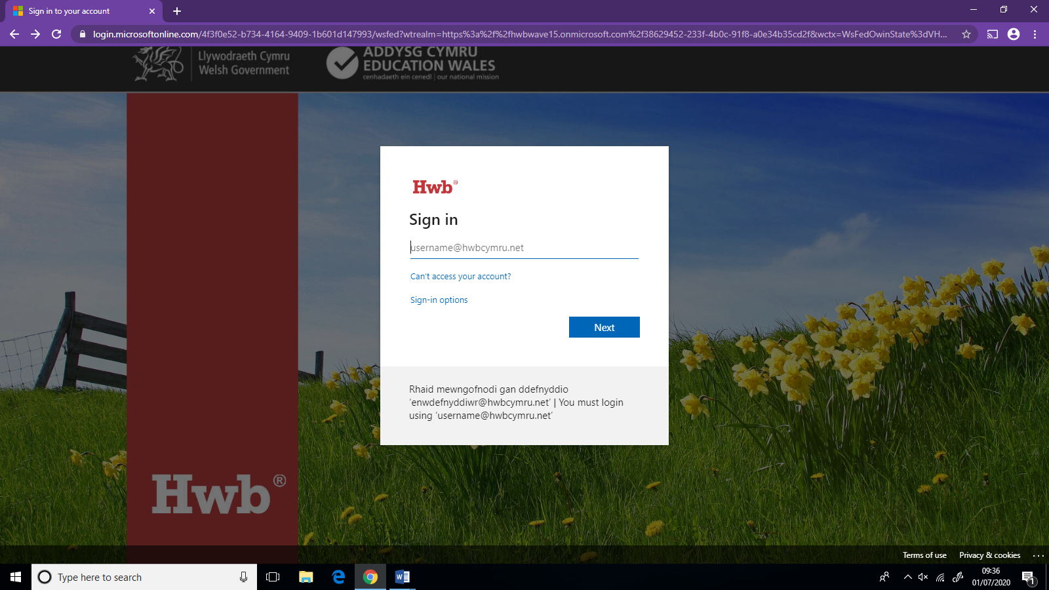

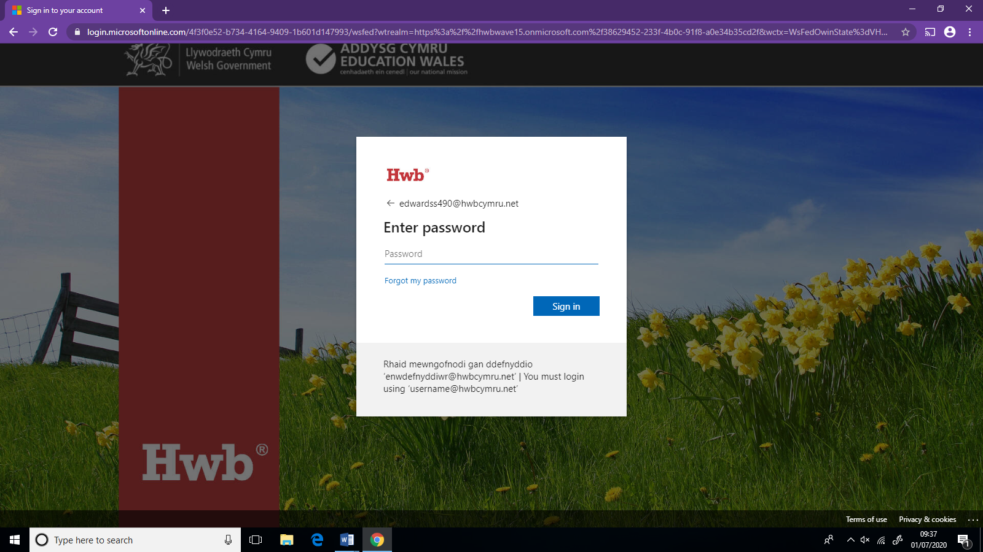

3. Your next screen will look like the one below. You then need to click on the icon that says Office 365
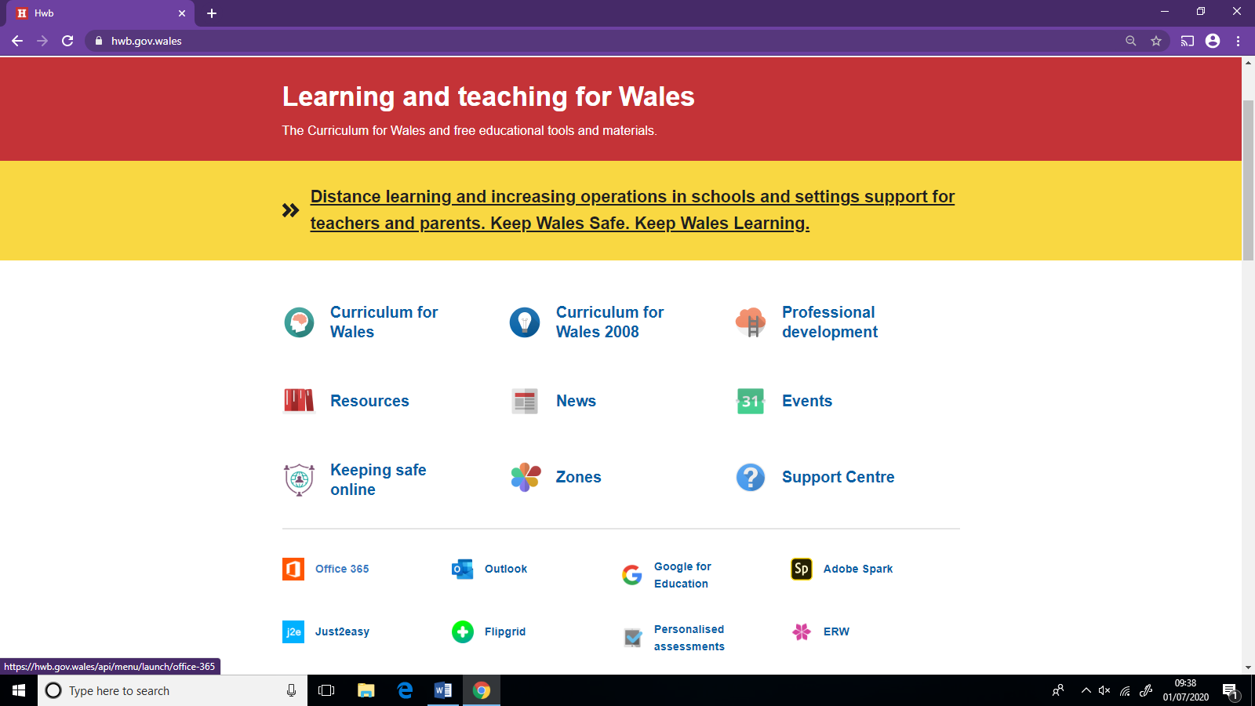

4. You are then taken to this screen. You will then need to click on the Teams App.
5.You will then be taken to this screen. We strongly advise you to download the app. Whether you are using a laptop, tablet or phone. By having the app children will be able to use all the features such as being able to see everyone on the video call.
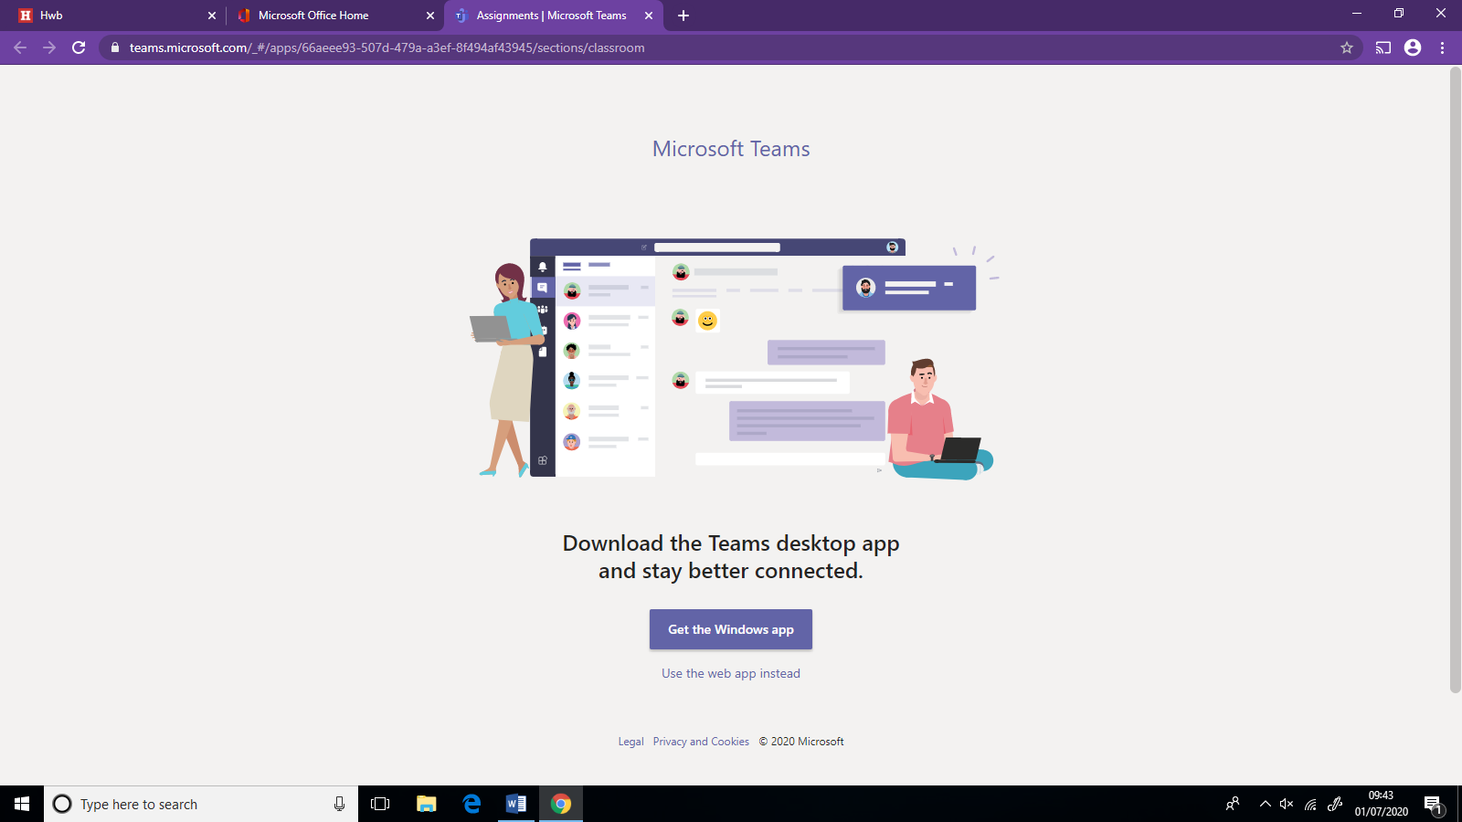

6.
If you use the web app instead this is the screen you will be taken to.
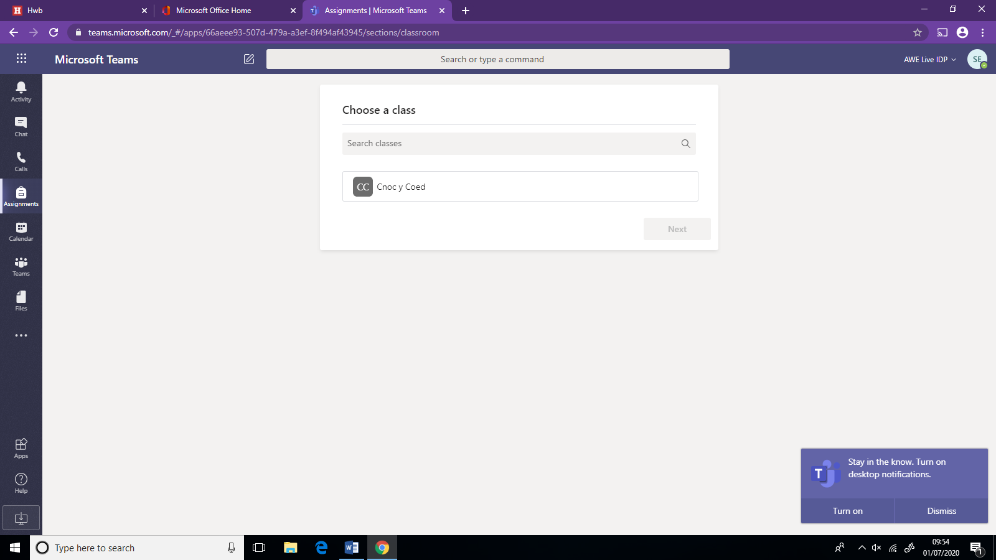

7.You then need to press on calendar on the left-hand side. This will then take you to the screen below. Your child’s teacher will set a meeting on a particular date and this will show on the calendar. On the meeting you will need to press join.
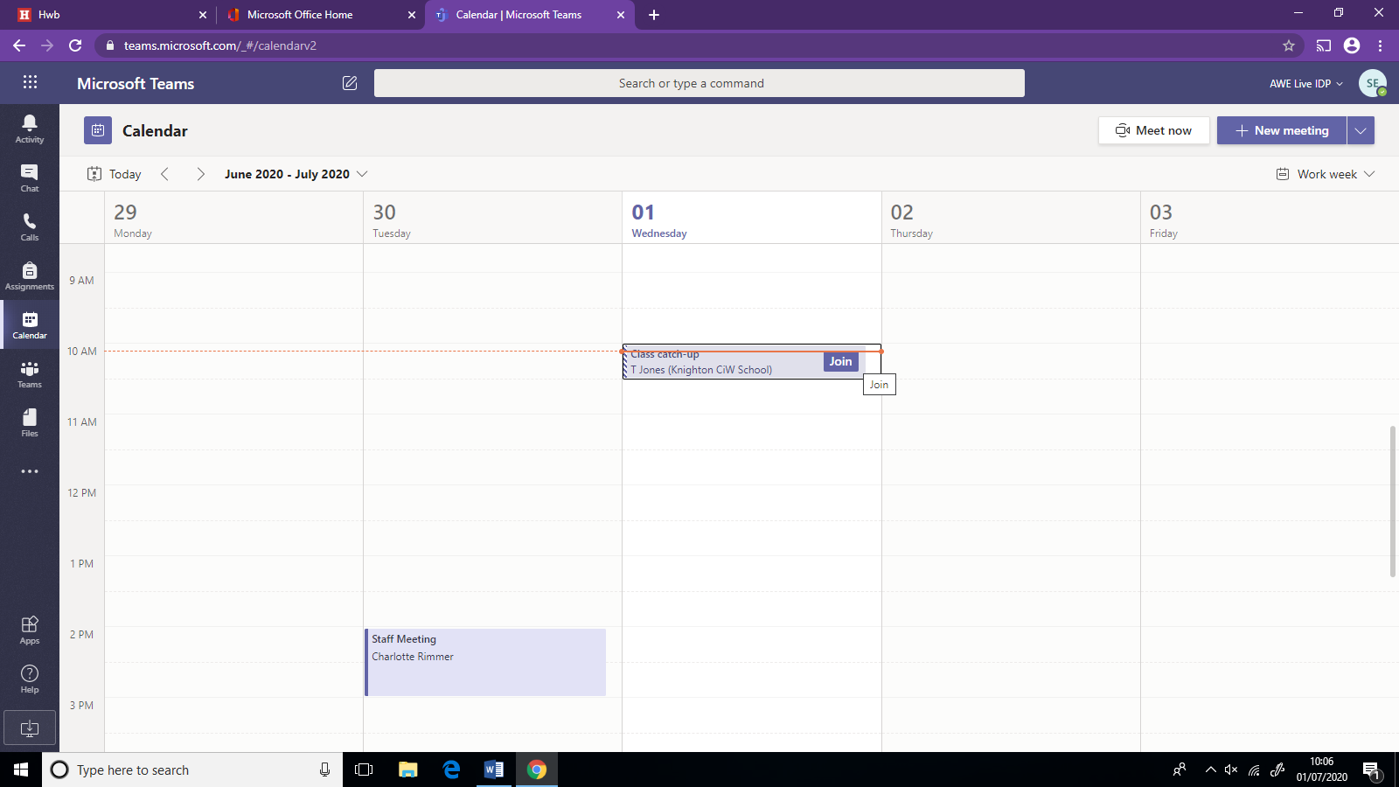

8.After you press join this screen will appear. If you press Join Now it will take you to the meeting with the rest of the class and teacher.

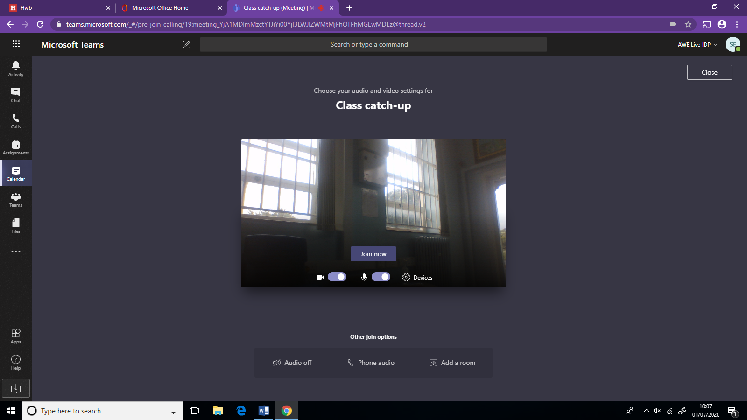
9. When using the web app you will only be able to see one large screen of whoever is talking most like the screen below.
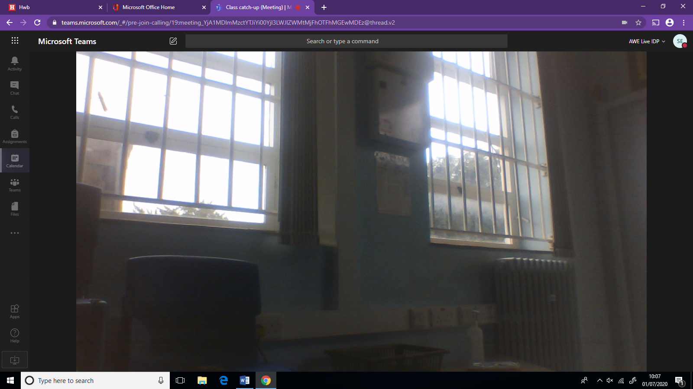

10.If you move the mouse around this toolbar will appear on the screen. If you press the camera button it will turn the camera off so the other participants won’t be able to see you. The microphone button next to it when pressed will turn you on to mute. This will be handy to remember as 30 children all taking at the same time could be loud so the teacher may ask you to mute. You should also be able to see a little hand. If you press this hand it is way of showing your teacher that you have a question.
