Mantle – 6/7/2020
During the session that we looked at our new topic Water, Water Water all those months ago, some of you were really interested in the coral reef. What I’d like you to do is create a fact sheet using websites to discover some information about the coral reef.

A good example of what a fact sheet looks like is this:
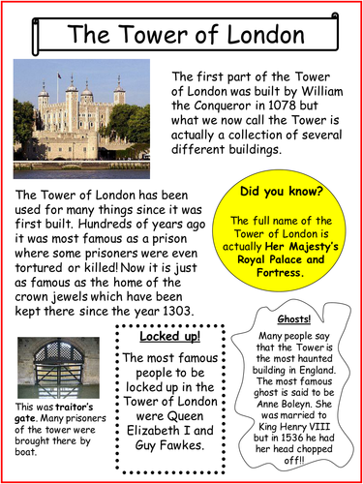

You can create your fact sheet on the computer or on some paper. It is up to you.
I’d like you to find:
- Why the coral reef is important?
- What is a coral reef?
- Where are the coral reefs located?
- Types of coral reef.
- Any other facts you’d like to include.
Then make sure you have excellent pictures to share!
Some useful websites: https://www.ducksters.com/science/ecosystems/coral_reef_biome.php
https://kids.kiddle.co/Coral_reef#:~:text=Formation-,The%20Importance%20of%20Coral%20Reefs,environment%20for%20fishes%20to%20breed.&text=The%20corals%20also%20influence%20the%20amount%20of%20carbon%20dioxide%20in%20the%20ocean.

