MONDAY
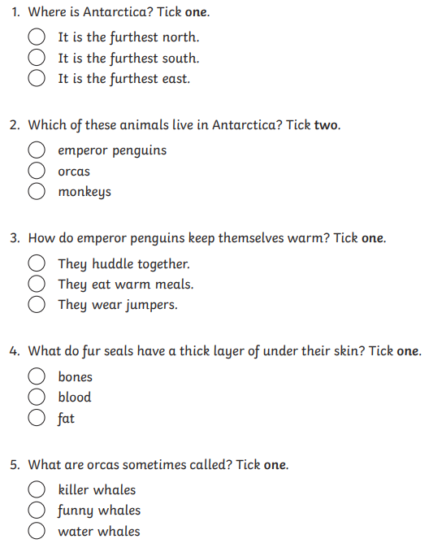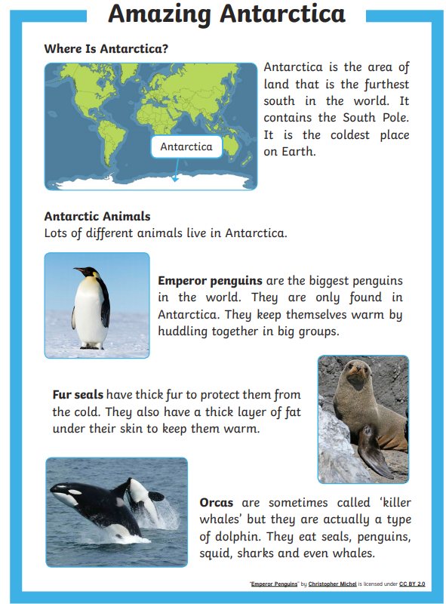

Maths
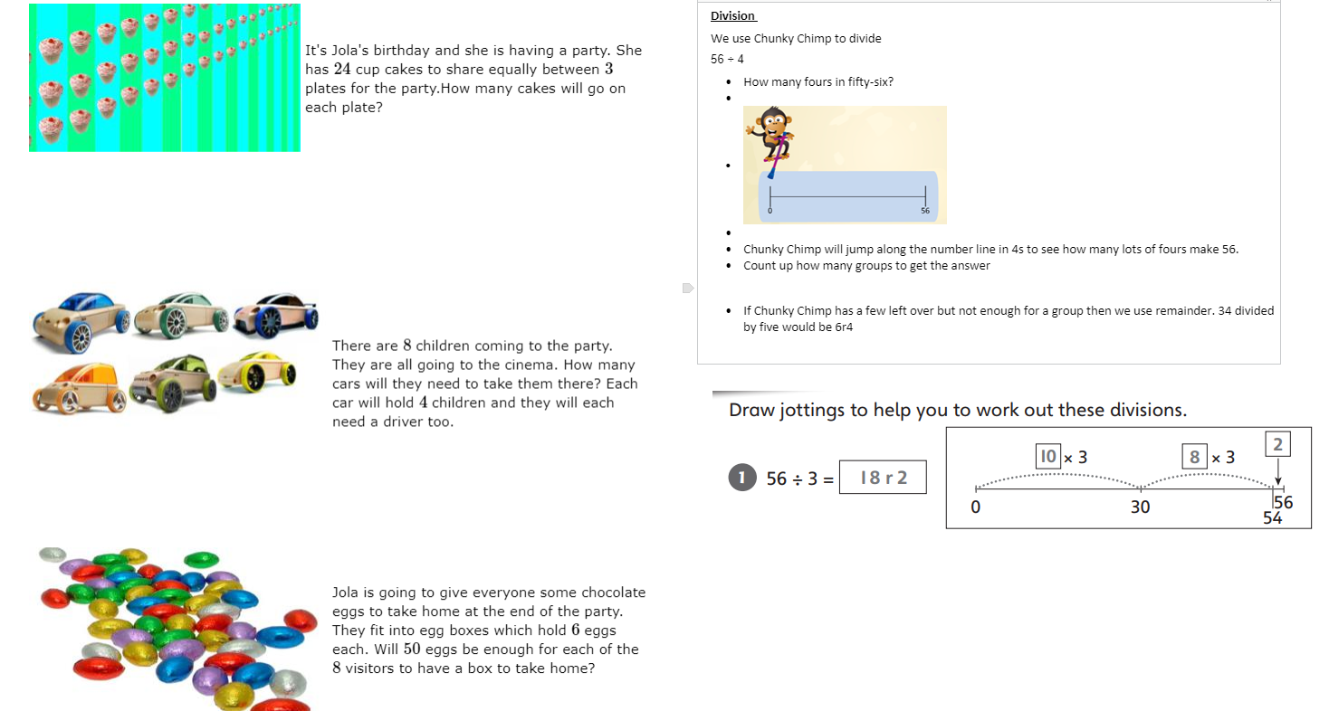
Water, Water, Water
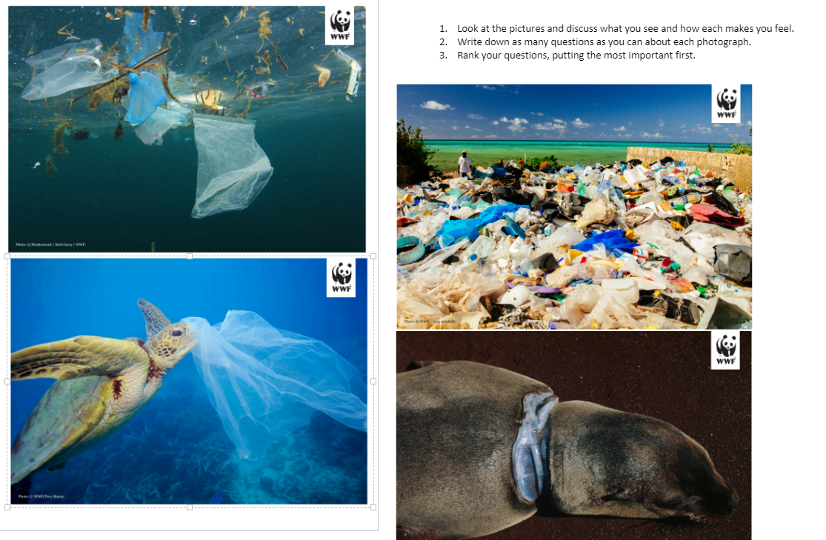

TUESDAY
Maths
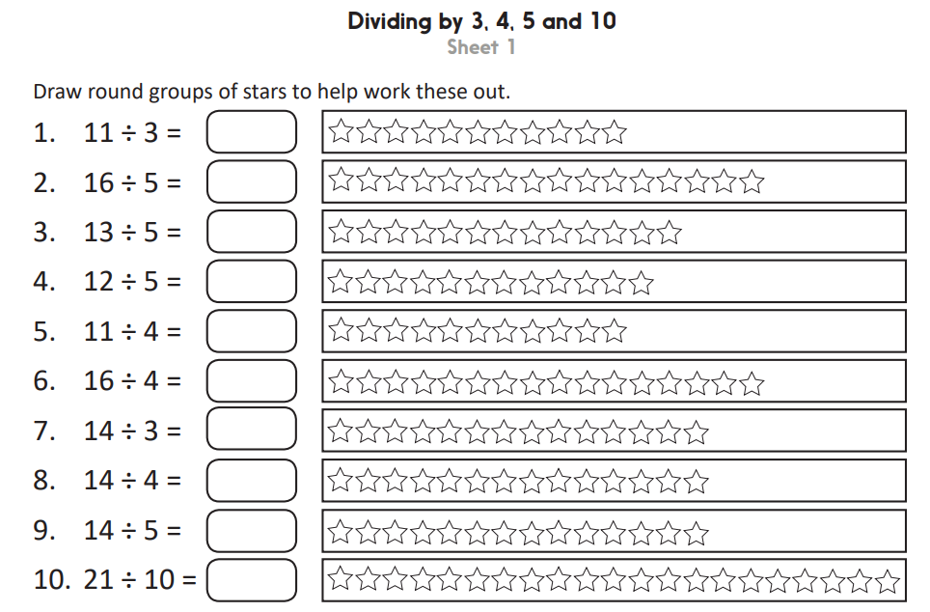
Iaith
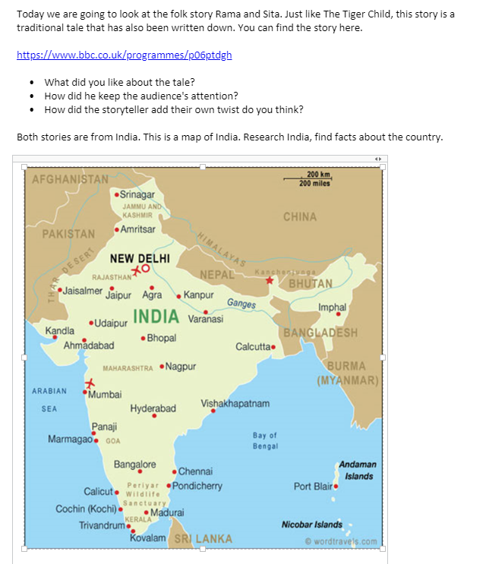
Expressive Arts
We are creating a wall display in school at the moment on health and well being!

We would love some photographs of what you have been doing during lockdown to be displayed on the wall! This could be a photo, drawing or mood board.

The five steps of well being are:
1. Connect with others
2. Stay Active
3. Learn a new skill
4. Mindfulness
- Give to others

WEDNESDAY
Welsh
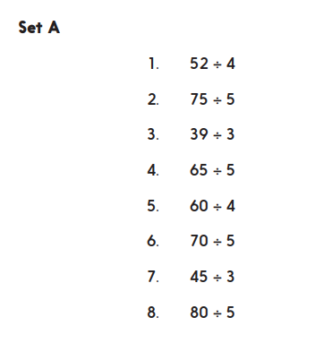
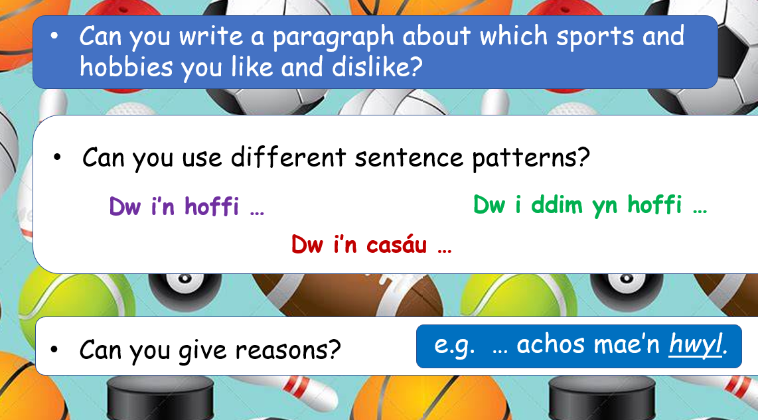
Maths

Science
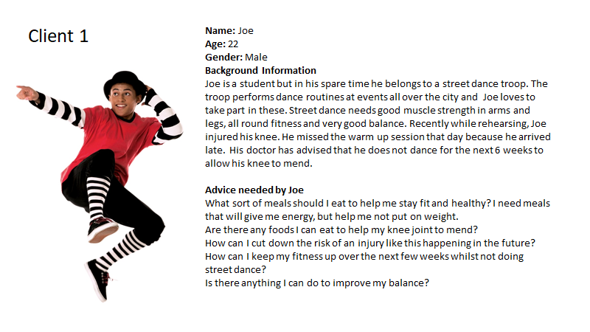
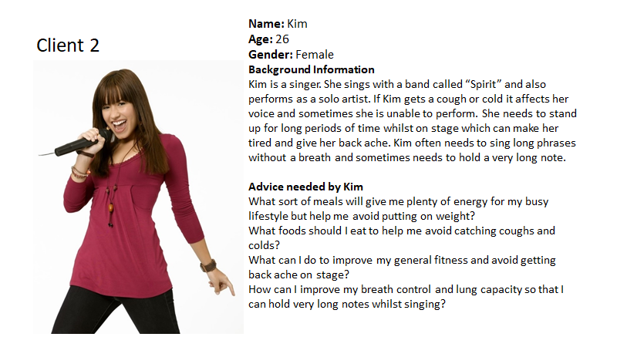

- Read the clients information. Choose the client you would like to work for.
- Research the different food groups for your client.
- Name a food group.
- Why do we need to eat that food group?
- Give examples of food that belong to that group?
- https://www.bbc.co.uk/bitesize/clips/zytjmp3
- Create a balances eat well plate for your client. This will show the clients what foods belong to each food group.
- Place types of food on the plate that belong to that food group.
- 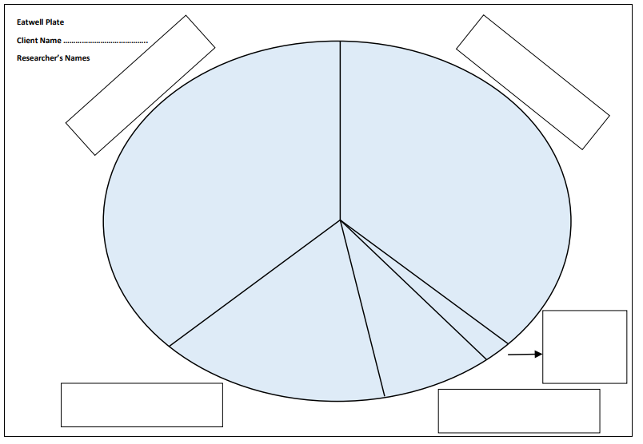

THURSDAY
Iaith

Re-read the Rama and Sita story. Today we are going to create our own version of the story. You can change some of the details (setting, animals who helped, what Sita leaves behind) but the main parts will stay the same.

Create a story mountain or story board for your own story. Remember to change a few aspects but keep the 5 main parts the same.
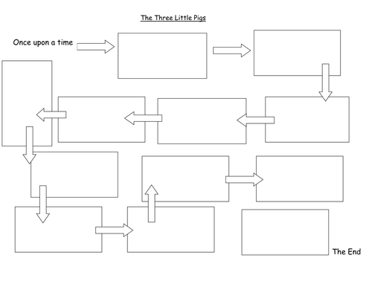
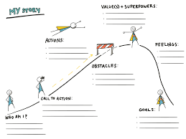

Maths
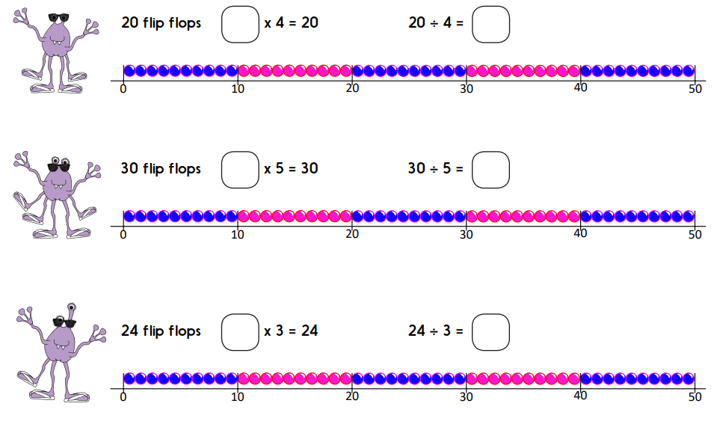

COMPUTING
https://makecode.microbit.org/#editor

Rock, Paper, Scissors

FRIDAY
Iaith
Use your story map/mountain from yesterday to rewrite the start of your story.

The start of your story should include detail about the setting. Include lots of detail so that the reader can picture the story in their mind.

You are only writing the starting paragraph today!

Remember to include:
- Prepositions
- Adjective

Maths
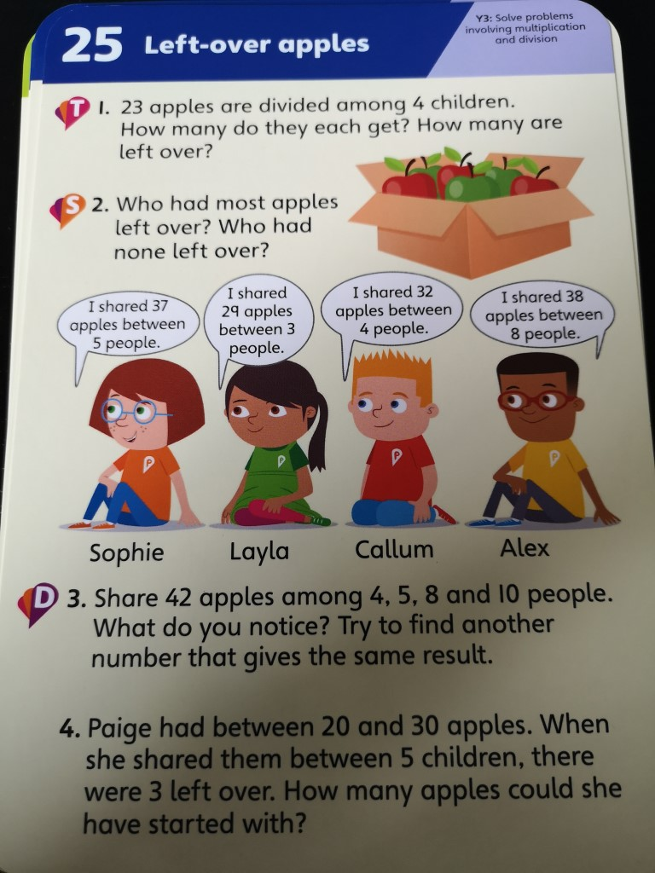

Well-Being
https://en.calameo.com/read/000777721945cfe5bb9cc?authid=Xu9pcOzU3TQx

Read the story and share some of the worries you have at the moment.

