Iaith – Poetry
Hi everybody. This week we will be planning a poem based on Plastic Pollution and the animal you chose to research. Next week you will be writing your poems.
Monday
Remember your fantastic poems from this year? You’ve written some amazing poetry including Haiku and Acrostic.
Can you remember their features?
Here are some websites to remind you of what a these poems include:
Haiku: https://www.bbc.co.uk/teach/class-clips-video/english-ks1-ks2-understanding-poetry/zfvkt39
Acrostic: https://www.twinkl.co.uk/teaching-wiki/acrostic-poem
Task: Create a mind map or bullet point lists on the features of all these poems. What makes them different to the other poems?
Tuesday
Now you remember what the features are of these poems, can you work out what the examples below are? Are they haiku or acrostic poems?
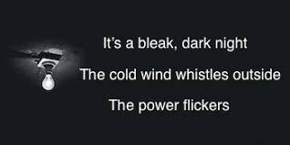
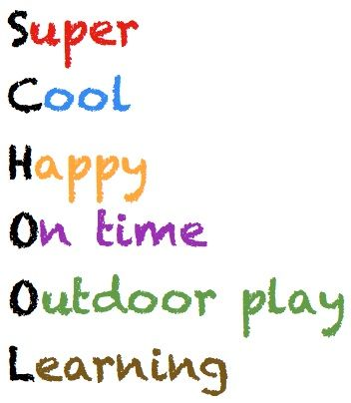

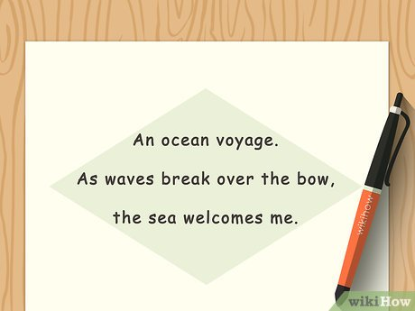
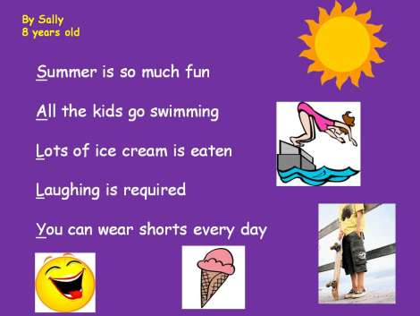

Wednesday
Which poem was your favourite? Decide which you’d like to do to add to your project on plastic pollution?
Write me a paragraph or bullet point list of why you’ve chosen that particular style of poem.

Thursday
Your poem will be based on Plastic Pollution.
So today you need to brainstorm what you might like to write about. Here are some ideas:
- Recycling – just like the poem below you could tell people why or what theu should recycle.
- Your animal – You might like to describe your animal first and then explain what dangers they face.
- Plastic – You might want to base your whole poem on the dangers of plastic and how to stop using it.
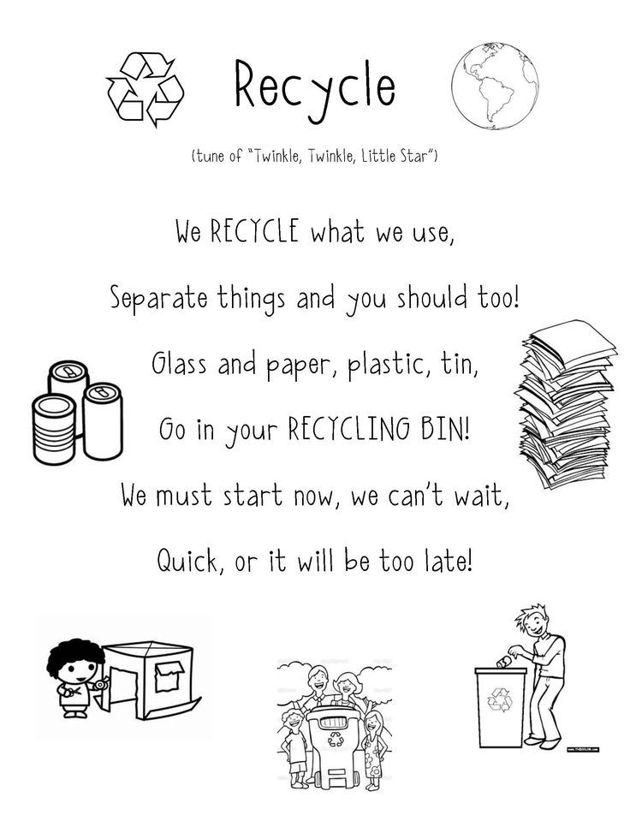
Friday
All good poems have exciting vocabulary. Which words would you like to use in your poem? Create a list or mind map and brainstorm some ideas. Use this word bank to help.
