Discussion Activities

1. Where in the World:
Composing of three short activities (that might form a three-part lesson), this focuses on the ‘reading’ of satellite images and their comparison to familiar landscape and objects.
Activity A: landmarks
Show the PowerPoint presentation and ask the children to guess what each picture shows on slides 2-4. They each show a recognisable feature (natural and man-made) that have been photographed from space using a satellite – slides 5-7 show the same landmarks from ground level. Some points for discussion:
The scale of each satellite image is very small – the area shown is large but details are hard to see.
Height is difficult to judge – Mt Taranaki, for instance, looks like it might be flat (or even a hole)
The images contain both natural and man-made features. Differences include symmetry, straight lines and shapes that are clearly designed.

B. Reading satellite images
Go to https://www.stem.org.uk/elibrary/resource/35853 if you would like more images, I’m not sure of the quality we will get printing and it is quite a paper-heavy resource. Alternatively, you could search for other satellite images to use as a discussion point.
The handout images should be printed as large as possible, with maximum resolution, in colour – this will allow the greatest amount of detail to be seen. They can also be opened on a large screen using image viewing software available on most computers by double-clicking the file.
The children can be encouraged to look very carefully at the images – maybe in silence for 30 seconds, before discussing the image in pairs. Satellite analysts would take great care and time, methodically and consciously scanning the image with their eyes in good light.
They might look for:
• Man-made and natural features, • Evidence of people or other living things including plants • Any changes in height • Indications of the climate • The location (coastal, mountain region, plain, city etc) • Anything else they find interesting.
Pairs might then be put into quads to explain what is in their image.

C. Image ‘Bingo’
A game of ‘bingo’ might involve teachers reading the following list if features, with children putting up their hands or marking on a sheet which are found in their picture:
beach, cliff, coast, forest, hill, mountain, sea, ocean, river, soil, valley, plants, clouds, town / village, factory, farm, house, office, port, harbour
These words may also form a vocabulary list or key word display.

A.
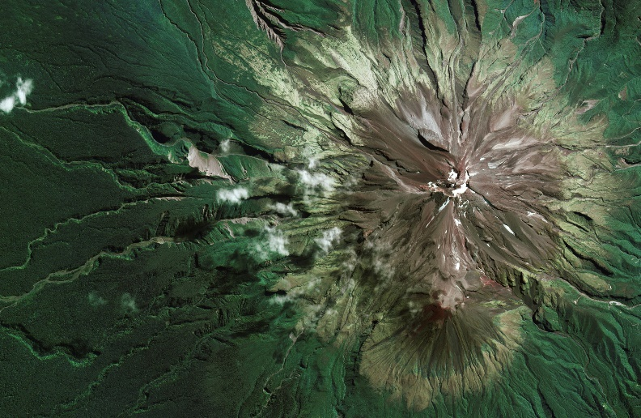 | 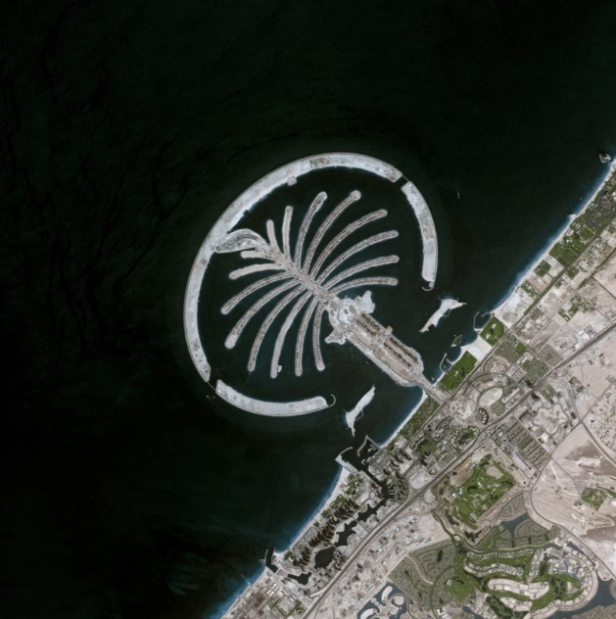
 | 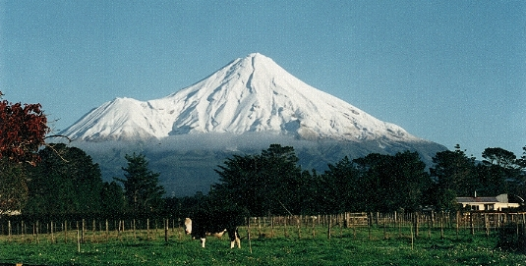
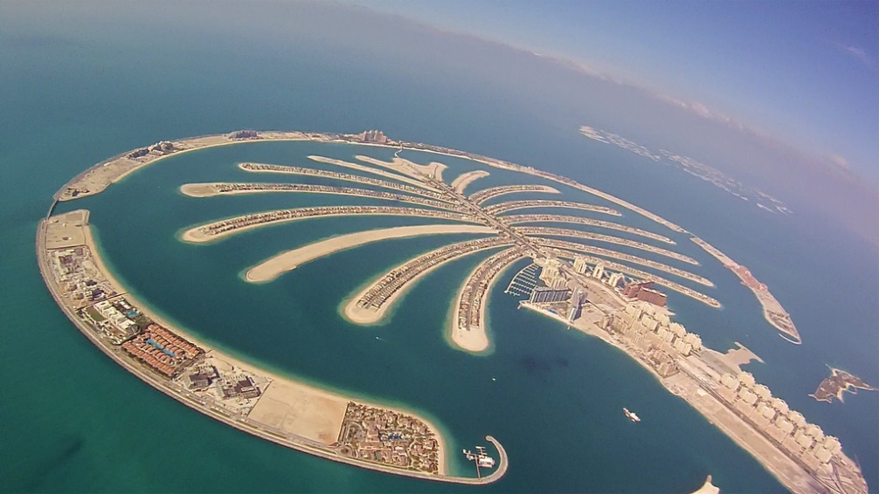 | 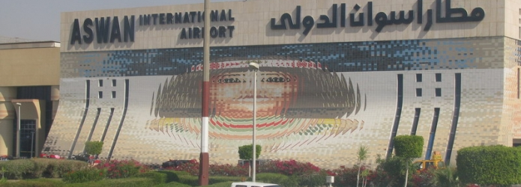
Mt. Taranaki, New Zealand
Dubai, UAE
Aswan International Airport, Egypt

B

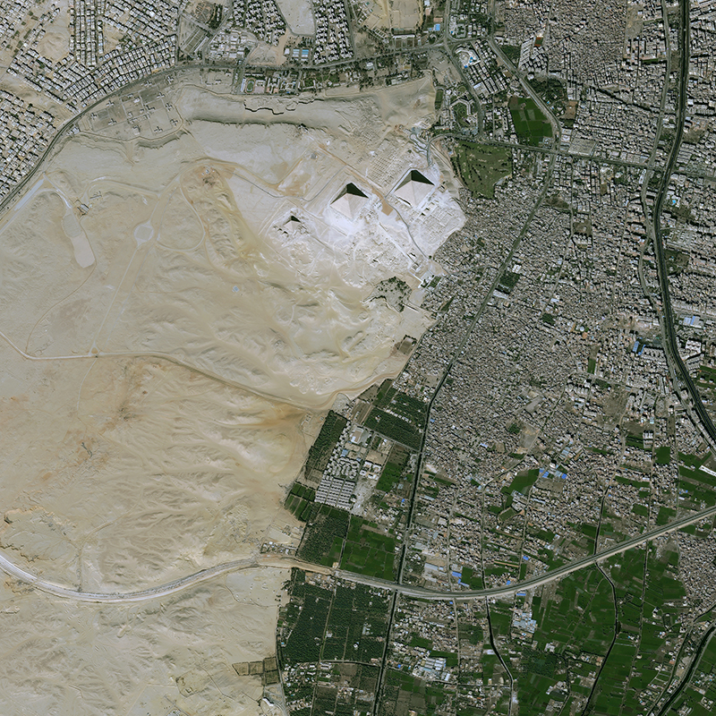

Cairo Pyramids Egypt 2013

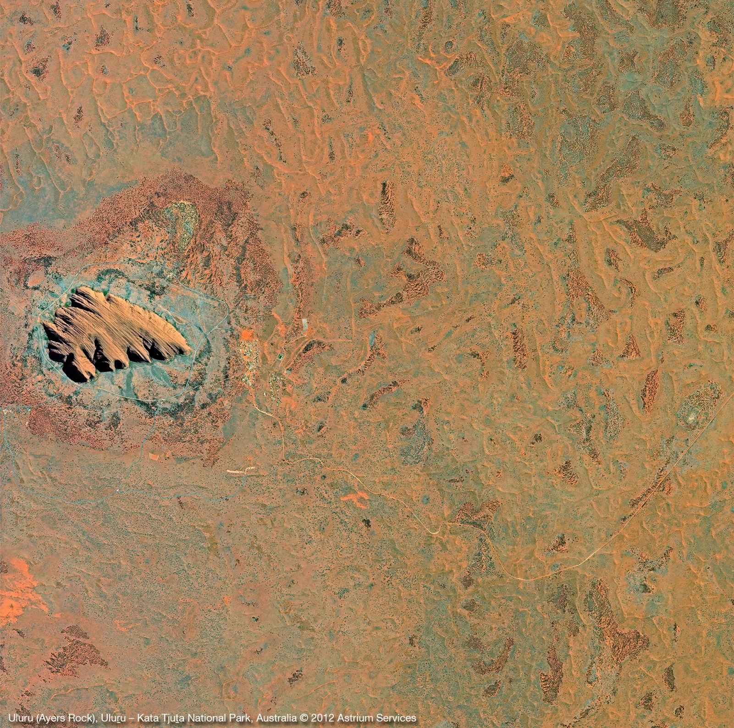
Uluru Australia 2012

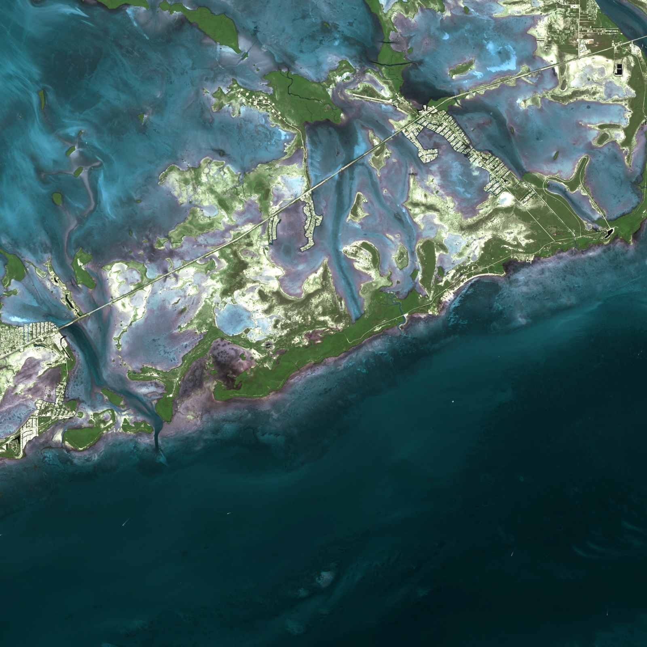
Florida Keys United States 2005

