WB 15/06/20
So we’re looking at measures again, but this week with a focus on mass (or weight as we often, and incorrectly, refer to it…bonus points if you can explain why!)!
Please send your maths work to jonest499@hwbmail.net or to the Cnoc-y-coed Facebook page so I can see how you’re getting on.
Thanks,
Miss Jones

Monday
https://www.bbc.co.uk/bitesize/clips/zbvgkqt
Play with different objects…how heavy do they feel? Compare them. Try to find something that weighs 100g, 500g, 1kg and label them so that you have a known weight to compare them to and try to guess the weight of other objects based on them.
Use a table to record your predictions and the actual weight (It could be difficult depending on the scales used on your weighing scales.

Pg 65- green & blue
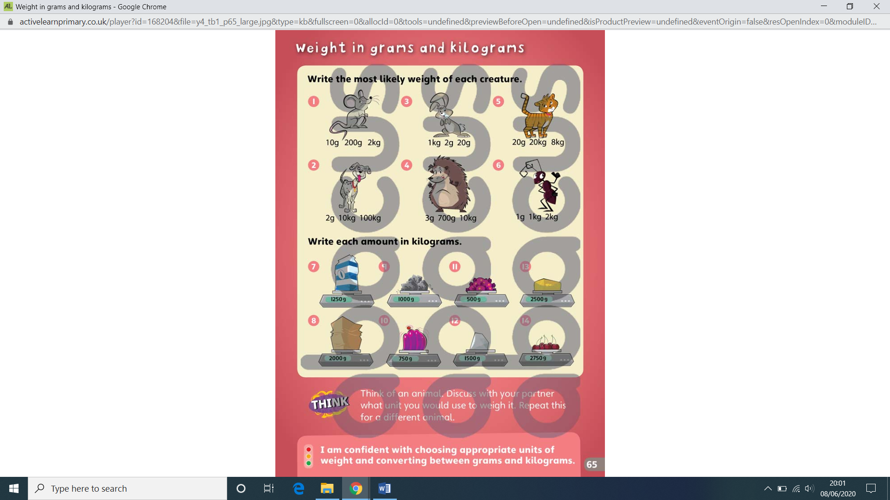

Mon-Reds

Tuesday
Green

Tues-Blue

Tues-Red

Tues-Challenge questions

Any day!
Cook or bake something together- a meal, pudding, snack…anything that’s on your menu this week. Follow the recipe and use the weighing scales and measuring jug to be accurate (this may be tricky depending on the scales you have- in school we have a variety which makes it easier!). Send me a photo…if it looks good I might be tempted to try the recipe myself; if we’re honest, if it contains chocolate I’m likely to give it a go!!!

Thursday
Potions…we all love them. When I was younger my best friend and I would raid our parents’ food cupboards and mix all sorts, then leave them on top of our wardrobes to see how long it would take for them to go mouldy…! Yuck!
Create your own mixture; it could be for slime, dough, anything…write the recipe, measure it out, make slightly different versions…have fun! See how it turns out! But please, ask your parents before you raid the cupboard and maybe don’t keep it in your bedroom (or theirs)!

