Week 9 playscripts
This week your will be using your prior learning to help you to write a playscript using playscript features. Your play script must have a water theme but it is your decision how you get this into your plot/storyline)
Monday
Character planning
Task: Use your skills, which you developed in the story writing week, to plan your characters to use in your own playscript. Plan these however you like but I’ve attached the ‘Character planning’ sheets we used during story writing to support you, should you want them.

Tuesday
Playscript planning (plot/storyline)
Use a story mountain, comic strip or flowchart plan to plan the plot/storyline of your play. You could use the Water Woman comprehension to base your play on or the stories you wrote earlier this term. As long as your plan includes a water theme, its over to you!

Planning formats:
Story mountain

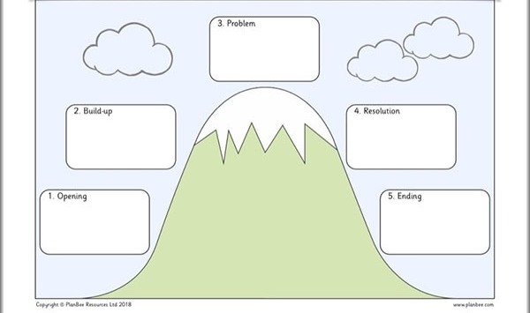

Comic strip

Flow chart:
Set the scene

Build up

Problem

Resolution

Ending

Wednesday, Thursday and Friday

Now it’s time to write your own playscript. Make sure you use all your leaning from last week to support you, your character plan and the storyline plan from yesterday. Use the ‘Playscript features tick sheet’ to self-assess your writing. Edit your work; check for: playscript features, correct punctuation and spellings.

If you have time you could give yourself some stars and a wish to complete. You do not need to write a second/final draft.

