Monday
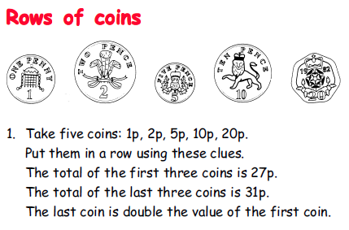

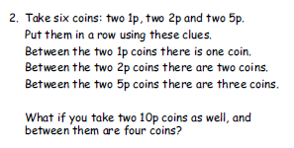

Tuesday
Solve the word problems on the next page.
To decide what you need to do (+ - x ÷) you will need to ‘try smaller numbers’. Above the numbers, replace them with a smaller number (between 1 and 10)- you must make sure the biggest number remains the biggest and that the smallest number remains the smallest. This should help you to decide what to do. Solve the real calculations. Do one set, do them all…it’s up to you!
For example
Betty wins £1200 on the lottery. She wants to share it equally between her 4 grandchildren. How much will they each get?
Becomes…
Betty wins £10 on the lottery. She wants to share it equally between her 2 grandchildren. How much will they each get?
They should establish that ‘the answer is £5 because 10 shared between 2 is 5, so I need to share/divide’.

4 people have a meal which costs £36 altogether. How much does it cost them each? | Ben is 25 years old and his Dad is 26 years older. How old is Ben’s dad?
There are 97 bean bags in a box. If John takes 14 bean bags out of the box. How many will be left in the box? | Damien had 142 stickers. His Mum gave him 18 more.  He then gave half to his brother.  How many did he have left?
The football team is planning a trip. There are 13 boys and 4 seats in each school car. How many cars are needed to take the team? | Francis has 28 sweets Sandra has 25 sweets. If Francis gives 2 to Sandra how many sweets will each girl have?

Annie has 28 crayons. She is given another 13 crayons and finds 8 in her bag. How many crayons does Annie end up with? | There are 45 cards in Sara's collection. If the cards are split into 5 bags, how many cards in each bag?
In a school of 128 children.  46 of them walk to school. 36 come by bus. The rest come by car.  How many of the children come to school in a car? | A box holds 70 biscuits. How many biscuits are left if 17 are eaten?
It takes me 2 hours to paint each wall. I have 3 days and am going to work from 12 noon till 5 o’clock each day. How many full walls will I paint? How much of the last wall would I paint? | Sally had 5 packs of pens. There were 8 in each pack. She lost 7 of the pens.  How many did she have left?

Jade’s mum buys a pack of 8 kiwi fruit for £1.92. Individual kiwi fruit cost 30p each. How much cheaper is each kiwi fruit by buying in a pack? | The class can make 19 sandwiches from every loaf of bread. They have bought 4 loaves and intend to share all the sandwiches equally between the children. If there are 24 children in the class how many sandwiches each?
The shopkeeper has 1227 red pens and 3439 blue pens. How many pens does he have altogether? | Computers cost £349, laptops cost £696. How much more do laptops cost?
I buy a magazine for £2.36 and a book for £2.64. I get 50% off. How much do I spend? | A family were going to travel 200 miles. In the first hour they travelled 48 miles. In the second hour they travelled 65 miles. How much further did they have to go?

Wednesday
Green and Blue groups

Wednesday - Red

