MONDAY 29th JUNE 2020
Iaith
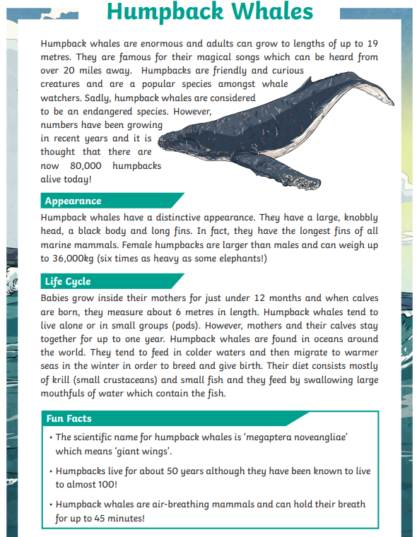
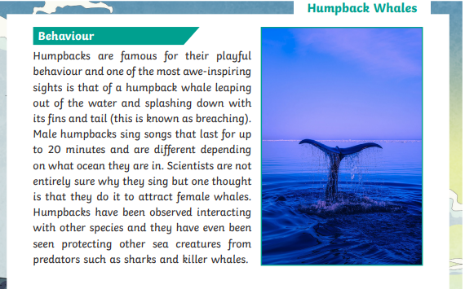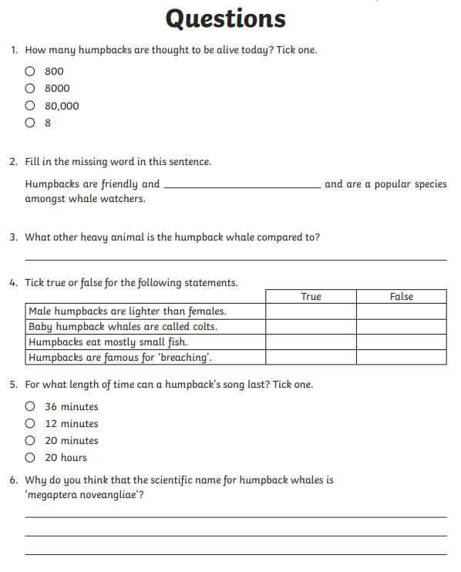

Maths
- Collect a range of containers (egg cups, cups, buckets, bottles etc).
- Measure out 300ml and fill a cup with the water.
- Sort the containers according to whether you think they hold more or less than 300ml.
- Once you have estimated use a measuring jug to find out the real measurement.
- Fill in the table.
Container | Estimate | Actual

Repeat this with 500ml in one of the containers and then estimate again.

Can you put the containers in order from holds the least to most?

Water, Water, Water
Look at the fact sheets below.
Design a poster explaining how important the ocean is. You must include:
- A title
- Bold and colourful
- Why the ocean is important to you
- 2 or 3 facts
- A message you would like to pass on to others about the ocean
- Colourful pictures.
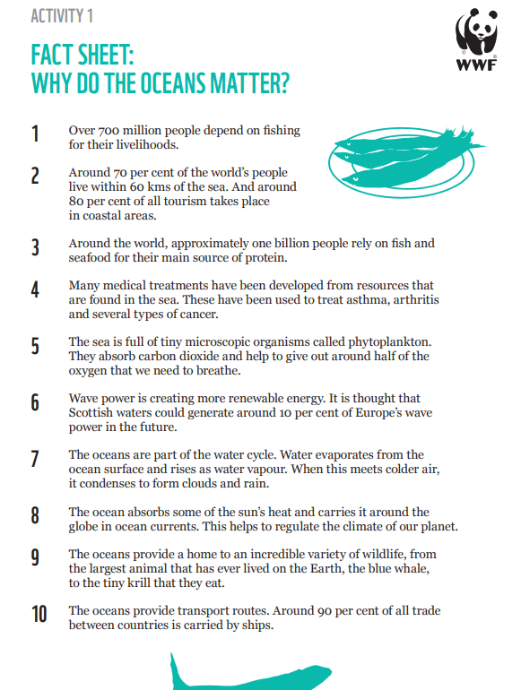

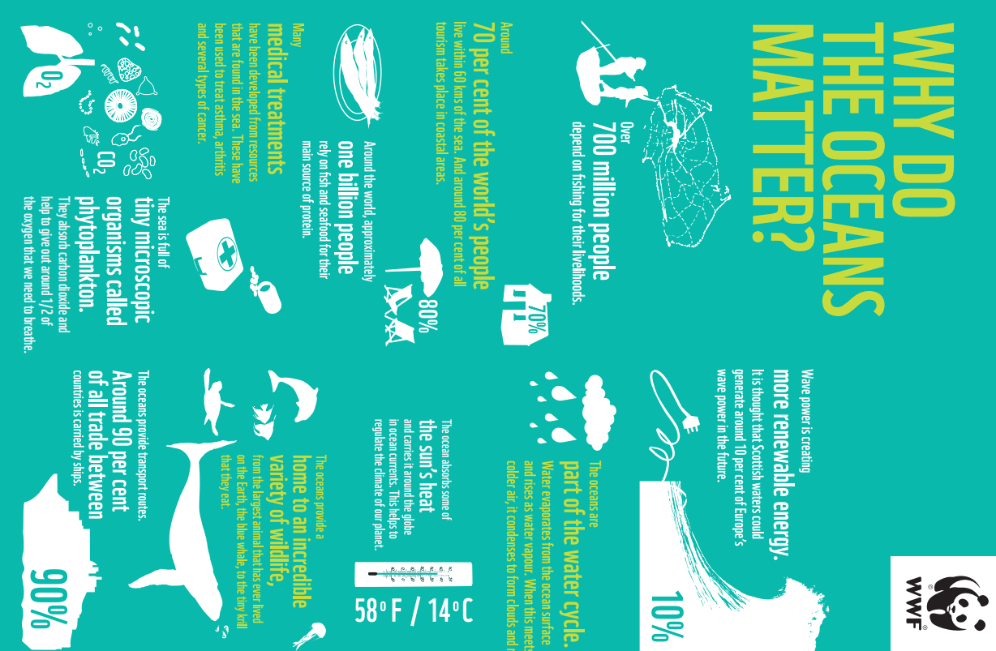

TUESDAY 30th JUNE 2020
Iaith
https://youtu.be/tVXgh9Dce-U
This is a folktale from India. A folktale is a story that has been passed down orally to explain events and entertain. Listen to the story above.

- What do you think about the story?
- Was it a good tale to explain why humans keep cats/pets?

On the website below there are so many different folk stories. Take a look at a few of them and choose your favourite. I am not going to read them. I would like you to write a synopsis of around 100 words to explain the story and the message behind them.

https://www.worldoftales.com/browse_all_folktales.html#gsc.tab=0

Maths
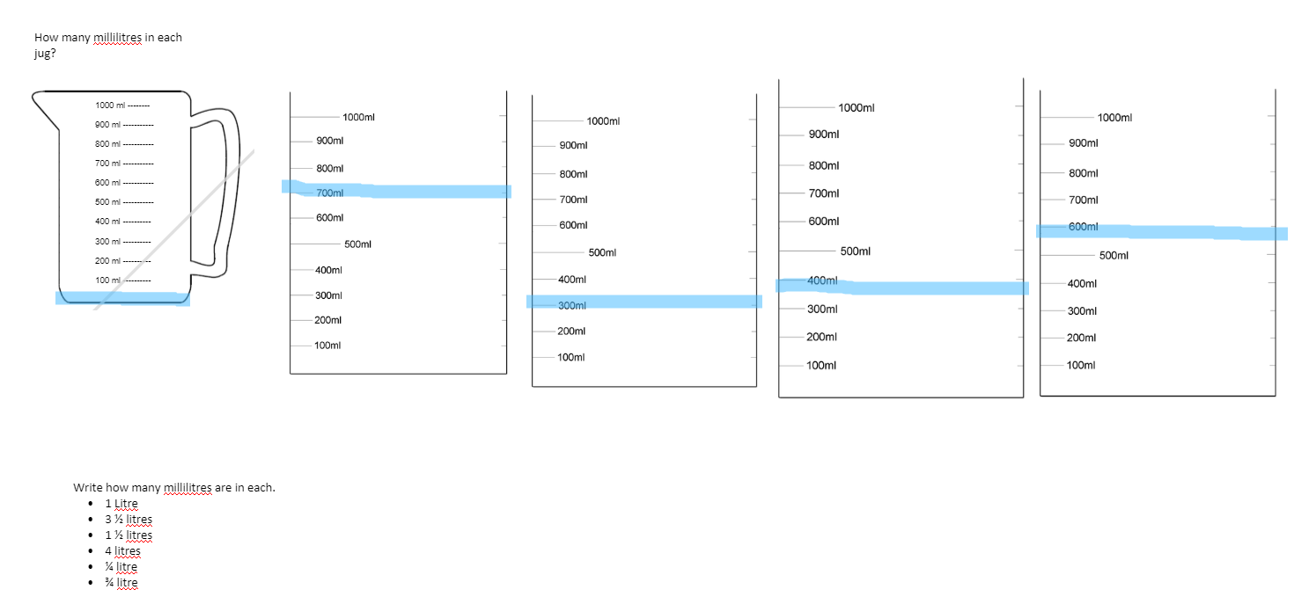

Expressive Arts
Could you use the style below to create your own ocean scene? Use a big black outline around the shapes.
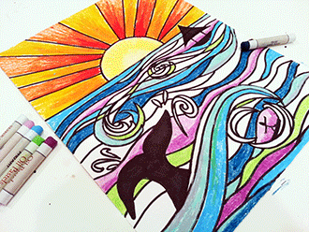

WEDNESDAY 1st JULY 2020
Cymraeg
Fill in the questionnaire by asking family members the questions.
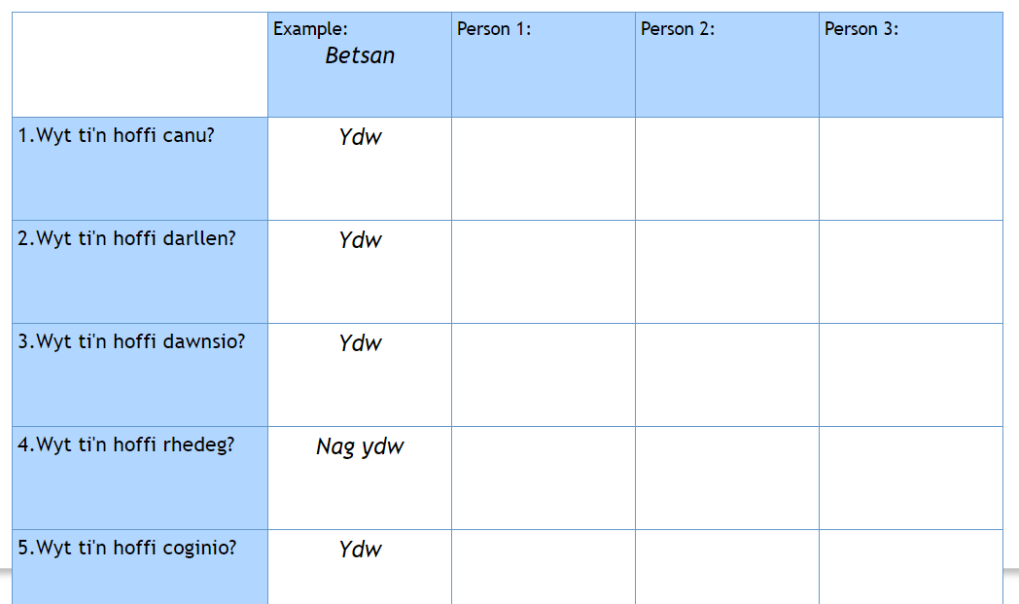

Maths
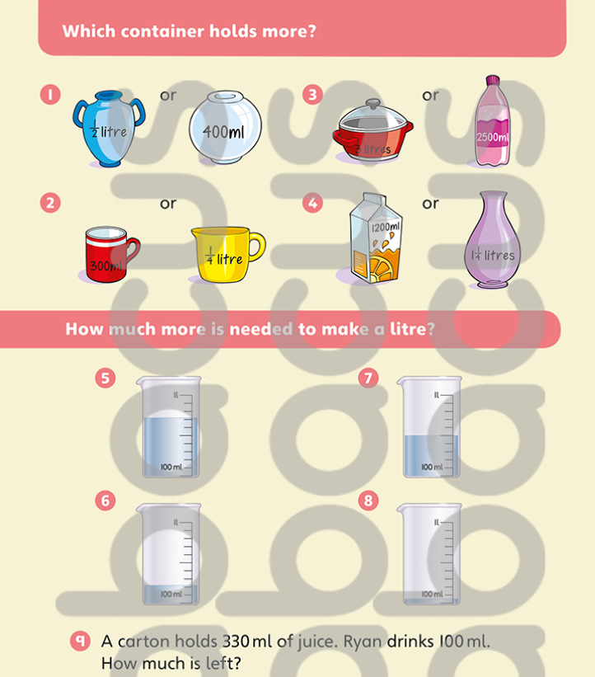

Science
Over the next few science sessions, we are going to become personal trainers! A personal trainer gives advice to people on how to get into shape, train, eat well and live a healthier lifestyle.

Today we will look at diet. Our diet is everything we eat and drink. Nutrition is the nourishment in foods and drinks we need to stay healthy. Let's look at what humans and animals naturally eat.

https://www.bbc.co.uk/bitesize/topics/z6882hv/articles/z96vb9q

Can you create a list of animals that are an herbivore, carnivore, or omnivore?

THURSDAY 2nd JULY 2020
Iaith
Listen to The Tiger Child again from yesterday. It has only recently been put into writing, for most of its existence it would have been told orally. What do you think would happen each time a story is told? The animals might have changed, the events, the speech or the setting.

When a person re-tells this they may exaggerate the size of the dog or how fast it was running or how aggressive it was to make the story sound more exciting but the main points will stay the same.

1. Identify the 5 main points from The Tiger Child.
2. Retell the story to a family member.
3. You can add more detail or change something.
4. You have to keep the 5 points the same.

Maths
Create a potion using different liquids.

You need to measure each ingredient out and write it down.

Your potion should be less than 1litre.

I made a potion that would make people fly.
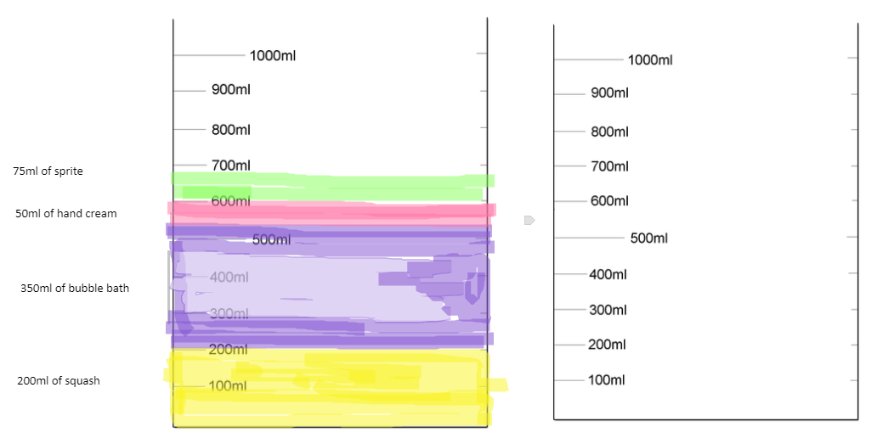

Computing
https://makecode.microbit.org/#editor

FRIDAY 3rd JULY 2020
Iaith
Preposition Game to Play with Another Person
- Person 1 hide an object. Person 2 cover their eyes.
- Person 1 to give a preposition on where they have hid the object (above, below, over, under, on, inside, beside, outside, by, behind, between, in).
- From that preposition person 2 to find the object. Person 1 to say whether they are hot or cold.
- Write the preposition sentence, e.g. The block was under the bucket.
- Repeat, swapping the roles.

We use prepositions to tell us time, place or cause.

Telling us about the place something happened.
At the new, harder level, the game became more serious.

Telling us about the time something happened
From the early afternoon on, the game became more serious.

Telling us about why something happened
With more people, the game became more serious

Maths
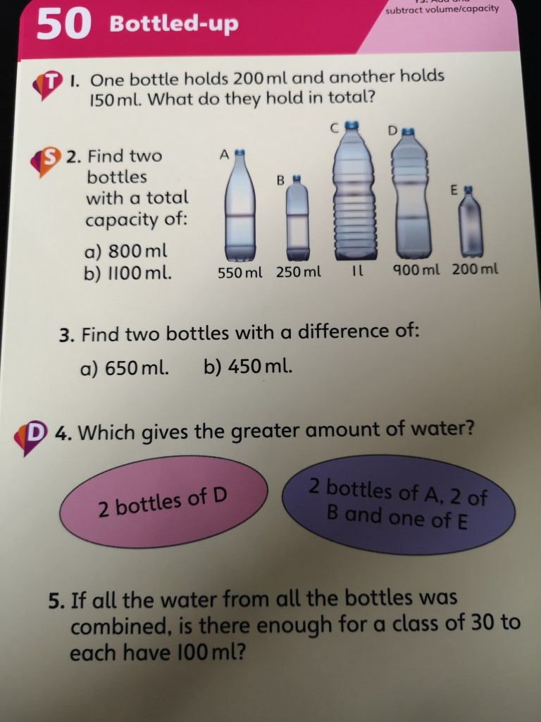

PE
Play your favourite outdoor game!

