Mantle Project
Miss Edwards emailed WWF Cymru who are very excited to receive your projects you’ve started for mantle. If your parents are happy for me to share your work with them then I will do. They even mentioned that SKY (tv) would also be interested in seeing them!
So far as part of your project to protect sea animals from plastic pollution you have created:
- Persuasive Letter
- Poster
- Discussion on ‘Should animals be kept in an aquarium?’
- Model of your animal.
- Research on your animal.
- A table/graph on what plastic you’ve used at home.

How can I display my work?
- Create a powerpoint with all your work.
- Video the different pieces while you explain them.
- Create a large display.
- Or any other ways you can think about.
Here is an example of a large display
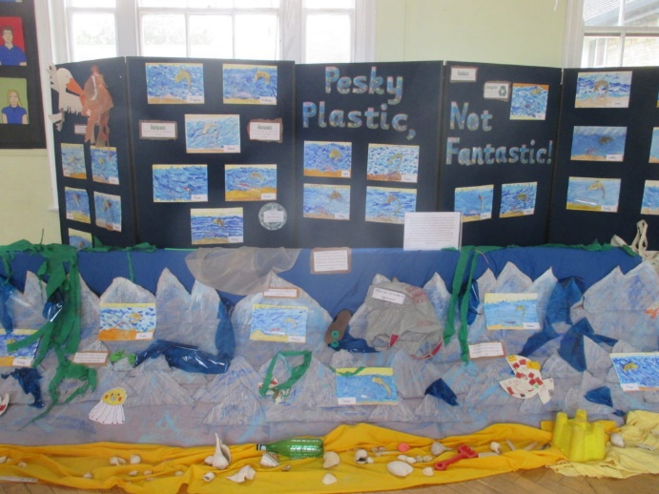
What have we got left to do?
Miss Edwards would love to see these completed before she leaves in 3 weeks, so we have a few things left to do.
- Start putting the work you’ve started already together.
- Create a scene like the one above of the sea with plastic in it. – You can use a large piece of cardboard, and use the plastic you would normally recycle.

