Iaith/Literacy Planning
Summer Term Week 6
1st June 2020
This week the children will be recapping or learning about different types of sentences.

Monday 1st June 2020
WALT: To be aware of and be able to recognise different types of sentences
Today the children will be finding out about the 4 types of sentence.

Can you watch the clip or look at the PowerPoint and list the 4 types of sentences?

Sentence Types (clip) Types of sentences-PowerPoint

Complete the worksheet.

Different types of sentences worksheet

Tuesday 2nd June 2020
WALT : I can write a set of questions.
? ? ? ? ? ? ? ? ? ? ? ? ? ? ? ? ? ? ? ? ?
Today you will be writing questions and asking your family them.

Watch the clip about questions.

Questions???

Who? What? Where? When? Why? What happened?

Think about 5 questions you would like to ask your family members. Write them down, ask them and record their answers. Remember good listening.

Remember the ? at the end.

My example
Who is your favourite football team?
Where would you like to go when lockdown is over?
What is your favourite colour?
When were you born?
What was you favourite subject at school?
What is for lunch?

I look forward to reading your questions and answers.

Wednesday 3rd June 2020
WALT: I can write statement sentences that are correctly punctuated.
Watch the video clip to remind you about statement sentences.
Statement sentences

I challenge you to write 10 statement sentences about one of the pictures.

Can you use adjectives in your sentences and different sentence openers?

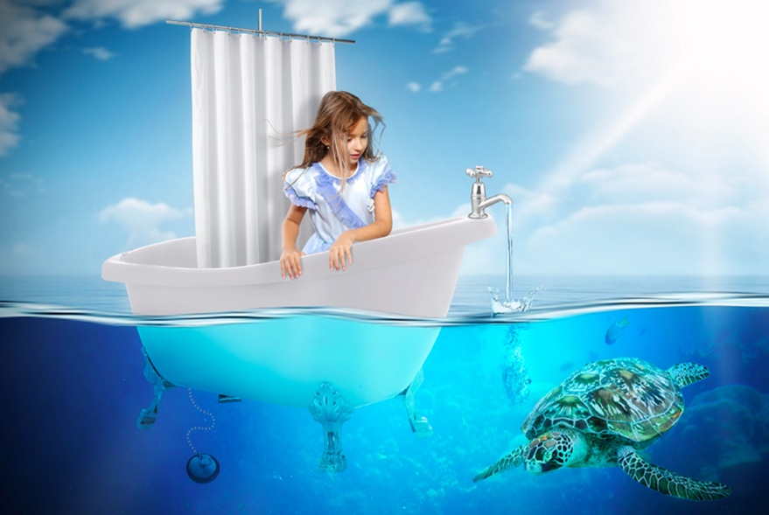

We are looking forward to reading them!

Thursday 4th June 2020
WALT: I can punctuate the end of sentences correctly.
Watch the clips about exclamation marks.

Exclamation marks ! Exclamation mark 2!

Complete the worksheets. You can do them on hwb or print them out.

Year3/4/5 Year 6

Friday 5th June 2020
Follow the link and play Spell blaster on Hwb.

Spell baster

Complete your reading comprehension
Year3/4 Reading Comprehension | Year 5 Reading Comprehension | Year 6 Reading Comprehension

Have a wonderful weekend!

