Here is a list of challenges to keep you busy. I have split them into sections (creative/literacy/maths/nature/well-being/games/fun). I will also try and complete one a day and will share it on the class Facebook page. As always please send me your videos and pictures, they make me smile.
List of Activities
Creative/Art and Craft
Activity | Instructions | Tick
Toilet Roll Craft | 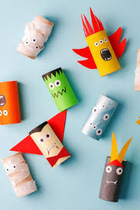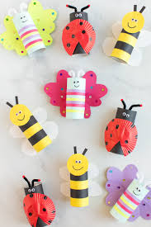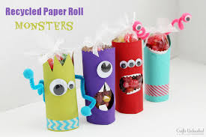
Make Slime
Shadow Drawing | 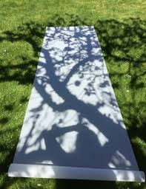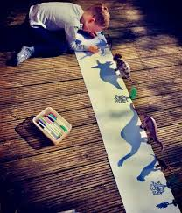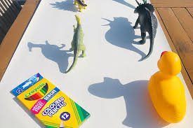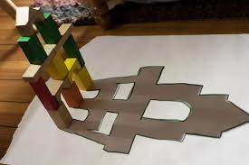
Michelangelo | He used to paint laying down. Stick some paper to then underneath of a chair or table and create your own masterpiece.
Finger Paint Art | 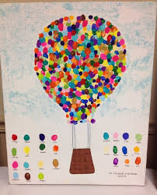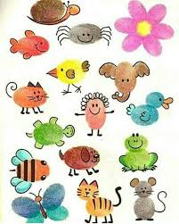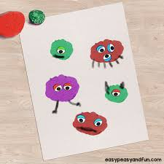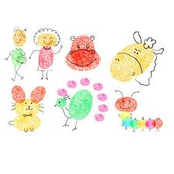
Origami | https://www.youtube.com/watch?v=1kZjq8f8Mpo  https://www.easypeasyandfun.com/easy-origami-for-kids/  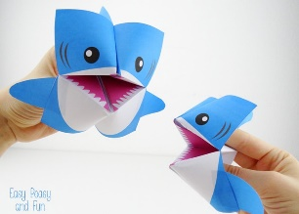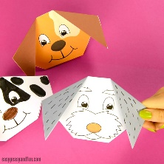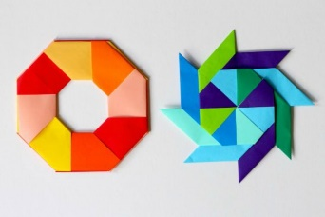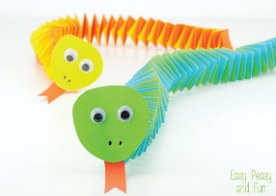
Musical Instruments | Create a musical instrument using recycled materials.  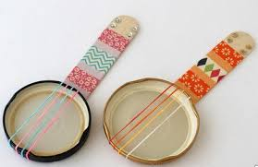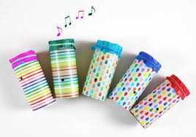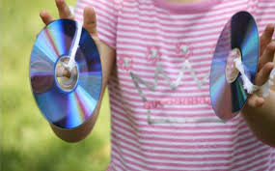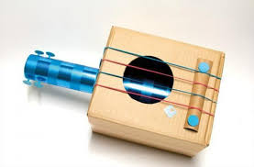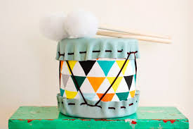
Drawing | http://www.robbiddulph.com/draw-with-rob  Type into YouTube How to draw…  They have so many fun ideas such as minions, unicorns, animals, dragons, people.
Paper Airplane | Create a plane and fly it. Can you throw it again and make it go further? Have a competition with the family.  Again google/youtube paper airplane and you will find so many different designs.
Paper Fidget Spinners | https://www.youtube.com/watch?v=CPV_5IjFu5o
Vegetable/snack animals | 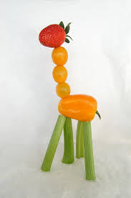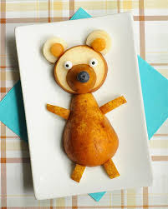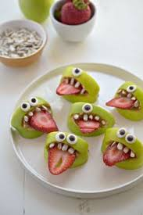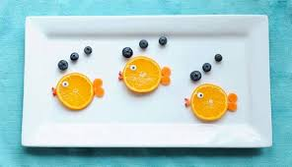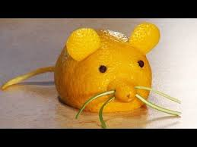
Junk Modelling | 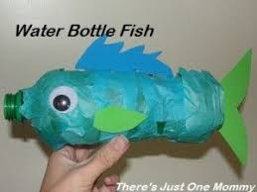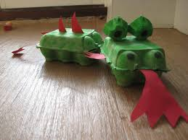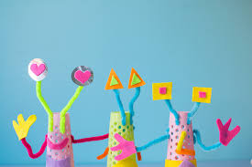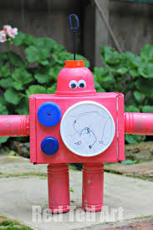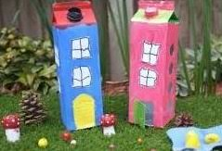
Egg box art | 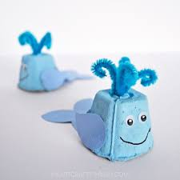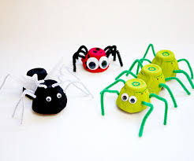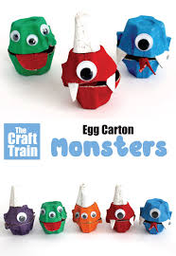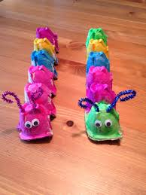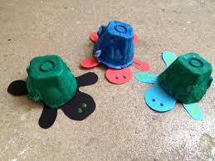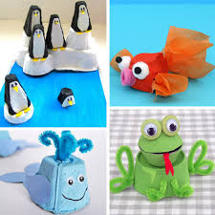
Create a paper spinner | 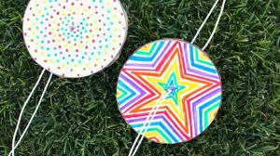  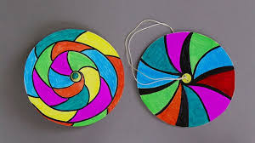  - Colour two fun circles on carboard  - Cut out  - Glue two circles together  - Make two small holes on either side of the centre  - Thread string through and tie
Clothespin Paper puppets | 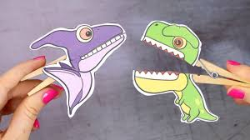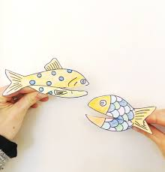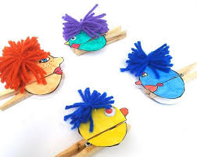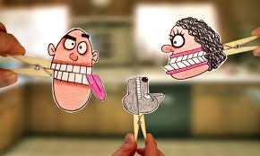
Create a town in a cardboard box | 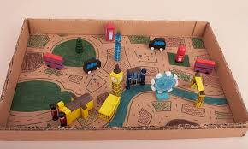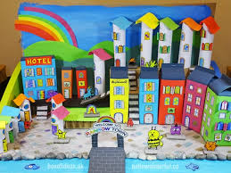
Expand an image | Cut a picture from a magazine article, and glue it to a blank sheet of paper with plenty of space around it. Now get the kids to finish the picture. Will an alien fly overhead, or a dinosaur appear behind the castle?
Make sock puppets | 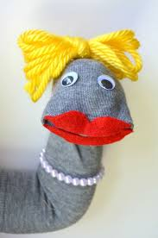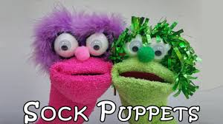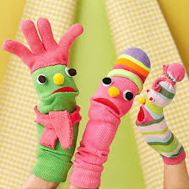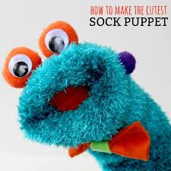
Physical
Living Room Disco | Create a playlist and dance your socks off!
Make your own video workout | Create your own workout video with a couple of exercises and post it on the class Facebook page. We can then test your workout and give you feedback. For ideas you could look at Joe Wicks PE lessons on YouTube.
Obstacle Course | Create your own obstacle course and see how fast it takes to get around it. Can you do it quicker? Can you beat a family member’s time? Maybe try it blindfolded and family members give instructions.
Dancing Era | Pick an era and play music. Will you choose the 50s, 60s, 70s, 80s? find a new song that you really like that you have not heard before.
Yoga | Cosmic Kids Yoga on YouTube has hundreds of videos.
Hop Scotch | Create your own hop scotch game and play with a family member.
Joe Wicks | Need to burn some energy off, follow another video!
Dance Class | Pick a dance workout from YouTube to follow.
DIY Laser Maze | 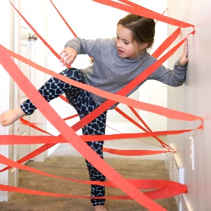
Twirling | Attach ribbon to a stick and do some twirling!
Golf | Build your own indoor golf course  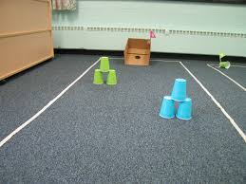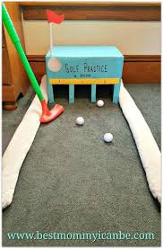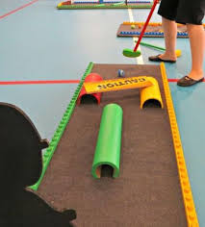
Well-Being
Family Dance | Make decorations together. Bake some yummy treats and create a playlist. Party all day long.
Happy News | Research happy news articles from around the world and make your own happy news bulletin.
Baby Me | Look at photographs of you now and as a baby. Make a list of all the things you did at the different ages. How do you look similar/different?
Chores | We all want to help our parents. They are juggling so much with work and being your teachers. Help them out and complete a few chores around the house.
Family Tree | Learn all about your family by creating a family tree.
Grateful Jar | Start a grateful jar. Every day write on a piece of paper one thing you are grateful for and the best part of your day. Keep the jar sealed until the end of the year. Then share all the memories you would have forgotten about.
Role Model | We are all great roll models. Create a collage on being a role model, include pictures and words.
Peaceful Place | Where is your peaceful place? Can you draw it? Describe it? Imagine being there?
Cloud Watch | Lay on the ground and just watch the clouds. Can you see any shapes? Patterns?
Save the World | Create a superhero. Draw your superhero and write about his/her power.
Facetime | Talk to someone you haven’t seen in ages.
Time Capsule | Create a Covid-19 time capsule. Place all the things that would remind you of this time in a box. Bury the box and agree on a year you will dig it up. It is best to choose a year a long way off so you do not remember what is in the box.
Memory Lane | Sit with your family and look through old photographs and videos.
Holiday Time | If you are anything like me then you are missing going away and exploring. If you could go anywhere, where would it be. Create a holiday vision board for the destination after researching it. Can you plan a family holiday to then place? Look at how you would get there, where you would stay, what you would do, what you would see.
Worry Fish | 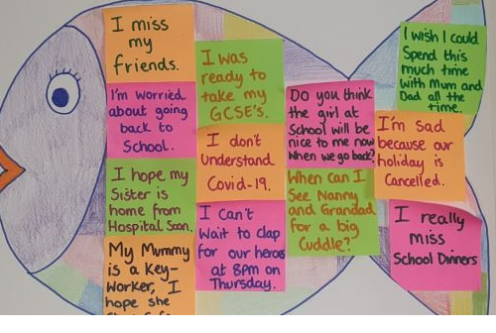  Create a worry fish and place post it notes on the fish. Write on the notes things that you are worried about. Choose a post it every day to take off the fish and talk about with an adult or friend.
Colouring | Mindfully colour in silence. Choose a picture and some colours and just sit and colour.
All about me | Create a collage all about you!
I am amazing | You are all amazing for different reasons. List all the ways you are amazing!
Literacy
Hangman | Play with a family member.
Letter | Write a letter to a family member on how much you miss them and what you have been up to.
Alphabet Race | Write the alphabet down the page. Decide on a subject (films, food, animals) and try and find a word that starts with the letter of the alphabet that also fits the subject.
Diary Entry | Write a daily diary as if you were an alien who is stuck living with a weird human family. What normal thinhs have your family done today that would seem really strange to an alien.
Puppets | Create your own puppets and a theatre. Perform your show for the family.
Boy/Girl | This is one of my favourite childhood games. Draw a grid with headings boy, girl, place, colour, food, animal. film. Say a letter and you have 1 minute to fill in as many as you can. For every one you get 1 point, however if someone else has written the same as you then you don’t get a point.
Comic Strip | Create your own comic strips. Look for examples on the internet then write your own.
Topic Brainstorm | Place the topic in a bubble in the middle of the paper. Write as many words as you can think of that goes with the topic. Example topics: Under the sea, Water, School, Things you miss, What you will do out of lockdown
Alison is an Acrobat in Asia | Take a letter of the alphabet and find a name, job and country starting with that letter. Write the sentence. Can you do the whole alphabet?
Tongue Twisters | Research some tongue twisters and practice saying them fast.
Bravery | A lot of people are being brave in the world right now. Can you write me a story of a time you wee brave. Remember to use descriptions.
Hidden Treasure | Hide treasure somewhere inside or outside. Create a map of your house that someone else could use to find the treasure.
Invisible Ink | Pretend you are a secret agent and write a message.  - Squeeze some lemon juice into a bowl and add a few drops of water.  - Mix the water and lemon juice with the spoon.  - Dip the cotton bud into the mixture and write a message onto paper.  - Wait for it to dry.  - When you are ready to read your message, heat the paper by holding it close to the radiator or light.
Potion Making | Create a potion and write the recipe.
Pen Pal | Send letters to a friend you haven’t seen since the last day in school.
Read | Have a reading afternoon. Find a comfy area.
Word Chains | Think of a topic such as animals. You will start with an animal such as tiger. You then take the last letter of that word to create the next one. So if I used tiger my next word could be rat.
Languages | Learn welsh or another language on Dualingo (free app)
Map Fun | Look at a map of Knighton, Wales, Uk or World and plan an adventure
Hot seating | Hot seating - you or a family member can pretend to be a favourite TV/story/video game character. Encourage everyone else to 'interview' the person in the hot seat
Audio Books | https://stories.audible.com/discovery  https://www.wizardingworld.com/chapters/reading-the-boy-who-lived  https://www.worldofdavidwalliams.com/elevenses-catch-up/
Maths
Count Down | - 4 large number cards with the numbers 25, 50, 75 and 100  - A set of cards with the digits 1-10 on them with at least two cards for each number.  - Select 6 cards out of the big and small number cards  - Generate a 3-digit number  - Get to that number using add/take away/divide/multiply
Wild Jacks | - Other than the Jacks, remove all of the picture cards from the deck. Jacks are wild cards and can be used at any time to represent any number from 1-10.  - The aim of the game is to reach the target number. To make the target number, shuffle the pack and turn over the top two cards. If either are a 10 or jack, put them to the bottom. The 2 cards turned over make the target number. For example, if you turn over the 5 of hearts and then the 2 of diamonds, your taget number is 52.  - Each player is dealt 5 cards. Players then can add, subtract, multiply and divide to try to reach the target number. If the target number is reached using all 5 cards, 10 points. If it is made using less than 5 cards, 5 points.
First to 100 | Shuffle a pack of cards and place face down. Each player takes one card and turns it over in front of them. Record then number on the card (Ace=1, picture=10). Each player takes a second card and adds the number to the first number, recording it on paper. Keep taking cards until the first person reaches 100.  VARIATION: Start on 100 and take the numbers away. First to 0 wins. You could also multiply the cards together using grid method, first to 1000 wins.
Dots and Boxes | Draw a page of dots or use dotted paper.  - The first player draws a line to join one of the dots to another of the dots, the next player then does the same.  - This continues until one player manages to join the line to make a box. They write their initial in the box and get another go. Once they are no longer able to complete a full box, it goes back to the other player.  - The winner is the person who has their initials in the most boxes at the end of the game.
Paper Battleships | - Each player draws out a grid with A-J along the bottom and 1-10 up the side.  - They then plot ships of various sizes on the grid by colouring in the squares. One ship five squares long (the aircraft carrier), one ship four squares long (battleship), two ships three squares long (cruiser and submarine), one ship two squares long (destroyer).  - The first player shoots by calling out a grid reference, e.g. B3. If it hits an empty square the other player shouts, ‘miss!’ whilst the first player draws a cross, but if it hits a square with a ship in it, they have to shout ‘hit’ and the other player draws a dot. Each player keeps track of their hits and misses on a separate grid.  - Once all the squares for a ship have been hit, that ship then sinks. The winner is the one to sink all the other person’s ships first.
Bingo (Times Tables) | Each player write 5 numbers on a piece of paper, which are multiples of a given times table. For example: if they were doing the 5 times table, they might write 10, 35, 45, 60.  Another person can lead the game and call out multiplication questions from the chosen times table.  If the player has an answer, they can cross it out. First person to cross out all their numbers is the winner.
Scavenger Hunt | Give kids a grid with some pre-set weights and lengths on. T will then be a challenge for them to find something in the garden that is approximately 10cm long or something in the house that weighs 300g.  Get your kids to gather all the items they think match the weights and length and then check.
Yes/No | Both players put a card on their head. It could have a number on it, shape etc.  The first player asks a question which can only be answered with yes or no.  Keep asking questions until they answer correctly.
24 | Use a pack of playing cards (just the numbers). Each player picks 4 number cards at random from the pile. They then need to find a way to manipulate the 4 digits using any of the four operations so then end result is 24. For example, if they chose 4, 7, 8, 8, they could do 8 divided by 8 is 1, 7-1=6, 6x4=24.
Telling the Time | Try drawing a clock on the ground with chalk. Then, get your child to use their body to make the hands of the clock. Say a time and they have to show it.
Pig Dice Game | Throw the die and the player records the number that they roll. As long as a one isn’t thrown, the player can roll again and add the number to their total. After each throw, the player has to decide whether to throw again or keep the points they’ve scored. If a one is thrown at any point, the player loses all the points scored so far. The first player to score 100 is the winner.
Biggest Number | Each player draws a place value grid, with an agreed number of places. E.g. Thousands, hundreds, tens and ones. Using a deck of cards (Ace=1, Picture=0) players take turns to draw a card from the pile, and each player chooses which column to record the number in. The winner is the person to have the biggest number recorded at the end of the round.
Nature
Build a Bug Hotel | 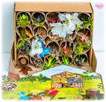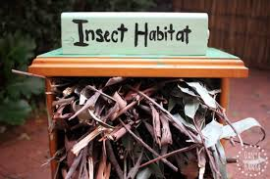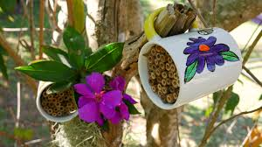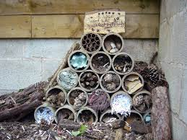
Bird Feeders | https://happyhooligans.ca/32-homemade-bird-feeders/  This website has some great ideas on different bird feeders.
Picnic | Help make a picnic to enjoy outside in the sun.
Rocks and Pebbles | Collect rocks and pebbles and then decorate.  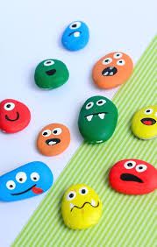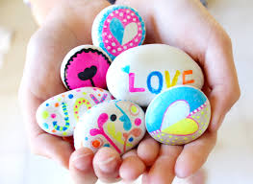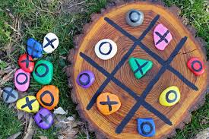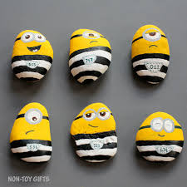
Scavenger Hunt | Create a list of things to find in the garden. Take your list outside and try and find as many things as possible
Planting | Make your garden even prettier by planting some lowers, herbs or plants.
Boats | Make a twig boat and see if it floats.  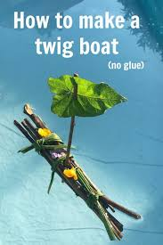
Camping | When it is warm outside, put up your tent in the back garden and pretend you are camping.
Make a Weather Station | How to make a rain gauge  - You just need an empty two-litre plastic bottle, which you cut two thirds of the way up. Then turn the top part of the bottle upside down and place it in the bottom part using sticky tape to secure.  - Use a ruler to make a scale in centimetres on a piece of tape and stick it on the bottle.  - Find an open space in the garden away from any shelter and dig a hole to bury the gauge so that around 5cm of it is sticking out of the ground.  - Then simply check your rain gauge every day at the same time, measure the amount of rain it has collected and empty the bottle.  How to make a wind vane  - Draw a 25cm arrow on a piece of card and cut it out, then draw around the arrow to make another one and cut it out.  - Place a pen top between the two arrows and glue together. Get four matchsticks and a cork and push the matchsticks into the long side of  the cork at right angles to each other.  - Label four pieces of card with N, S, E, W and attach these to the ends of the matchsticks with Blu-tack.  - Fill a bottle with sand and push a knitting needle into the cork and then push into the sand. Balance the arrow on top of the needle and place the wind vane in an open area using a compass to point the N label North. The arrow will show you the direction the wind is blowing from.
Hunt | Go on a minibeast hunt. What did you see? Draw and label the minibeasts you found. Can you find a fact about them?
Natural Art | Using any natural materials create a picture.  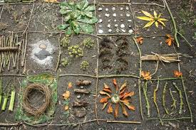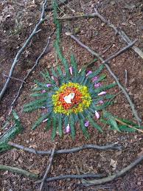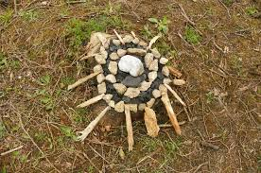
Sun | Watch the sunset/sunrise
Walk | Go for a walk and take a photograph of something you like. When you get back home paint/colour/collage/draw your favourite part of the walk.
Flowery Friends | When you go on a walk or play in the garden, pick a selection of natural items including different shaped and coloured leaves, grass, flowers (if you’re allowed!), sticks and pine cones – whatever you come across! At home, take a sheet of paper and draw a simple face outline. Use glue to stick the items you’ve collected to the paper, using different pieces to make the arms, legs and body. You can create a different flower friend every time you play!  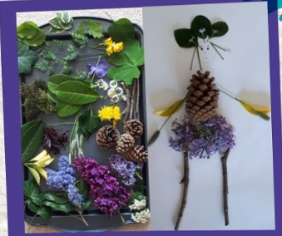
Mini Garden | Create a miniature garden  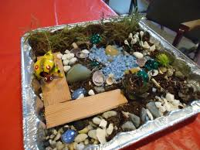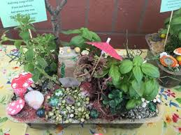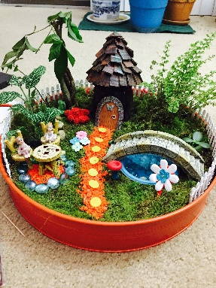
Puzzles and Games
Create a quiz | Create a family quiz and then play with another family over facetime/zoom.
Jig-Saw
Maze | 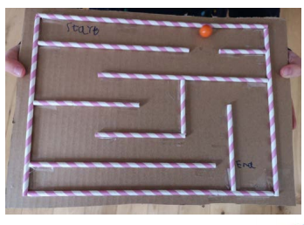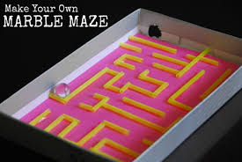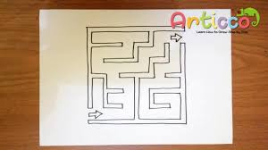
Wordsearch
Foosball Table | 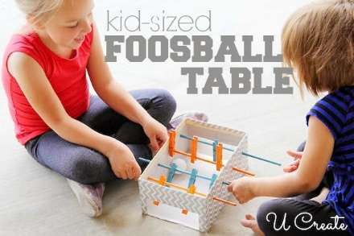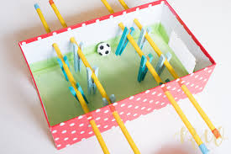
Crossword
Cards | Learn a new card game.
Make your own skittles | 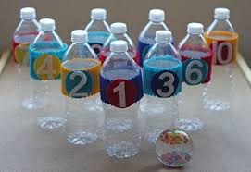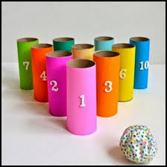
Floating Ball
Charades
Indoor Volleyball | Use a balloon
Balloon Ping Pong | 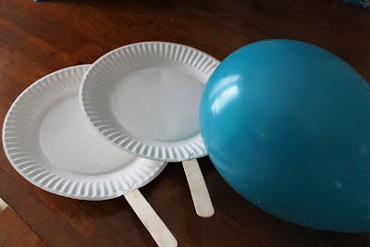
Learn to juggle
Croquet | Create and play croquet in your garden
Bingo | Create your own bingo cards and then play as a family.
Board Game
Fun
Virtual Trip  Complete a Virtual Field Trip Log if you want.  Destination:  Description:  What I learned:  The best part:  Draw your favourite part: | Museums  https://britishmuseum.withgoogle.com/ - British Museum  https://www.metmuseum.org/art/online-features/metkids/ - Metropolitan Museum of Art  https://www.mos.org/mos-at-home - Museum of Science  https://learning.sciencemuseumgroup.org.uk/resources/?type=at-home - Science Museum  https://naturalhistory2.si.edu/vt3/NMNH/ - Smithsonian National Museum of Natural History  http://www.museivaticani.va/content/museivaticani/en/collezioni/musei/tour-virtuali-elenco.1.html The Vatican  Landmarks  https://www.royal.uk/virtual-tours-buckingham-palace - Buckingham Palace  https://www.cyark.org/projects/mount-rushmore-national-memorial/virtual-tour - Mount Rushmore  https://www.english-heritage.org.uk/visit/places/stonehenge/history-and-stories/stonehenge360/ - Stonehenge  https://www.nationaltrust.org.uk/giants-causeway/features/take-a-virtual-tour-of-the-giants-causeway - Giants Causeway  https://www.taj-mahal.net/newtaj/ - Taj Mahal  https://www.thechinaguide.com/destination/great-wall-of-china - Great Wall of China  https://www.esbnyc.com/about/live-cam - Empire State Building  https://www.canterbury-cathedral.org/virtual-tour/ - Canterbury Cathedral  Zoos and Wildlife  https://kids.sandiegozoo.org/videos - San Diego Zoo  https://www.montereybayaquarium.org/animals/live-cams - Monterey Bay  https://www.edinburghzoo.org.uk/webcams/panda-cam/ - Edinburgh Zoo  https://sanctuaries.noaa.gov/vr/ - Virtual Dives  https://www.youtube.com/playlist?list=PLg-ZmYeeKdTvjUaG23DoRacU0BpBfpoQd – Safari  Fun  https://youtu.be/GtfkemNzG_I - M&M Factory  https://www.nasa.gov/mission_pages/station/main/suni_iss_tour.html - International Space Station  https://accessmars.withgoogle.com/ - Mars  https://moon.nasa.gov/resources/168/tour-of-the-moon-4k/ - The Moon  https://www.farmfood360.ca/ - Farms  https://www.youtube.com/channel/UCYyJUEtYv-ZW7BgjhP3UbTg - Walt Disney World Rides
Cooking Show | Create your own cooking show by filming yourself baking. Upload onto the Facebook page and we could all try it out.
Blind Taste Test | Blindfold a member of the family and create a taste test. Will they know what they are eating?
Ice Cream in a Bag | - Place the milk (300ml semi skimmed), sugar (1tbsp caster sugar) and vanilla (1/2 tsp) into a freezer bag. Close and secure with sticky tape.  - Tip the ice (1kg) and salt (6 tbsp) into the large bag, then place the freezer bags insode the larger one and seal well.  - You need to keep the bags moving for 10-15 minutes from hand to hand or take turns shaking it.  - Remove the ice cream bag, open and scoop into bowls.
Food Around the World | Research foods from over countries and get cooking. Tell me if they are worth making and I may give it a go!
Fashion Show | Get dressed up and walk the catwalk. But some funny and strange looks together. Change your outfits and strike a pose.
Movie Day | Grab a blanket, drink and popcorn and start your movie marathon. Tell me what film you have watched and give me one sentence on why I should watch it.
Ice Lollies | Create your own ice lollies. How creative can you be?  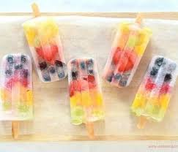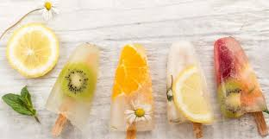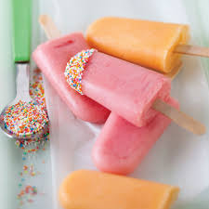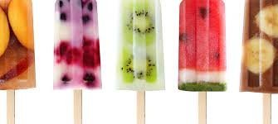
Photoshoot | Go on your very own photo shoot. Choose some outfits and accessories and strike some poses.
Fruit Skewers | Create fruit skewers to eat. You could always drizzle chocolate over them to make them into a treat.
Pizza Party | Make pizzas and have a party. Show me pictures of your pizzas.  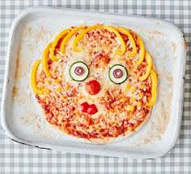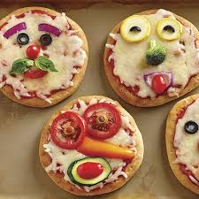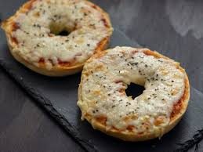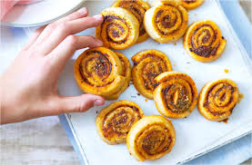
Camping | Make a fort and sleep in it for the night. Remember your torch!
Colourful Toast | Using food colouring paint, a pattern onto the bread and then toast.  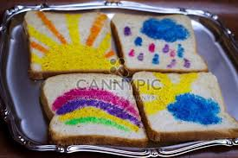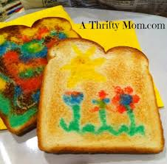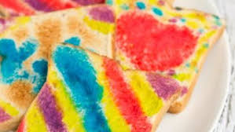
Floor is Lava | Play the floor is lava with your family. Nobody is allowed to step on the floor. What do you do? How do you get to the next room? There are some pretty funny YouTube clips on this game (check them first for the language used, or watch them on mute).
Cake in a mug | - Add 4tbsp of self-raising flour, 4tbsp caster sugar and 2tbsp cocoa powder to then largest mug you have and mix.  - Add 1 medium egg and mix in as much as you can, but don’t worry if there’s still dry mix left.  - Add the 3 tbsp milk, 3 tbsp vegetable oil and a few drops of vanilla essence and mix until smooth.  - Add 2tbsp chocolate chips, nuts or raisins and mix again.  - Centre your mug in the middle of the microwave oven and cook on high for 1 ½ -2 mins, or until it has stopped rising and is firm to touch.
Family Has Talent | Create your own talent show.
Start a Band | Start your own band using household items such as pots and pans.
Learn a magic trick
Clapping | Learn some classic hand-clapping games  https://icebreakerideas.com/hand-clapping-games/
House of Cards | Using a pack of playing cards make your own house. How high can you build it?
Fidget Spinners | https://youtu.be/CPV_5IjFu5o
Paint with bubbles | To create these bubble blower paintings, mix bubbles with food color of choice and then use bubble wands to blow the bubble mixture onto the paper of your choice for creative and beautiful designs that will delight your kids!
Teacher | Pretend to be a teacher. Can you teach your family something?

